**Software Requirements Specification**

**for**

**East Blue Portal**

**Version <1.0>**

**Group No.: Group 6**

| **Tan Jun Xian** | **242UC2452B** |  |
| --- | --- | --- |
| **Sokmaed Ong Yu Kang** | **242UC244V6** |  |
| **Lai Joon Li** | **242UC2452F** |  |
| **Muhammad Loqman Bin Ahmad Fariz** | **1231301695** |  |

|  | | |  | |
| --- | --- | --- | --- | --- |
|  | | |  | |
|  | | |  | |
|  | | |  | |
| **Date:** | | **23 May 2025** | | |

**Table Content**

**1. Introduction 5**

1.1. Purpose 5

1.2. Scope 6

1.3. Product Overview 7

1.3.1. Product Perspective 7

1.3.2. Product Functions 9

1.3.3. User Characteristics 10

1.3.4. Limitations 12

1.4. Definitions 13

**2. References 14**

**3. Requirements 15**

3.1. Functions 15

3.2. Performance Requirements 49

3.3. Usability Requirements 50

3.4. Interface Requirements 52

3.4.1. System Interfaces 52

3.4.2. User Interfaces 52

3.4.2.1. Student 52

3.4.2.2. Lecturer 64

3.4.2.3. Administrators 71

3.4.2.4. Parent 77

3.4.3. Hardware Interfaces 81

3.4.4. Software Interfaces 82

3.4.5. Communications Interfaces 82

3.5. Logical Database Requirements 83

3.6. Design Constraints 88

3.7. Software System Attributes 89

3.8. Supporting Information 91

3.8.1. Summary of Key Elicitation Findings 91

3.8.1.1. Type of Elicitation Used 91

3.8.1.2. Explanation of Elicitation Use 91

3.8.1.3. Benefits 92

3.8.1.4. Challenges Faced 92

3.8.1.5. Recommendations 92

3.8.2. Sample Input/Output Formats 93

**4. Verification 95**

4.1. Verification Approach 95

4.2. Verification Criteria 98

**5. Appendices 104**

5.1. Assumptions and Dependencies 104

Assumptions and Dependencies 104

5.2. Acronyms and Abbreviations 105

**Revisions**

| **Version** | **Primary Author(s)** | **Description of Version** | **Date Completed** |
| --- | --- | --- | --- |
| 1.0 | Tan Jun Xian, Lai Joon Li, Sokmaed Ong Yu Kang, Muhammad Loqman Bin Ahmad Fariz | Initial complete draft of the Software Requirements Specification for East Blue Portal, outlining all proposed features and system requirements. | 23/5/2025 |

# Introduction

## Purpose

Through the integration of the Student Information System (SIS) and the Learning Management System (LMS), the university aims to improve the efficiency of administrative procedures such as course registration, student enrolment, and academic record management. The goal of this integration is to decrease the frequency of manual data entry errors and remove redundant tasks.

In addition, the system aims to improve the user experience for students. Students can access administrative and educational resources through a single interface through to the integrated platform, which provides a smooth user interface. Students are more satisfied with the university's services overall as a result of the improved usability and convenience.

Other than students, administrative gain from the integration since it gives them access to all necessary course management resources in one place. This includes functions like grading, managing assignments, uploading course materials, and interacting with students. Effective course delivery and organisation are encouraged by this simplified system.

The university can get a complete view of student performance and engagement by combining academic activity from the LMS with student data from the SIS. By using this data for reporting and analysis, it will be easier to make well-informed decisions that will support student success programs and improve academic results.

## Scope

The goal of the software product, called East Blue Portal, is to develop a single platform that connects the university's Learning Management System (LMS) and Student Information System (SIS).

Important university procedures like student enrolment, course registration, academic record management, SMS notification, and course material access will all be simplified by this integrated platform. The software product will increase productivity, reduce manual work, and reduce errors in administrative tasks linked to academic operations through combining the features of SIS and LMS into a single, integrated system.

The East Blue portal's development aims to reach a number of advantages, goals, and objectives:

* **Streamlined Procedures**: By automating and streamlining administrative duties linked to course registration, student enrolment, and academic record management, the software will reduce errors and manual work.
* **Greater User Experience:** The system will improve accessibility and user experience by giving administrators, lecturers, parents and students a single interface, which will increase productivity and satisfaction.
* **Improved Communication:** By integrating SIS and LMS, students and lecturers will be able to communicate more effectively and receive timely updates on assignments, course schedules, and academic progress.
* **Flexibility and Scalability:** The software will be built to grow with the university and adapt to its changing needs, guaranteeing flexibility and scalability over time.
* **Academic Excellence:** The East Blue Portal will help to improve the overall academic experience and promote excellence in teaching and learning by improving administrative procedures and facilitating enhanced access to learning materials.
* **Cost Savings:** The university will save money on time and resources by automating manual tasks and improving productivity.

## Product Overview

### Product Perspective

### 

*Figure 1.3.1.1 Overview Diagram*

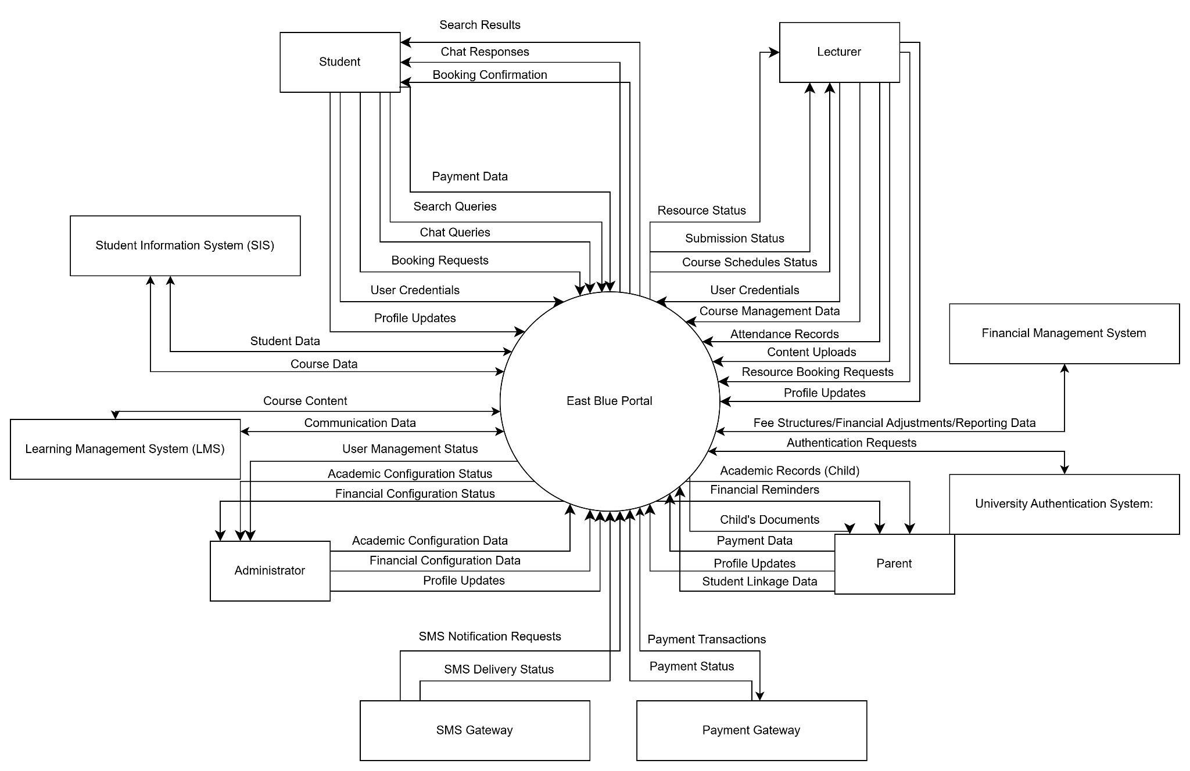

*Figure 1.3.1.2 Context Diagram Diagram*

<https://drive.google.com/file/d/1JnCAi-yHJR8-E8RWUKVrynEZBMQKvRA2/view?usp=sharing>

An integrated system called East Blue Portal was created to optimise academic procedures in a university setting. It connects the Learning Management System (LMS) and Student Information System (SIS) to streamline academic and administrative duties, making it an essential component of the wider educational ecosystem.

In reference to other products, East Blue Portal serves as a link between systems that are normally kept separate allowing for smooth data exchange and communication between course management and student records. Although it functions independently, it interfaces with the university's current databases, authentication systems, and outside services like SMS notification platforms.

[Diagram Description: The overview diagram depicts East Blue Portal at the center, surrounded by interconnected components. On the left side are student users, follow up administrative users. On the right side are lecturer users and parent users. The central East Blue Portal component connects to the university's databases, SIS, LMS, and external services.]

### 

### Product Functions

* + - * + **User Authentication and Role-Based Access**: Securely logs in users (Students, Lecturers, Parents, Administrators) and provides access to functionalities and data appropriate to their role.
        + **Academic Management**: Allows students to view academic records (grades, CGPA, attendance), lecturers to manage courses (attendance, assignments, content), and administrators to manage academic structures.
        + **Financial Information Management**: Enables students and parents to view financial balances, make payments, and access payment history. Administrators can manage fee structures and financial reporting.
        + **Scheduling and Booking**: Provides timetable viewing for students, and allows students and lecturers to book resources such as consultations or rooms.
        + **Communication and Notification:** Facilitates communication through features like an AI chatbot and sends SMS notifications for important events like deadlines or low attendance.
        + **Profile and System Personalization:** Allows users to manage their profiles and customize their dashboard and notification preferences.

### User Characteristics

**Student Users**

* **Educational level:** Undergraduate students of bachelor's degrees and graduate students pursuing master's or doctoral degrees are among the student users; their educational backgrounds may have an impact on how experienced they are in academic terms and procedures.
* **Experience:** Depending on their educational background and exposure to digital learning environments, students' levels of experience with educational technology tools differ.
* **Technical Proficiency:** Although many students possess strong technological abilities, some may lack these abilities, especially if it comes to difficult software systems. To allow for users with different levels of technical expertise, the system should be designed with a user interface that is simple and clear instructions.

**Administrative Users**

* **Educational Background:** Most administrative users have a higher level of education and frequently hold bachelor's, master's, or doctoral degrees.
* **Experience:** They have worked in educational institutions before, and their knowledge of administrative procedures and educational technology tools.
* **Technical Expertise:**Although certain administrative users possess advanced technical skills, others might only possess basic technical knowledge. As a result, the system needs to be easy to use and requires minimal instruction to operate efficiently.

**Lecturer Users**

* **Educational Background:** A Master's degree is generally the minimum requirement and PhD is often preferred.
* **Experience:** They have experience in the educational field, and their knowledge of teaching students and using technologic to prepare educational materials such as computers or tablets.
* **Technical Expertise:** Although many lecturers have strong technological skills, some may not, particularly when it comes to complex software systems. The system should have an easy-to-use interface with clear instructions for users who have different technical skill levels.

**Parent Users**

* **Educational Background:** Parents can use a school portal without having any particular educational background. Regardless of their own educational background, the main goal of these portals is to give parents access to information about their child's education, including grades, attendance, and important school communications.
* **Experience:** Depending on their learning skill and exposure to digital learning environments, parents' levels of experience with educational technology tools differ.
* **Technical Expertise:** In general, parents who use portals must be familiar with online navigation and possess basic computer skills. Logging in, navigating menus, viewing information and replying to messages are all included in this. It's not always necessary to have a deep understanding of digital literacy because the portal should be easy to use and must be clear.

### Limitations

* + - * + **SMS Notification Delays**: While the system is designed to send timely SMS notifications, delivery to the end-user is subject to the operational status and potential delays of third-party SMS gateway services and telecommunication networks.
        + **Scope of AI Chatbot:** The AI chatbot's knowledge base is limited to information explicitly managed within the East Blue Portal and integrated SIS/LMS. It cannot provide information or answer queries outside this defined scope.
        + **Offline Functionality:** While the desktop application may support limited offline access for some features, most functionalities, especially those requiring real-time data (e.g., viewing current grades, submitting assignments, making bookings), require an active internet connection.
        + **Customization Scope**: Dashboard widget customization is limited to the predefined set of available widgets and layout options provided by the system. Users cannot create entirely new widget types without system updates.
        + **Supported Languages**: While multi-language support is a feature, the initial release will be limited to English, Bahasa Melayu and Chinese. Additional languages will be considered in future releases based on demand and resources.

## Definitions

* + - * + **East Blue Portal**: The integrated software solution that serves as the central platform for students, lecturers, parents, and administrators to access academic, financial, and administrative services at the university.
        + **Student Information System (SIS)**: The university's core system responsible for managing student data, including personal details, enrollment, registration, and academic records. The East Blue Portal interfaces with the SIS.
        + **Learning Management System (LMS)**: The university's platform for delivering and managing educational content, including course materials, assignments, quizzes, and communication tools. The East Blue Portal interfaces with the LMS.
        + **User Role**: A classification assigned to a user (e.g., Student, Lecturer, Administrator, Parent) that dictates their access rights and permissions within the East Blue Portal .
        + **Dashboard:** A personalized user interface within the East Blue Portal that provides an overview of relevant information, announcements, and quick access to frequently used functions, often customizable by the user.
        + **Widget**: A modular component within the East Blue Portal dashboard that displays specific information or provides a particular function (e.g., Timetable widget, Financial Summary widget)
        + **Use Case:** A description of a sequence of actions that the system performs to yield an observable result of value to a particular actor (user).
        + **CGPA (Cumulative Grade Point Average):** A measure of a student's overall academic performance throughout their program of study.
        + **SMS Gateway:** An external service used by the East Blue Portal to send Short Message Service (SMS) notifications to users' mobile devices

# References

1. Lane, G. K. (n.d.). *How to write an SRS Document (Software Requirements Specification Document)*. Perforce Software. <https://www.perforce.com/blog/alm/how-write-software-requirements-specification-srs-document>
2. *Requirement analysis techniques*. (n.d.). <https://www.visual-paradigm.com/guide/requirements-gathering/requirement-analysis-techniques/>
3. GeeksforGeeks. (2024, July 24). *Requirements Engineering Process in Software Engineering*. GeeksforGeeks. <https://www.geeksforgeeks.org/software-engineering-requirements-engineering-process/>
4. Pragmatic institute. (n.d.). *Prioritizing Software Requirements with Kano Analysis*. <https://www.pragmaticinstitute.com/resources/articles/product/prioritizing-software-requirements-with-kano-analysis/>
5. What is the kano model? meaning, working and categories. Young Urban Project. (2025, January 28).

<https://www.youngurbanproject.com/what-is-the-kano-model/#:~:text=The%20Kano%20Model%20helps%20businesses,what's%20most%20important%20for%20custom>

1. airfocus (n.d.) *What Is the Kano Model? Kano Model Definition, Origin & FAQ*

<https://airfocus.com/glossary/what-is-the-kano-model/>

1. *Enhance Customer Satisfaction with the Kano Model: Learn More on Our Blog*. (2024, August 2). HEFLO. <https://www.heflo.com/blog/kano-model>
2. Kano's model and five categories of quality attribute. | Download Scientific Diagram Using (n.d.) *Citation Generators Responsibly*

<https://www.researchgate.net/figure/Kanos-model-and-five-categories-of-quality-attribute_fig1_233473957>

# Requirements

## Functions

The Use Case Diagram below illustrates the main functions of the **East Blue Portal** and how different users interact with the system. There are four key actors:

* Student
* Lecturer
* Administration
* Parent

Each actor interacts with the system to perform specific tasks based on their role. The diagram shows major system functions such as login, viewing dashboard, managing academic and financial data, and booking services. The system also includes supportive features like Multi-language Support, AI Chatbot, and SMS Notifications.

To represent relationships between use cases, the diagram uses:

* <<include>>: Indicates that one use case always uses the behavior of another. For example, Online Booking includes both Venue Booking and Consultation Booking.
* <<extend>>: Indicates optional behavior. For instance, Profile Settings may extend into Change Password and Change Theme based on user actions.

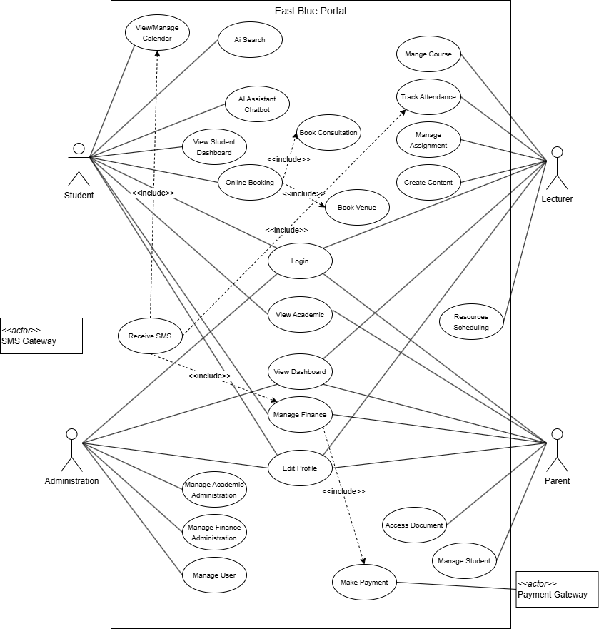

*Figure 3.1.1 Use Case Diagram*

<https://drive.google.com/file/d/1VfQDRXVtONjeqw3sMYvtWZPUVFw5bcPK/view?usp=sharing>

* + 1. Use Case Specification
       1. Student/Lecturer/Parent/Admin Login

*Table 3.1.1.1.1 Student/Lecturer/Parent/Admin Login*

| Use Case ID | REC_UC_0001 |
| --- | --- |
| Use Case Name: | Login |
| Description: | Allows users to securely log into the system based on their role. |
| PrimaryActor: | Student/Lecturer/Parent |
| Precondition: | 1. The user must be registered and have valid login credentials. |
| Postcondition: | 1. The user is redirected to their respective dashboard or shown an error. |
| MainSuccessScenario: | 1. User accesses the login page. 2. System checks for saved credentials in cookies. 3. Pre-filled login form is displayed (if data exists). 4. User submits login form. 5. System authenticates credentials via the database. 6. If valid, login is successful:   - Credentials saved in cookies.  - User redirected to dashboard.   1. 7. If invalid, error message is shown. |
| AlternativeScenario: | 1. Admin accesses the login page. 2. System checks user role. 3. If Admin detected, shows blank login form. 4. Admin submits login credentials. 5. Credentials are validated with the database. 6. If valid, Admin is redirected to the Admin dashboard. 7. If invalid, error message is displayed. |
| ExceptionScenario: | 1. Invalid credentials: Error message is displayed 2. Database or AuthService is unavailable: Login fails gracefully with error |

* + - 1. Student Dashboard

*Table 3.1.1.2.1 Student Dashboard*

| Use Case ID | REC_UC_0002 |
| --- | --- |
| Use Case Name: | View Student Dashboard |
| Description: | Allows the student to personalize their dashboard by arranging and adding widgets. |
| PrimaryActor: | Student |
| Precondition: | 1. Student is logged in 2. Dashboard UI is available 3. Database is online |
| Postcondition: | 1. Updated layout and widget preferences are saved and reflected on the dashboard |
| MainSuccessScenario: | 1. Student accesses dashboard 2. System retrieves saved preferences 3. Dashboard is displayed 4. Student repositions a widget 5. New layout is saved 6. System updates and reflects the change |
| AlternativeScenario: | 1. If no preferences exist, default layout is shown 2. If widget is unavailable, a message is shown |
| ExceptionScenario: | 1. Database is unreachable: error is shown 2. Widget Manager fails to update: changes are not saved |

* + - 1. Calendar View & SMS Notification for Student

*Table 3.1.1.3.1 AI Calendar View & SMS Notification for Student*

| Use Case ID | REC_UC_0003 |
| --- | --- |
| Use Case Name: | View/Manage Calendar |
| Description: | This use case allows a student to view their academic calendar, receive important notifications (via SMS), and get automated course recommendations based on preferences. |
| PrimaryActor: | Student |
| Precondition: | 1. Student is logged in 2. Calendar, Notification, and Enrollment modules are accessible 3. Database and SMS gateway are operational |
| Postcondition: | 1. Student sees calendar events and details 2. SMS notifications are sent if certain criteria are met 3. Student is optionally enrolled in recommended courses |
| MainSuccessScenario: | 1. Student accesses calendar 2. Calendar UI retrieves and displays schedule 3. Notification service checks for deadlines, attendance, and finance info 4. SMS reminders are sent if needed 5. Student configures preferences for auto-enrollment 6. System recommends courses 7. Student confirms enrollment 8. System updates schedule |
| AlternativeScenario: | 1. No upcoming events: calendar appears empty 2. No contact info found: skip SMS sending 3. Student skips enrollment recommendation |
| ExceptionScenario: | 1. Database or SMS service fails: display error or retry 2. Enrollment fails due to course capacity or prerequisite issues |

* + - 1. View Academic

*Table 3.1.1.4.1 View Academic*

| Use Case ID | REC_UC_0004 |
| --- | --- |
| Use Case Name: | View Academic |
| Description: | This use case enables users (primarily students) to access a comprehensive academic dashboard that includes grades, attendance, enrollment status, CGPA tracking, and achievements. |
| PrimaryActor: | Student, Parent |
| Precondition: | 1. User is logged in 2. Academic data is available in the database 3. Student is enrolled in at least one course |
| Postcondition: | 1. User can view up-to-date academic data in a readable and interactive format |
| MainSuccessScenario: | 1. Student navigates to academic dashboard 2. System retrieves complete academic record (current + past grades) 3. CGPA progression chart is generated 4. Course enrollment and degree tracker are displayed 5. Attendance data for all courses is shown 6. Achievements and recognitions are listed |
| AlternativeScenario: | 1. No academic achievements: section is hidden or shows a placeholder 2. No attendance data: system informs user data is pending or unavailable |
| ExceptionScenario: | 1. Database error or missing records: system shows fallback error message 2. Chart rendering issue: system provides tabular alternative |

* + - 1. Booking Venue/Consultation

*Table 3.1.1.5.1 Booking Venue/Consultation*

| Use Case ID | REC_UC_0005 |
| --- | --- |
| Use Case Name: | Online Booking |
| Description: | This use case describes the process by which a student books an appointment, either for a venue or a consultation, through the system. |
| PrimaryActor: | Student |
| Precondition: | 1. Student is logged in 2. Booking system and database are operational. |
| Postcondition: | 1. Appointment details are stored in the system. 2. Confirmation is provided to the student. |
| MainSuccessScenario: | 1. Student access the booking page. 2. System displays the appropriate booking form (venue or consultation). 3. Student fills in the required details and submits the form. 4. Booking request is sent to the Booking Service. 5. Booking Service stores the appointment in the database. 6. Confirmation of the booking is shown to the student. |
| AlternativeScenario: | 1. If required form fields are missing or invalid, the system prompts the user to correct them. |
| ExceptionScenario: | 1. Database is unreachable or fails during booking save. 2. Booking Service encounters an internal error. |

* + - 1. AI Chatbot Assistance

*Table 3.1.1.6.1 AI Chatbot Assistance*

| Use Case ID | REC_UC_0006 |
| --- | --- |
| Use Case Name: | AI Chatbot |
| Description: | Allows the student to ask academic or administrative questions to an AI chatbot and receive answers. |
| PrimaryActor: | Student |
| Precondition: | 1. Student is logged in 2. Chatbot and database are active |
| Postcondition: | 1. Student receives accurate information based on their queries |
| MainSuccessScenario: | 1. Student asks chatbot a question 2. Chatbot queries database 3. Chatbot provides relevant response 4. Follow-up queries are answered appropriately |
| AlternativeScenario: | 1. Chatbot clarifies or rephrases if question is ambiguous |
| ExceptionScenario: | 1. Database failure: chatbot informs student of service error 2. Chatbot unavailable: fallback message shown |

* + - 1. AI System Search

*Table 3.1.1.7.1 AI System Search*

| Use Case ID | REC_UC_0007 |
| --- | --- |
| Use Case Name: | AI Search |
| Description: | Enables the student to search across the system using an AI-powered global search bar. |
| PrimaryActor: | Student, Lecturer, Administration, Parent |
| Precondition: | 1. Student is logged in 2. Search component and DB are functional |
| Postcondition: | 1. Search results are retrieved and displayed to the student |
| MainSuccessScenario: | 1. Student enters query 2. 2. Search system receives it 3. 3. Database is queried 4. 4. Results returned and shown |
| AlternativeScenario: | 1. No results found: message shown to student |
| ExceptionScenario: | 1. Database/search component is down: error message displayed |

* + - 1. Manage Finance

*Table 3.1.1.8.1 Manage Finance*

| Use Case ID | REC_UC_0008 |
| --- | --- |
| Use Case Name: | Manage Finance |
| Description: | Enables user to manage their financial records, including viewing current balances, accessing payment history and receipts, checking financial aid information, and making online payments. |
| PrimaryActor: | Student, Parent |
| Precondition: | 1. User is logged in 2. Finance service, database, and payment gateway are operational. |
| Postcondition: | 1. User can view and update their financial records, initiate payments, and receive notifications. |
| MainSuccessScenario: | 1. User opens the Finance section. 2. System displays balance and pending payments. 3. User views payment history and downloads receipts. 4. User reviews financial aid/scholarship info. 5. User chooses to make a payment and completes it through the payment gateway. 6. System sends payment deadline reminders if applicable. |
| AlternativeScenario: | 1. No aid or scholarships: system shows "no records available." 2. - No payment history: show "no previous transactions." |
| ExceptionScenario: | 1. Payment gateway failure: show error message, allow retry. 2. - Database offline: show error, disable further actions. 3. - Notification system down: no reminders sent. |

* + - 1. Edit Profile

*Table 3.1.1.9.1 Edit Profile*

| Use Case ID | REC_UC_0009 |
| --- | --- |
| Use Case Name: | Edit Profile |
| Description: | This use case allows users to personalize their profile by updating notification settings, appearance preferences, and language/regional options. |
| PrimaryActor: | Student, Lecturer, Administration, Parent |
| Precondition: | 1. User is logged in 2. Profile and settings modules are accessible 3. Database is operational |
| Postcondition: | 1. Updated preferences are saved and applied immediately or on next session |
| MainSuccessScenario: | 1. User accesses profile settings 2. User updates notification preferences (email, SMS, in-app) 3. User customizes appearance (theme, layout, color scheme) 4. User selects preferred language and regional settings 5. System saves all updates to the database 6. Confirmation is displayed to the user |
| AlternativeScenario: | 1. User makes changes but cancels before saving: no update is applied |
| ExceptionScenario: | 1. Database error while saving settings: system notifies user and retains old preferences 2. UI error: system reloads settings and prompts retry with error |

* + - 1. User Management

*Table 3.1.1.10.1 User Management*

| Use Case ID | REC_UC_0010 |
| --- | --- |
| Use Case Name: | Manage User |
| Description: | This use case enables an admin to manage all user accounts, including creating, editing, deactivating, bulk importing/exporting users, and managing account security such as password resets. |
| PrimaryActor: | Admin |
| Precondition: | 1. Admin is logged into the system. 2. Database and user services are operational. 3. Admin has the necessary permissions. |
| Postcondition: | 1. User accounts are created, updated, or deactivated. 2. Bulk user actions are completed. 3. Passwords are reset or security settings updated. |
| MainSuccessScenario: | 1. Admin accesses User Management. 2. Admin creates, edits, or deactivates user accounts. 3. Admin performs bulk import/export. 4. Admin resets passwords and manages security. |
| AlternativeScenario: | 1. If a user already exists, system shows "duplicate account" error. |
| ExceptionScenario: | 1. Database failure during save: system shows error. 2. File format error during bulk import: system rejects file with reason. |

* + - 1. Academic Administration

*Table 3.1.1.11.1 Academic Administration*

| Use Case ID | REC_UC_0011 |
| --- | --- |
| Use Case Name: | Manage Academic Administration |
| Description: | This use case allows the admin to configure academic structure, including academic periods, faculties/departments, course management, and academic policies such as grading scales and enrollment rules. |
| PrimaryActor: | Admin |
| Precondition: | 1. Admin is logged into the system. 2. System and database are operational. 3. Admin has academic configuration permissions. |
| Postcondition: | 1. Academic structure and settings are successfully configured and saved. 2. Courses and programs are properly scheduled and updated. |
| MainSuccessScenario: | 1. Admin configures academic periods (e.g., semesters). 2. 2. Admin sets up faculties, departments, and programs. 3. 3. Admin creates courses and assigns schedules. 4. 4. Admin overrides enrollment/prerequisites as needed. 5. 5. Admin configures grading scales and academic policies. |
| AlternativeScenario: | 1. If a course conflicts with an existing schedule, an error is shown. 2. If a department or program already exists, system prevents duplication. |
| ExceptionScenario: | 1. System error while saving configuration. 2. Database connection failure. 3. Invalid grading scale or schedule format. |

* + - 1. Financial Administration

*Table 3.1.1.12.1 Financial Administration*

| Use Case ID | REC_UC_0012 |
| --- | --- |
| Use Case Name: | Manage Finance Administration |
| Description: | This use case allows the admin to manage and configure financial systems including fee structures, payment gateways, reporting, and financial adjustments such as refunds. |
| PrimaryActor: | Admin |
| Precondition: | 1. Admin is logged into the system. 2. Financial systems and database are operational. |
| Postcondition: | 1. Payment systems, fee structures, and schedules are updated. 2. Reports and logs are generated. 3. Refunds or adjustments are recorded. |
| MainSuccessScenario: | 1. Admin configures payment systems and gateways. 2. Admin defines or updates fee structures and schedules. 3. Admin generates reports and views audit logs. 4. Admin processes refunds or applies adjustments. |
| AlternativeScenario: | 1. Gateway setup fails due to misconfiguration. 2. Attempt to generate report with no data returns warning. 3. Duplicate fee structure entry prevented. |
| ExceptionScenario: | 1. Database error during update. 2. Payment gateway unreachable. 3. Invalid refund amount or permissions denied. |

* + - 1. Dashboard for Admin, Lecturer, and Parent

*Table 3.1.1.13.1 Dashboard for Admin, Lecturer, and Parent*

| Use Case ID | REC_UC_0013 |
| --- | --- |
| Use Case Name: | Dashboard |
| Description: | This use case allows different user types (Admin, Lecturer, Parent) to view a role-specific dashboard containing relevant widgets and summaries based on their responsibilities and permissions. |
| PrimaryActor: | Admin, Lecturer, Parent |
| Precondition: | 1. The user is logged in 2. Dashboard components are configured and data is available. |
| Postcondition: | 1. The user sees a dashboard view with relevant information. |
| MainSuccessScenario: | 1. User logs in and accesses the dashboard. 2. System loads dashboard layout based on role. 3. System fetches and displays real-time data (e.g., summaries, alerts, charts). |
| AlternativeScenario: | 1. System shows the default layout. |
| ExceptionScenario: | 1. Dashboard fails to load due to a system error. 2. Data fetch timeout or database unreachable. |

* + - 1. Course Management for Lecturer

*Table 3.1.1.14.1 Course Management for Lecturer*

| Use Case ID | REC_UC_0014 |
| --- | --- |
| Use Case Name: | Manage Course |
| Description: | This use case allows lecturers to manage their assigned courses, including viewing upcoming class schedules, editing course details, and monitoring student enrollment and status. |
| PrimaryActor: | Admin, Lecturer, Parent |
| Precondition: | 1. Lecturer is logged in 2. Courses are assigned to the lecturer. 3. Class schedules and student records exist in the database. |
| Postcondition: | 1. Course data is displayed and/or updated. 2. Student and schedule information is retrieved and shown. |
| MainSuccessScenario: | 1. Lecturer accesses the Course Management interface. 2. System loads assigned courses. 3. Lecturer views course details including upcoming classes and student stats. 4. Lecturer edits course information if needed. 5. System saves and reflects the changes. |
| AlternativeScenario: | 1. No courses assigned: display empty state or warning. 2. Lecturer edits only partial course info. |
| ExceptionScenario: | 1. Database or schedule service is unavailable. 2. Save/edit operation fails due to validation errors. |

* + - 1. Attendance tracking for Lecturer

*Table 3.1.1.15.1 Attendance tracking for Lecturer*

| Use Case ID | REC_UC_0015 |
| --- | --- |
| Use Case Name: | Track Attendance |
| Description: | This use case allows lecturers to record and monitor student attendance, view attendance statistics, identify students at risk, send attendance-related reminders, and generate reports. |
| PrimaryActor: | Lecturer |
| Precondition: | 1. Lecturer is logged in 2. Course and student enrollment data are available. 3. Attendance system is operational. |
| Postcondition: | 1. Attendance is recorded or updated. 2. Attendance statistics are generated and shown. 3. Notifications may be sent to students with issues.. |
| MainSuccessScenario: | 1. Lecturer accesses the attendance module. 2. Selects a course and session. 3. Marks attendance for each student. 4. System saves the attendance. 5. Lecturer views statistics and can generate reports. |
| AlternativeScenario: | 1. Attendance already recorded: system allows update or blocks changes. 2. Lecturer only views stats without recording. |
| ExceptionScenario: | 1. Database/service failure. 2. Student/course data unavailable. 3. Notification service fails to send reminders. |

* + - 1. Assignment & Assessment Management for Lecturer

*Table 3.1.1.16.1 Assignment & Assessment Management for Lecturer*

| Use Case ID | REC_UC_0016 |
| --- | --- |
| Use Case Name: | Manage Assignment |
| Description: | This use case allows lecturers to create and manage assignments, set deadlines, grading rubrics, track submissions, assign grades, give feedback, and analyze student performance. |
| PrimaryActor: | Lecturer |
| Precondition: | 1. Lecturer is logged in 2. Assigned courses are available. 3. Students are enrolled. |
| Postcondition: | 1. Assignments are created/updated. 2. Grades and feedback are stored. 3. Performance metrics are accessible. |
| MainSuccessScenario: | 1. Lecturer creates or edits an assignment. 2. Sets deadline and grading rubric. 3. Views and tracks student submissions. 4. Grades submissions and adds feedback. 5. Views performance analytics. |
| AlternativeScenario: | 1. Edit existing assignment. 2. Regrade with updated rubric. 3. Download submissions offline. |
| ExceptionScenario: | 1. Submission data not loading. 2. Assignment creation fails due to system/database error. |

* + - 1. Content Creation for Lecturer

*Table 3.1.1.17.1 Content Creation for Lecturer*

| Use Case ID | REC_UC_0017 |
| --- | --- |
| Use Case Name: | Create Content |
| Description: | Lecturers create, upload, and manage learning resources such as lecture notes, videos, and readings. Content is structured into modules/topics and visibility is controlled. Student engagement is tracked via analytics. |
| PrimaryActor: | Lecturer |
| Precondition: | 1. Lecturer is logged in 2. Lecturer is assigned to a course |
| Postcondition: | 1. Content is uploaded and structured 2. Visibility settings are applied 3. Engagement data is tracked |
| MainSuccessScenario: | 1. Lecturer accesses course content module 2. Uploads files or creates resource entries 3. Organizes materials by topic/module 4. Sets visibility for each item 5. Views student interaction metrics |
| AlternativeScenario: | 1. Edit or delete existing content 2. Schedule content visibility for future dates |
| ExceptionScenario: | 1. Upload fails due to network or format error 2. Engagement data not available. |

* + - 1. Resource Scheduling for Lecturer

*Table 3.1.1.18.1 Resource Scheduling for Lecturer*

| Use Case ID | REC_UC_0018 |
| --- | --- |
| Use Case Name: | Resource Scheduling |
| Description: | Lecturers can schedule resources such as lecture halls, labs, projectors, and manage requests for teaching equipment. They can also set up office hours and view the availability and booking status of resources. |
| PrimaryActor: | Lecturer |
| Precondition: | 1. Lecturer is logged in 2. Access to scheduling module is granted |
| Postcondition: | 1. Booking is recorded in system 2. Resource status is updated 3. Conflicts are avoided |
| MainSuccessScenario: | 1. Lecturer accesses scheduling page 2. Searches for available resources 3. Selects resource and time slot 4. Submits booking request 5. Views updated schedule including confirmed/pending bookings |
| AlternativeScenario: | 1. Set recurring bookings (e.g., weekly classes) 2. Modify or cancel bookings 3. Set office hours |
| ExceptionScenario: | 1. Resource already booked (conflict) 2. Equipment unavailable 3. Booking not confirmed due to admin hold |

* + - 1. Document Access for Parent

*Table 3.1.1.19.1 Document Access for Parent*

| Use Case ID | REC_UC_0019 |
| --- | --- |
| Use Case Name: | Access Document |
| Description: | Allows parents to access a centralized repository of documents related to their child's academic and financial activities. This includes academic reports, transcripts, fee statements, official notices, and parent resources. |
| PrimaryActor: | Parent |
| Precondition: | 1. Parent is logged in 2. Parent is linked to student account(s) 3. Documents have been uploaded by the system/admin |
| Postcondition: | 1. Parent views/downloads documents |
| MainSuccessScenario: | 1. Parent logs in and accesses Document Center 2. System fetches list of categorized documents 3. Parent views/downloads selected document |
| AlternativeScenario: | 1. Filter by document type or date 2. View only unread/new documents 3. Access archived documents |
| ExceptionScenario: | 1. No documents available 2. Access denied due to missing student linkage 3. Document server unavailable |

* + - 1. Manage Student for Parent

*Table 3.1.1.20.1 Manage Student for Parent*

| Use Case ID | REC_UC_0020 |
| --- | --- |
| Use Case Name: | Manage Student |
| Description: | Allows parents to add, edit, or remove linked student profiles (typically their children) to access academic, financial, and communication services. |
| PrimaryActor: | Parent |
| Precondition: | 1. Parent is logged in 2. System allows parent-child linking |
| Postcondition: | 1. Student list is updated (add/edit/delete) 2. Linkage reflected in backend for document/academic access |
| MainSuccessScenario: | 1. Parent accesses Manage Student page 2. Parent views current linked students 3. Parent adds or edits a student profile (e.g., name, student ID) 4. System updates the database and confirms the action |
| AlternativeScenario: | 1. arent removes a student 2. Validation on student info (e.g., must exist in university system) 3. Set primary/default student |
| ExceptionScenario: | 1. Entered student ID is invalid or not found 2. Parent not authorized to manage student 3. Database update fails |

* + 1. Sequence Diagram

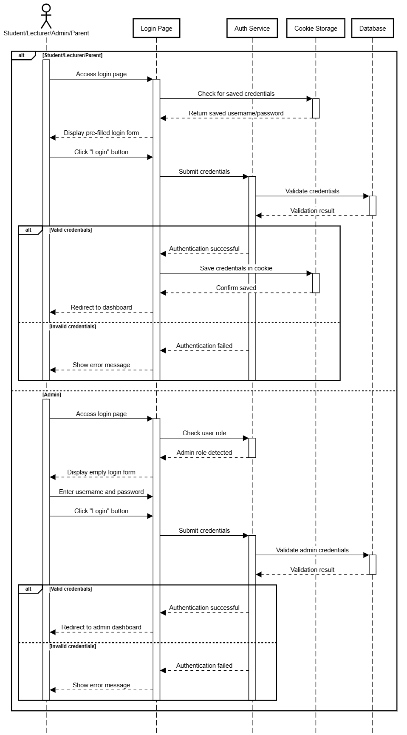

*Figure 3.1.2.1 Sequence Diagram for* ***Student/Lecturer/Parent Login***

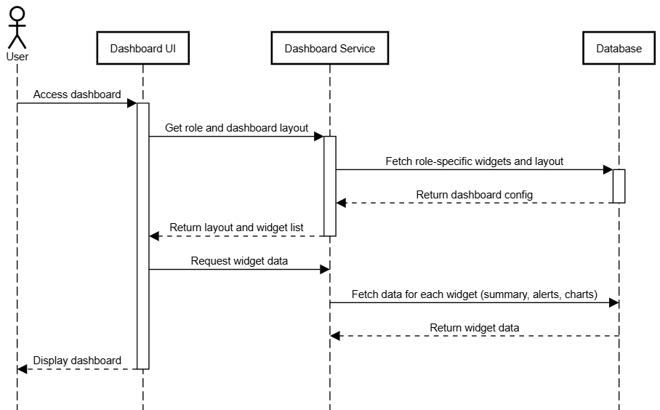

*Figure 3.1.2.3 Sequence Diagram for* ***View Student Dashboard***

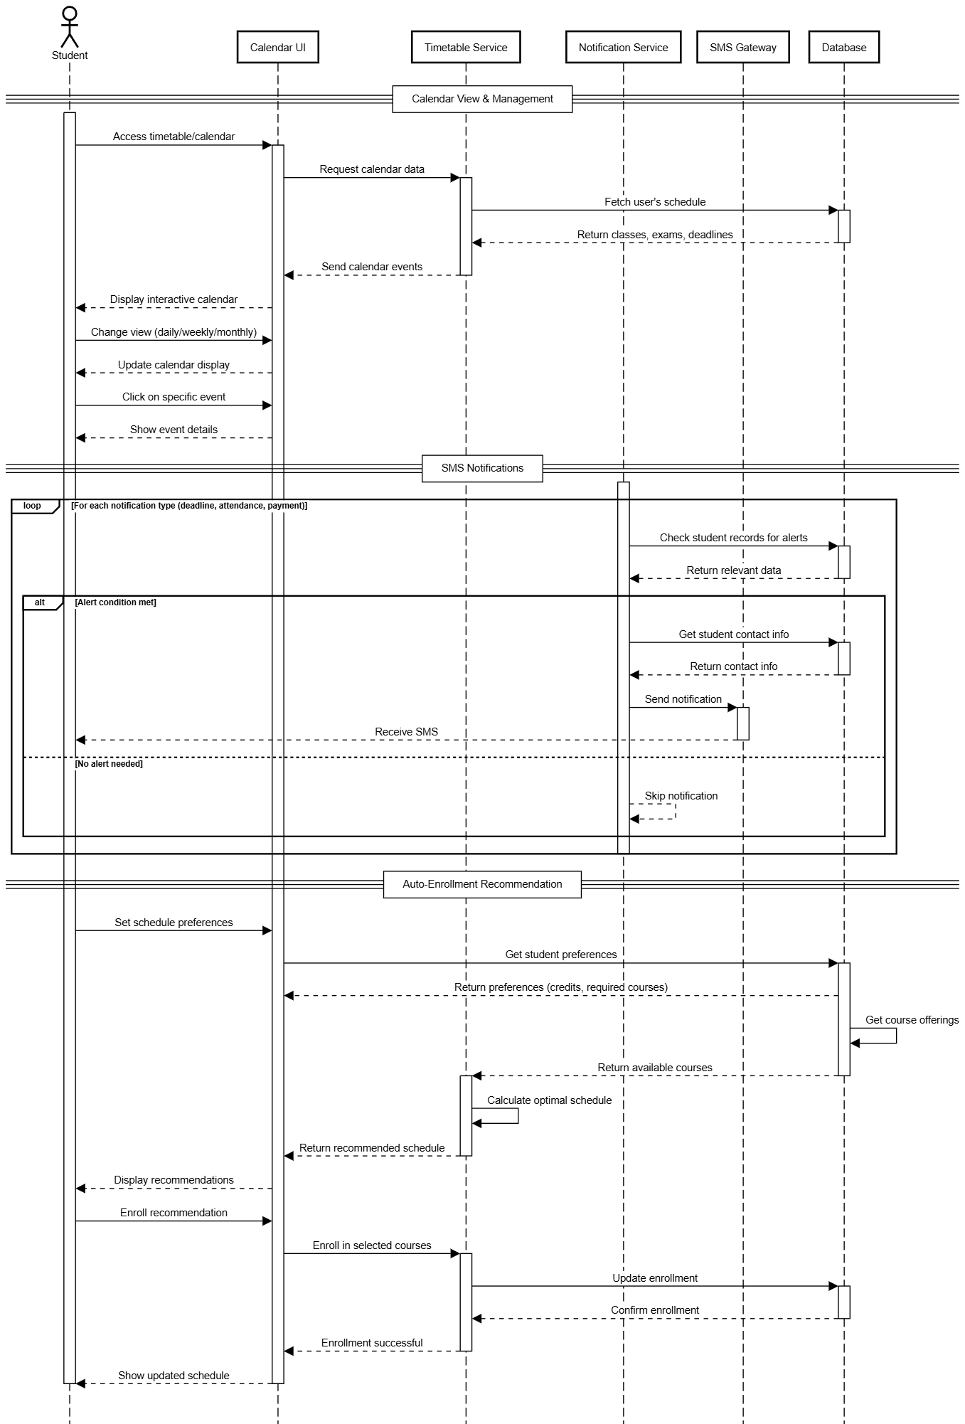

*Figure 3.1.2.4 Sequence Diagram for* ***View/Manage Calendar***

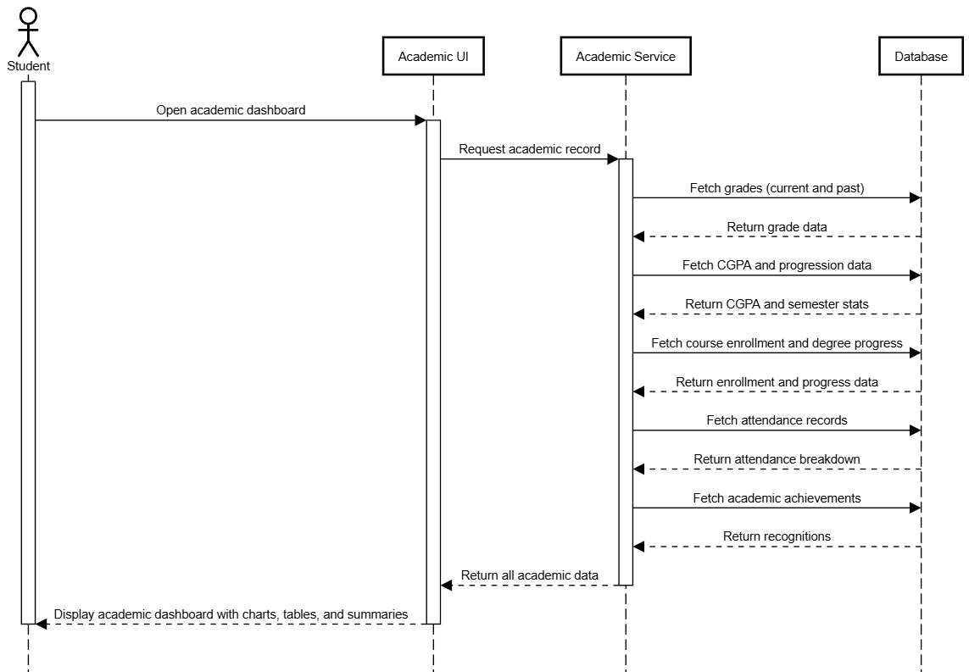

*Figure 3.1.2.5 Sequence Diagram for* ***View Academic***

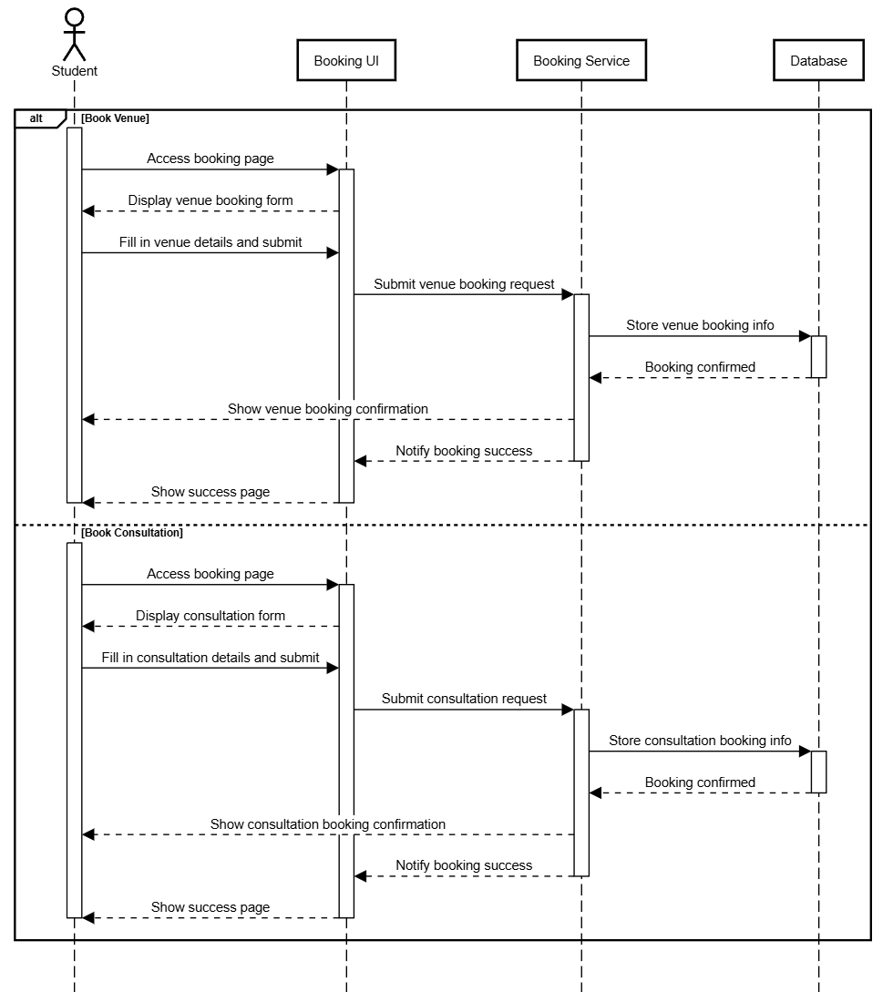

*Figure 3.1.2.6 Sequence Diagram for* ***Online Booking***

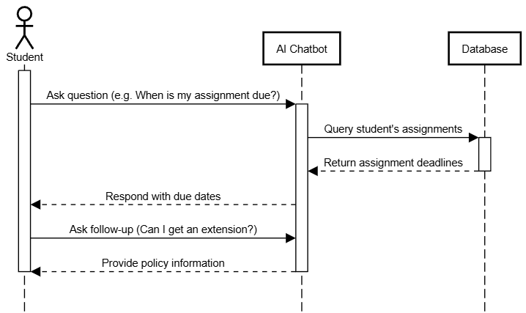

*Figure 3.1.2.7 Sequence Diagram for* ***AI Chatbot***

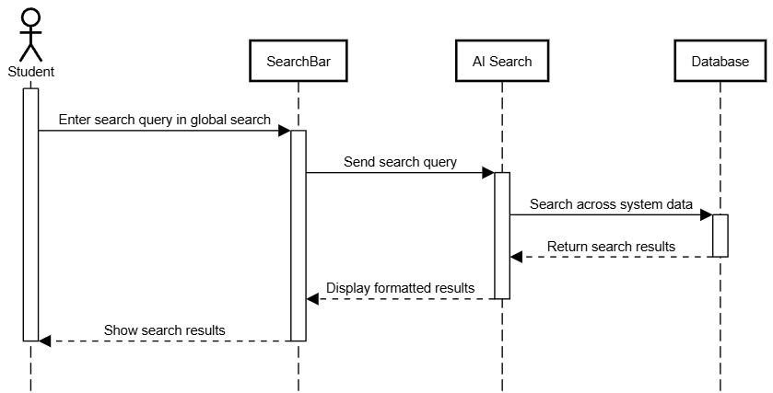

*Figure 3.1.2.8 Sequence Diagram for* ***AI Search***

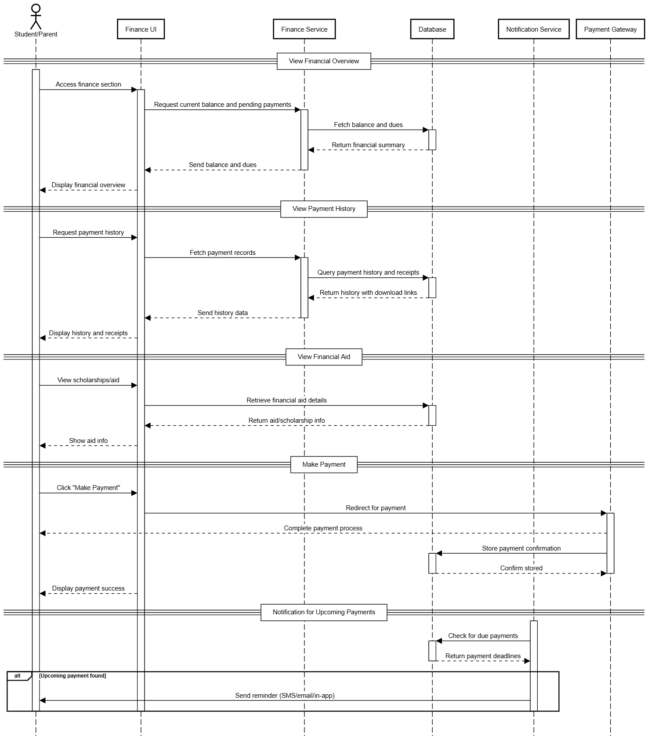

*Figure 3.1.2.9 Sequence Diagram for* ***Manage Finance***

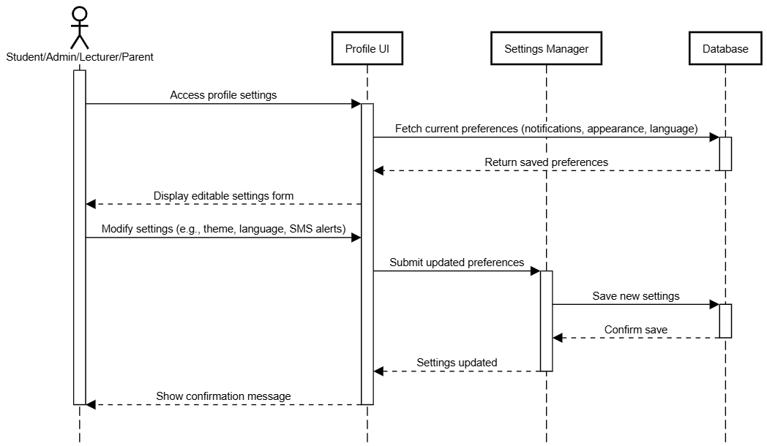

*Figure 3.1.2.10 Sequence Diagram for* ***Edit Profile***

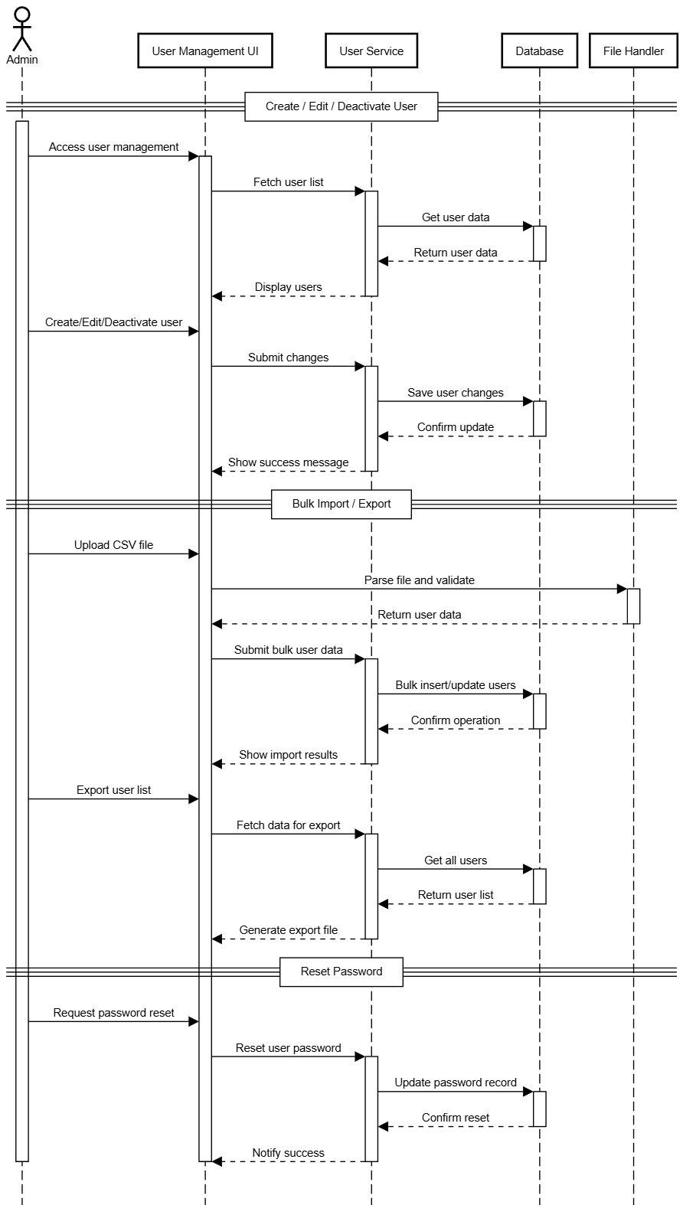

*Figure 3.1.2.11 Sequence Diagram for* ***User Management***

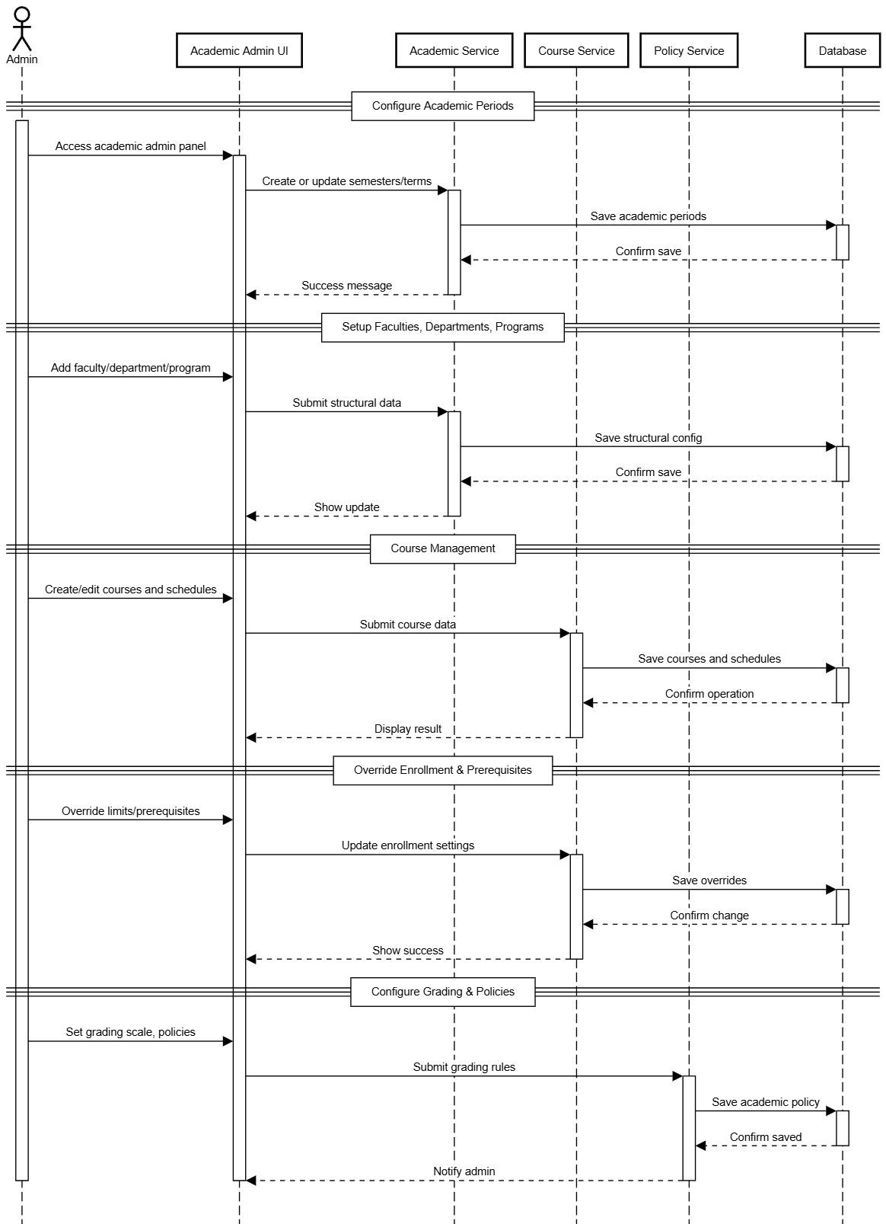

*Figure 3.1.2.12 Sequence Diagram for* ***Manage Academic Administration***

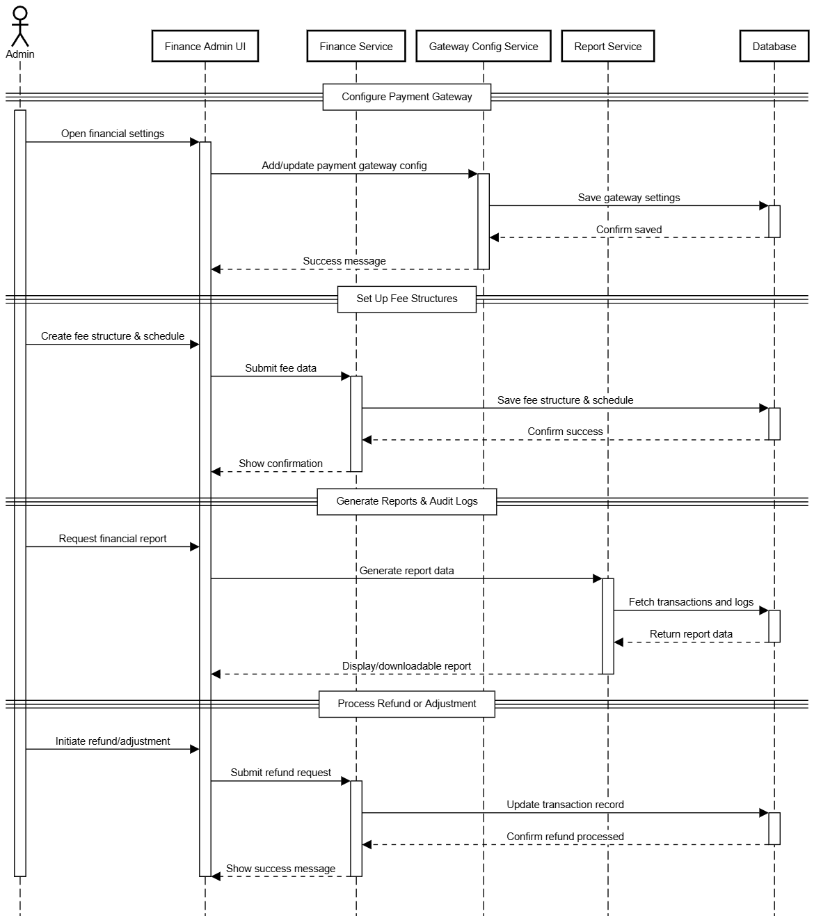

*Figure 3.1.2.13 Sequence Diagram for* ***Manage Finance Administration***

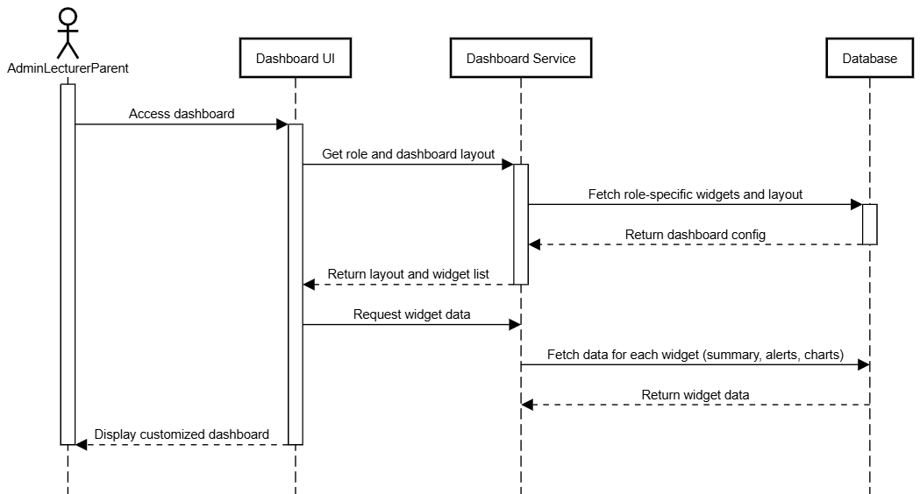

*Figure 3.1.2.14 Sequence Diagram for* ***Dashboard***

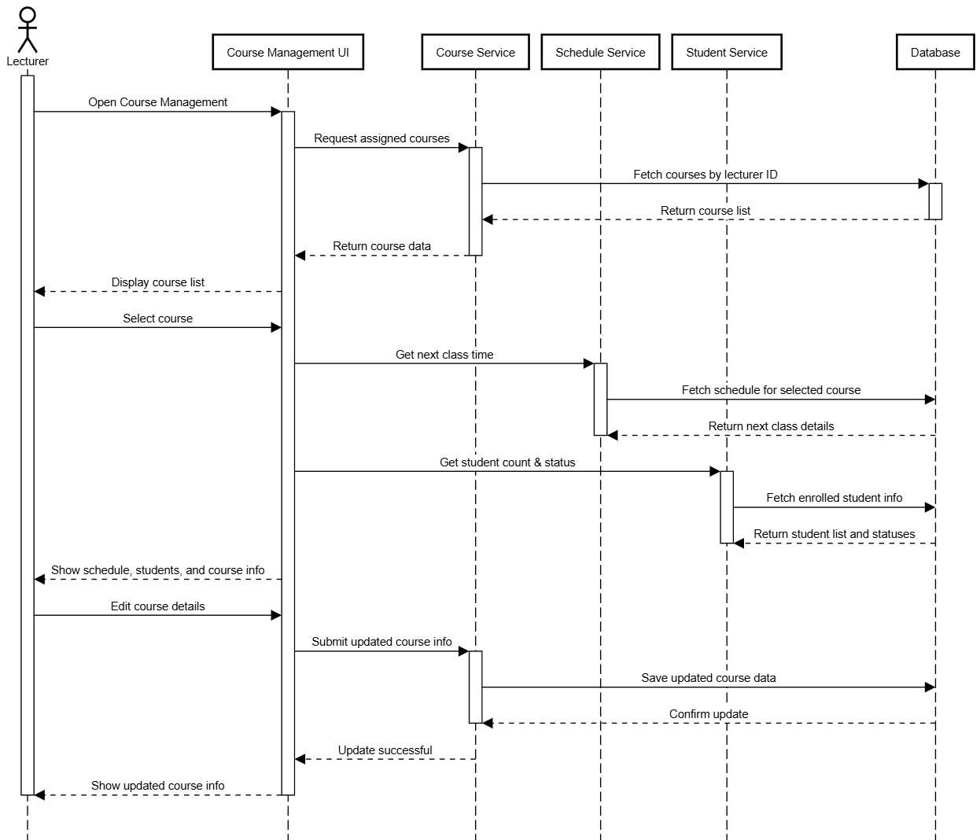

*Figure 3.1.2.15 Sequence Diagram for* ***Manage Course***

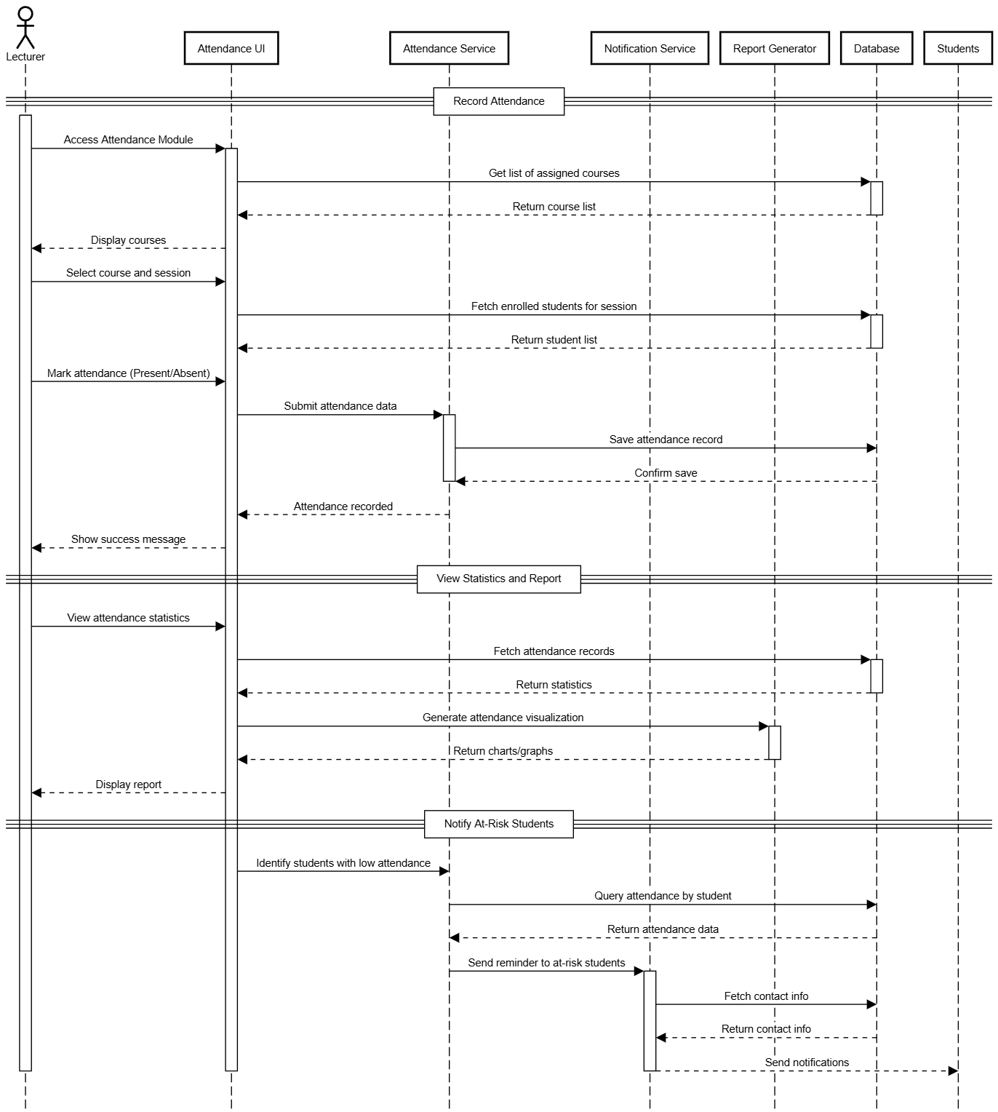

*Figure 3.1.2.16 Sequence Diagram for* ***Track Attendance***

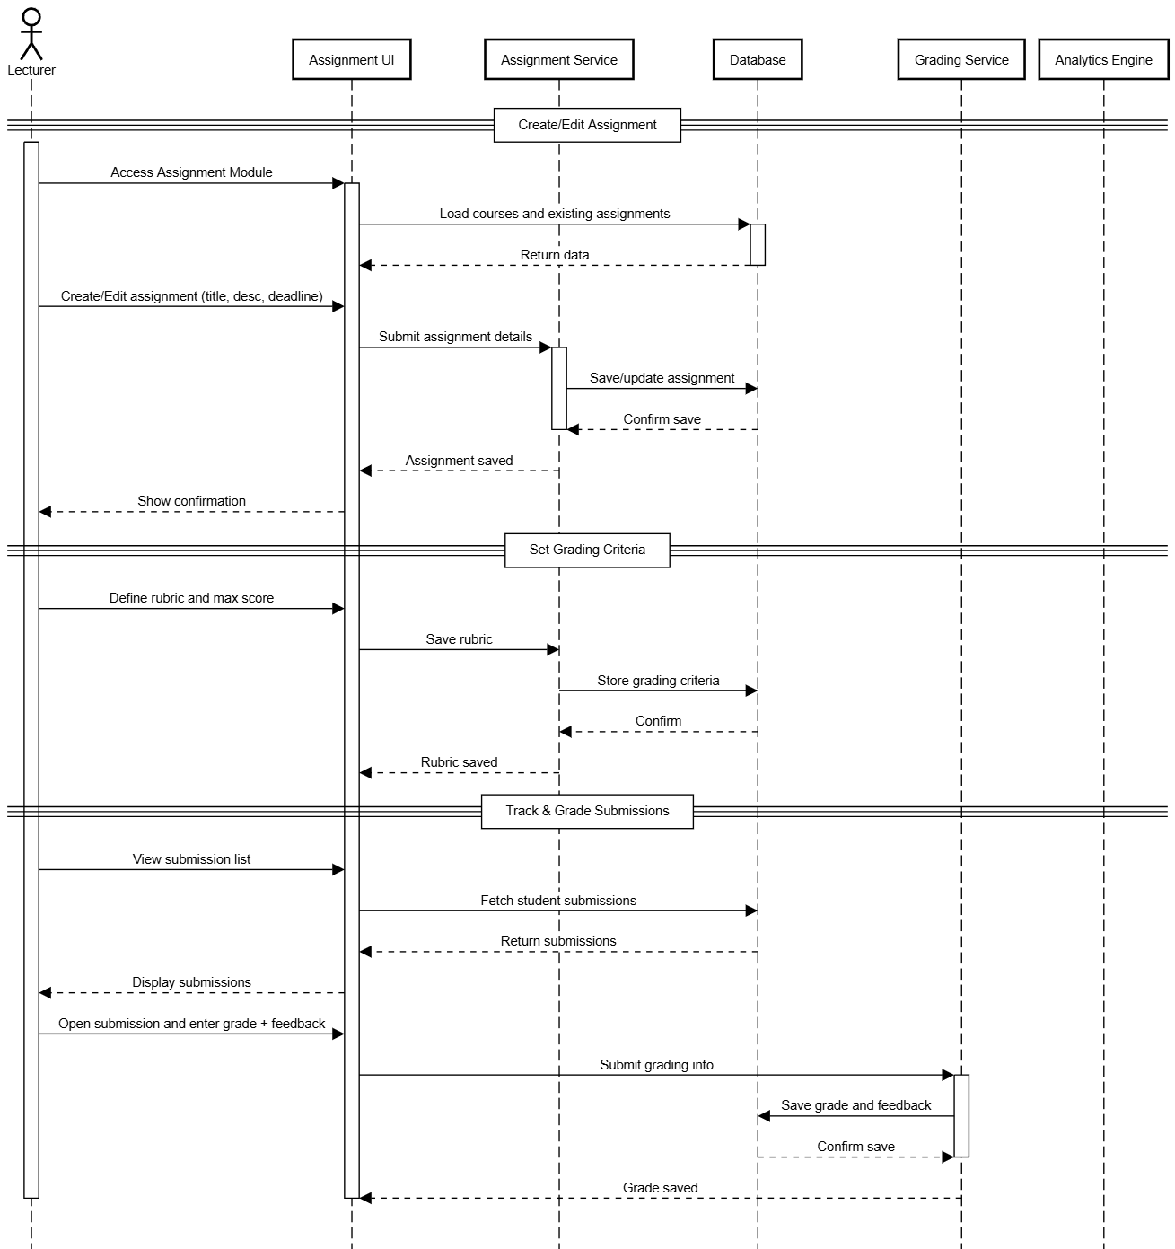

*Figure 3.1.2.17 Sequence Diagram for* ***Manage Assignment***

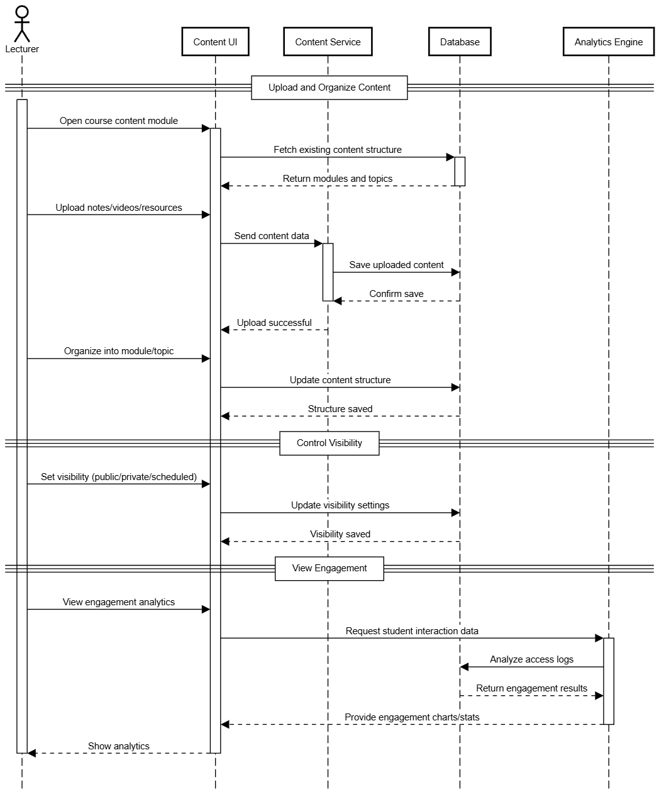

*Figure 3.1.2.18 Sequence Diagram for* ***Create Content***

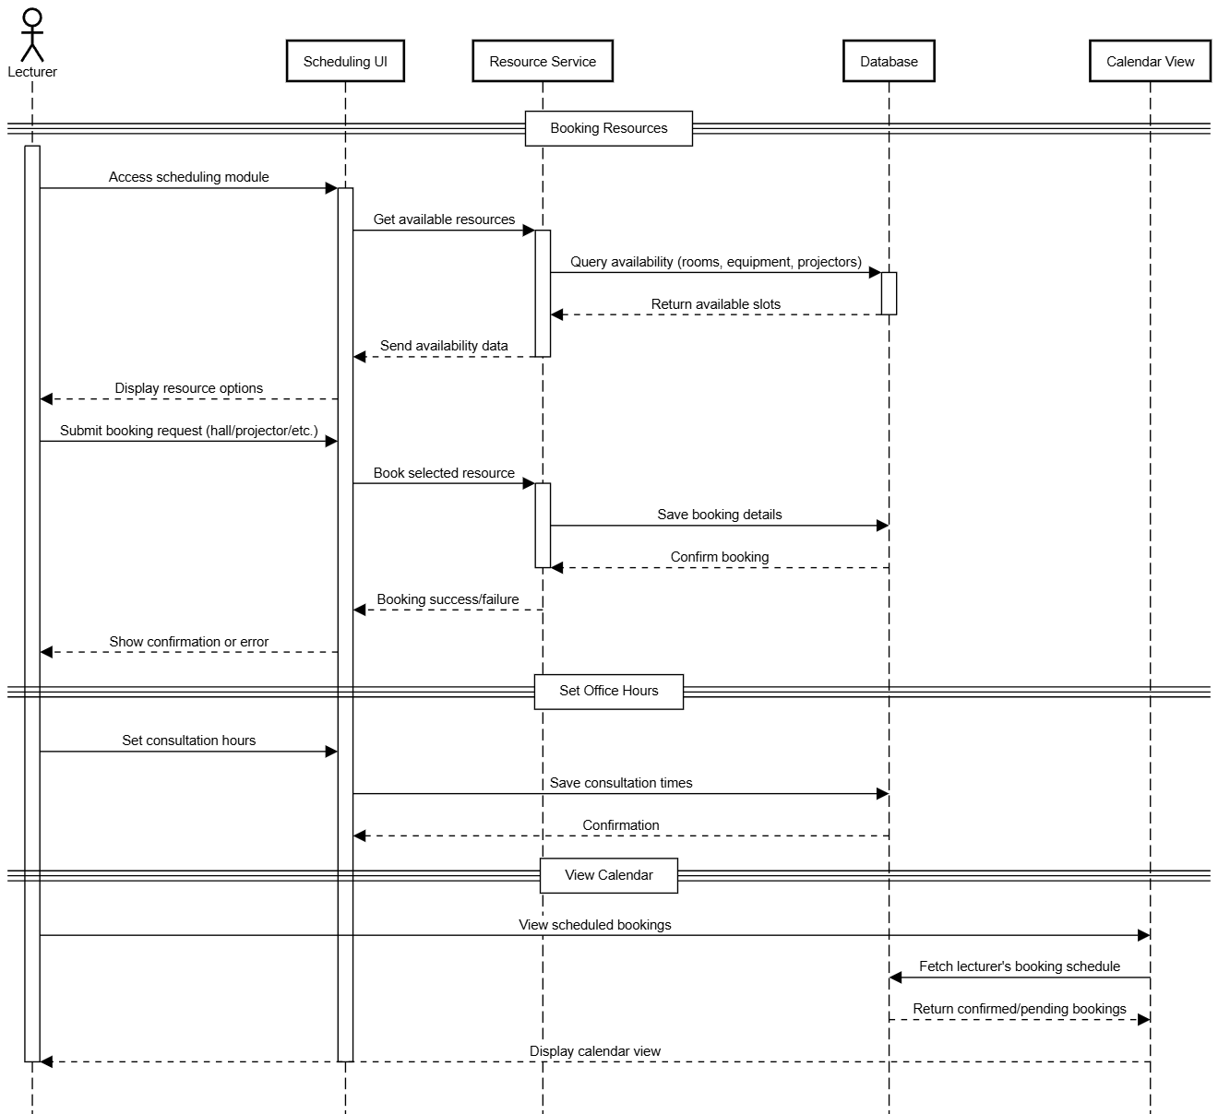

*Figure 3.1.2.19 Sequence Diagram for* ***Resource Scheduling***

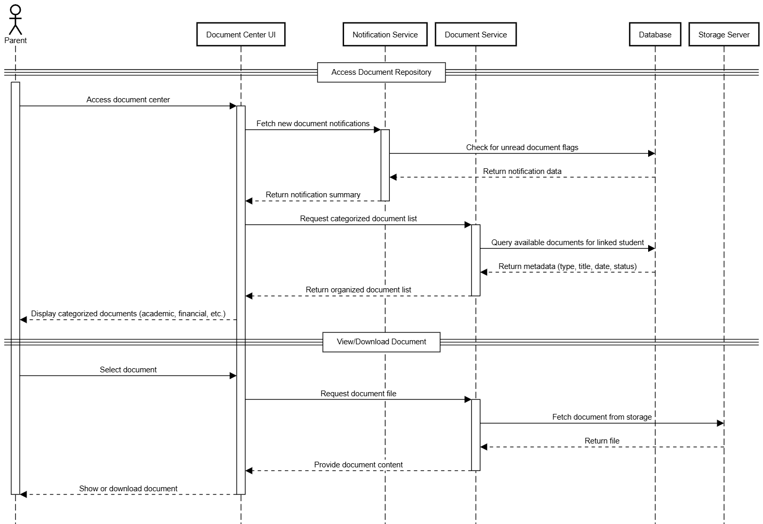

*Figure 3.1.2.20 Sequence Diagram for* ***Access Document***

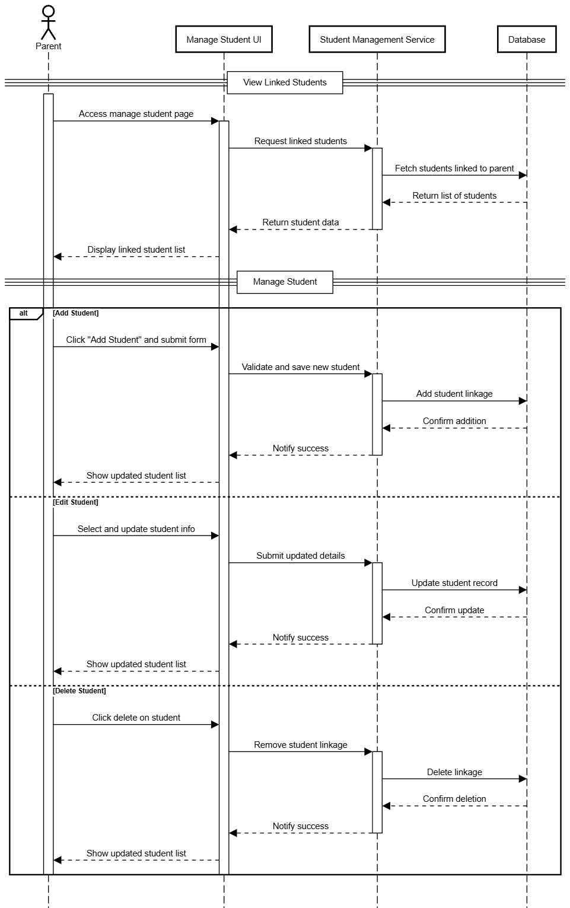

*Figure 3.1.2.21 Sequence Diagram for* ***Manage Student***

## Performance Requirements

Static Requirements:

Maximum Response Time:

* The SIS/LMS system should respond to user interactions within 5 seconds for operations for operations such as logging in, accessing course materials and submitting assignments

System Downtime:

* The system should have a maximum allowable downtime of 4 hours per month for scheduled maintenance activities.
* Unscheduled downtime should not exceed 1 hour per month

Minimum Hardware and Software Specifications:

* The system should be able to run on hardware with the following minimum specifications:

Desktop:

Processor: Dual-core 2.0 GHz CPU or better

RAM: 4GB

Mobile:

OS: IOS 14 and Android 9

RAM: 2GB

Storage: 100MB

* The system should be able to run on any web browser and search engine such as Google Chrome, Opera, Bing and more

Dynamic Requirements:

Maximum Concurrent Users:

* The system should support a minimum of 1000 concurrent users during peak usage times (e.g., registration periods, exam weeks).

Throughput Requirements:

* The system should manage a minimum of 1000 course registrations per hour during peak registration periods.

Scalability:

* The system should be capable of scaling up to support a 10% increase in concurrent users within a 6-month period without significant degradation in performance

## Usability Requirements

Usability Requirements:

Effectiveness:

* The system shall allow students to easily access their academic information, including grades, schedules, and course materials.
* The system shall enable instructors to efficiently manage course content, assignments, and assessments.

Efficiency:

* The interface shall support auto-fill, dropdown menus, and default values to minimize the time and effort required for data entry.
* The system shall load pages and display data within 3 seconds under normal load conditions.

Satisfaction:

* The portal shall achieve a System Usability Scale (SUS) score of at least 75/100 in usability surveys post-deployment.
* The system shall have an intuitive and user-friendly interface, contributing to user satisfaction.
* The system shall include an optional feedback form or quick rating tool for users to evaluate individual features and gather suggestions for improvement.

Quality in Use Requirements:

Effectiveness:

* The system shall provide accurate and real-time updates for key data such as grades, attendance, and billing, retrieved directly from integrated systems.
* Users shall receive confirmation notifications (via screen and/or email/SMS) for submitted requests or actions.

Efficiency:

* The system shall be accessible on mobile and desktop devices with responsive design, allowing users to access services efficiently in various contexts.
* The system shall respond to user requests within 2 seconds on average, ensuring swift access to information.

Satisfaction:

* User satisfaction surveys shall yield an average score of at least 4 out of 5, showing an elevated level of user satisfaction.
* Multilingual interface options shall be provided to increase satisfaction among non-native English speakers.

Avoidance of Harm:

* The system shall have a documented error rate of less than 1%, minimizing the risk of data loss or corruption
* All irreversible or critical actions (e.g., deleting requests, logging out, submitting forms) shall require explicit user confirmation.
* Sensitive personal and academic data shall be protected using encryption and secure login mechanisms, with access limited based on user roles.
* To prevent session hijacking, automatic logout after 30 minutes of inactivity shall be enforced.

## 

## Interface Requirements

### System Interfaces

* + - 1. Student Information System (SIS)
      2. Learning Management System (LMS)
      3. University Authentication System
      4. Financial Management System
      5. SMS Gateway

### User Interfaces

#### Student

* Login pages

Figure 3.4.2.1.1 displays the Login Pages, it is designed to save login credentials in cookies, so that students do not need to enter their username and password each time they log in.

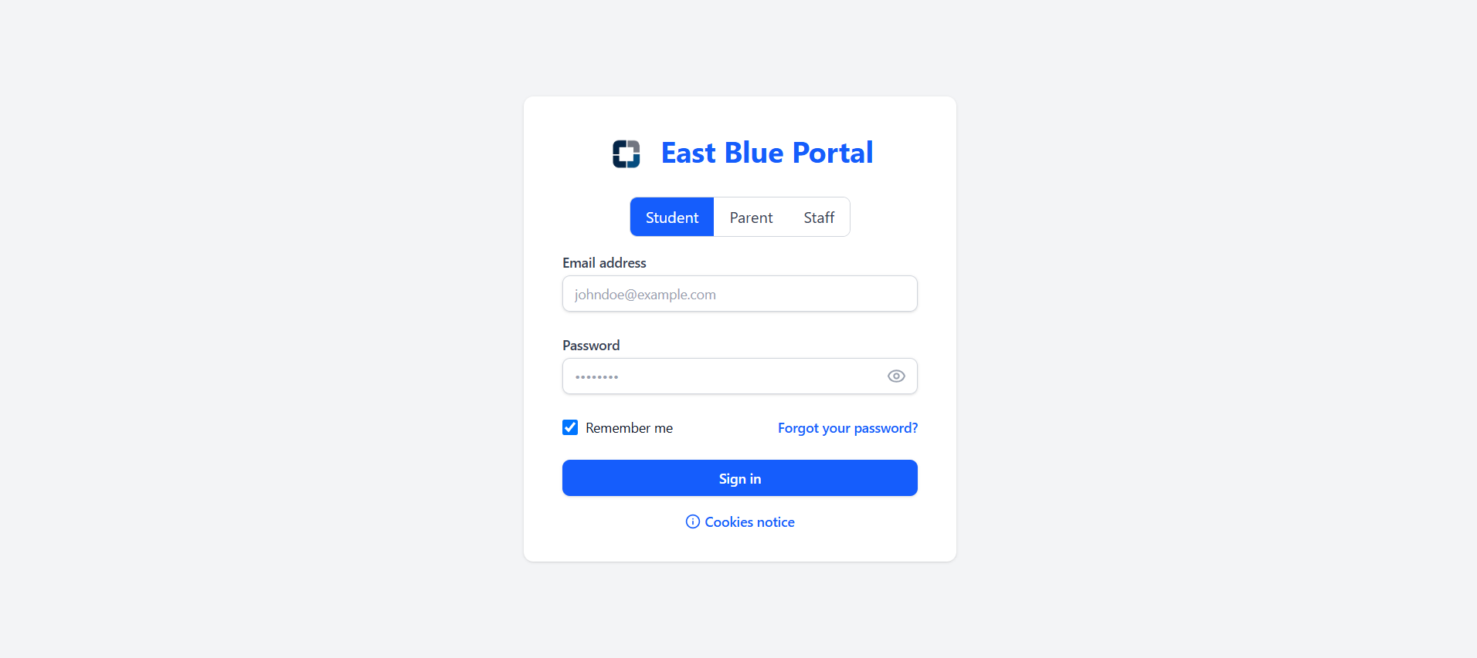

Figure 3.4.2.1.1 Login Pages

* Desktop Dashboard Page

After logging in, students are directed to a personalized dashboard Figures 3.4.2.1.2 and 3.4.2.1.3. The dashboard has navigation tabs and relevant student information. It also integrates an AI assistant that allows students to ask questions via chat. For instance, students can ask, “When is the SRE assignment due?” and the assistant will respond with the appropriate deadline or information. The customizable layout is similar to the iPhone's widget system, where users can resize components and personalize their dashboard by adding elements such as the timetable, user profile, and today's schedule, as shown in Figures 3.4.2.1.2 and 3.4.2.1.3.

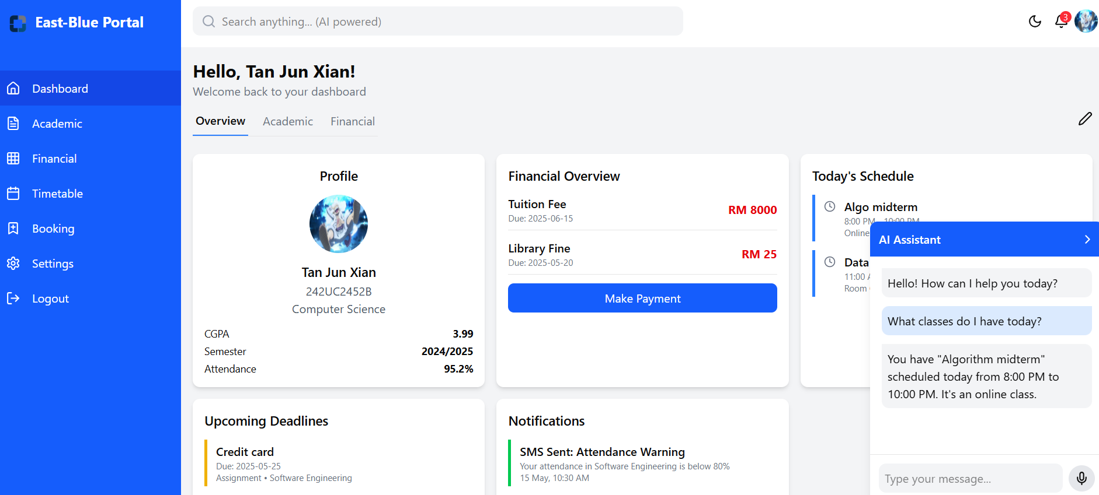

Figure 3.4.2.1.2 Desktop Dashboard Page

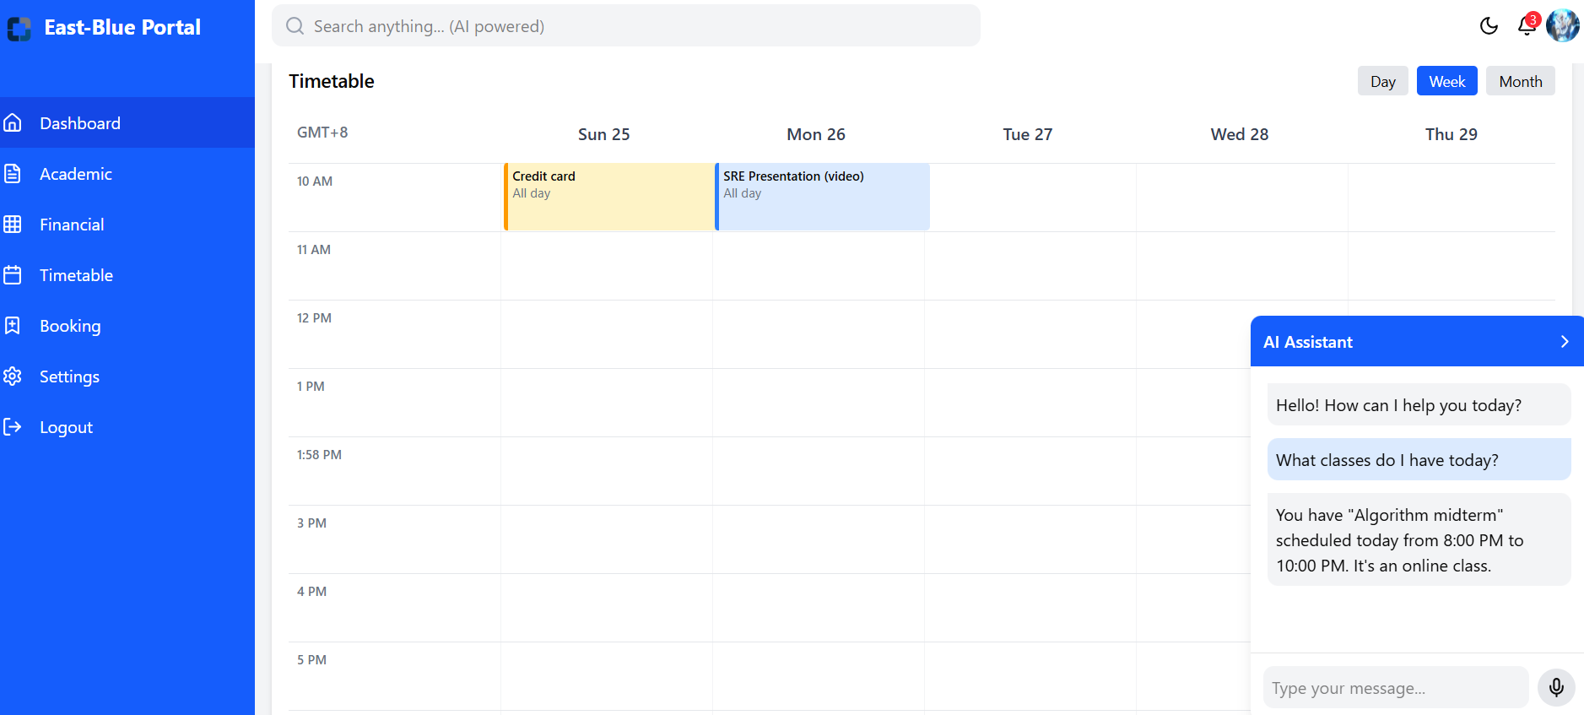

*Figure 3.4.2.1.3 Desktop Dashboard Page*

* Mobile Dashboard Page

Figure 3.4.2.1.4 displays the mobile dashboard page, which has the same layout and features as Figures 3.4.2.1.2 and 3.4.2.1.3 but is optimized for viewing within the mobile application.

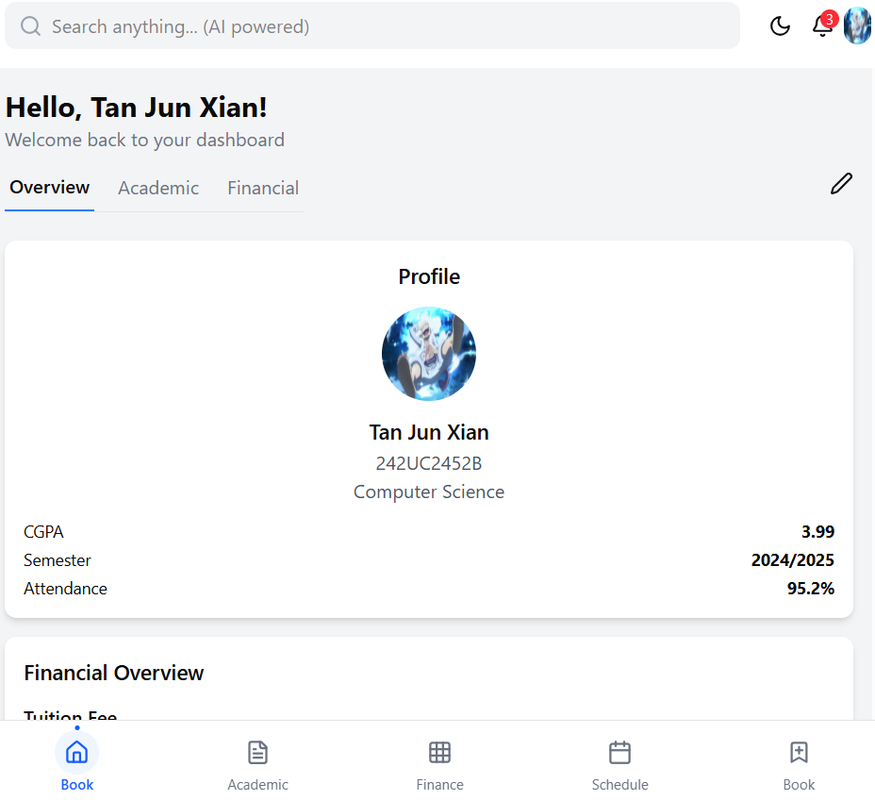

*Figure 3.4.2.1.4 Mobile Dashboard Page*

* Desktop Academic Page

Figures 3.4.2.1.5 and 3.4.2.1.6 display the desktop view of the Academic page. The interface includes a complete academic record showing both current and past grades, along with a CGPA progression chart that visualizes performance across semesters. It also features real-time course enrollment status, a degree progress tracker, a detailed breakdown of attendance for all enrolled courses, and a section highlighting academic achievements and recognitions.

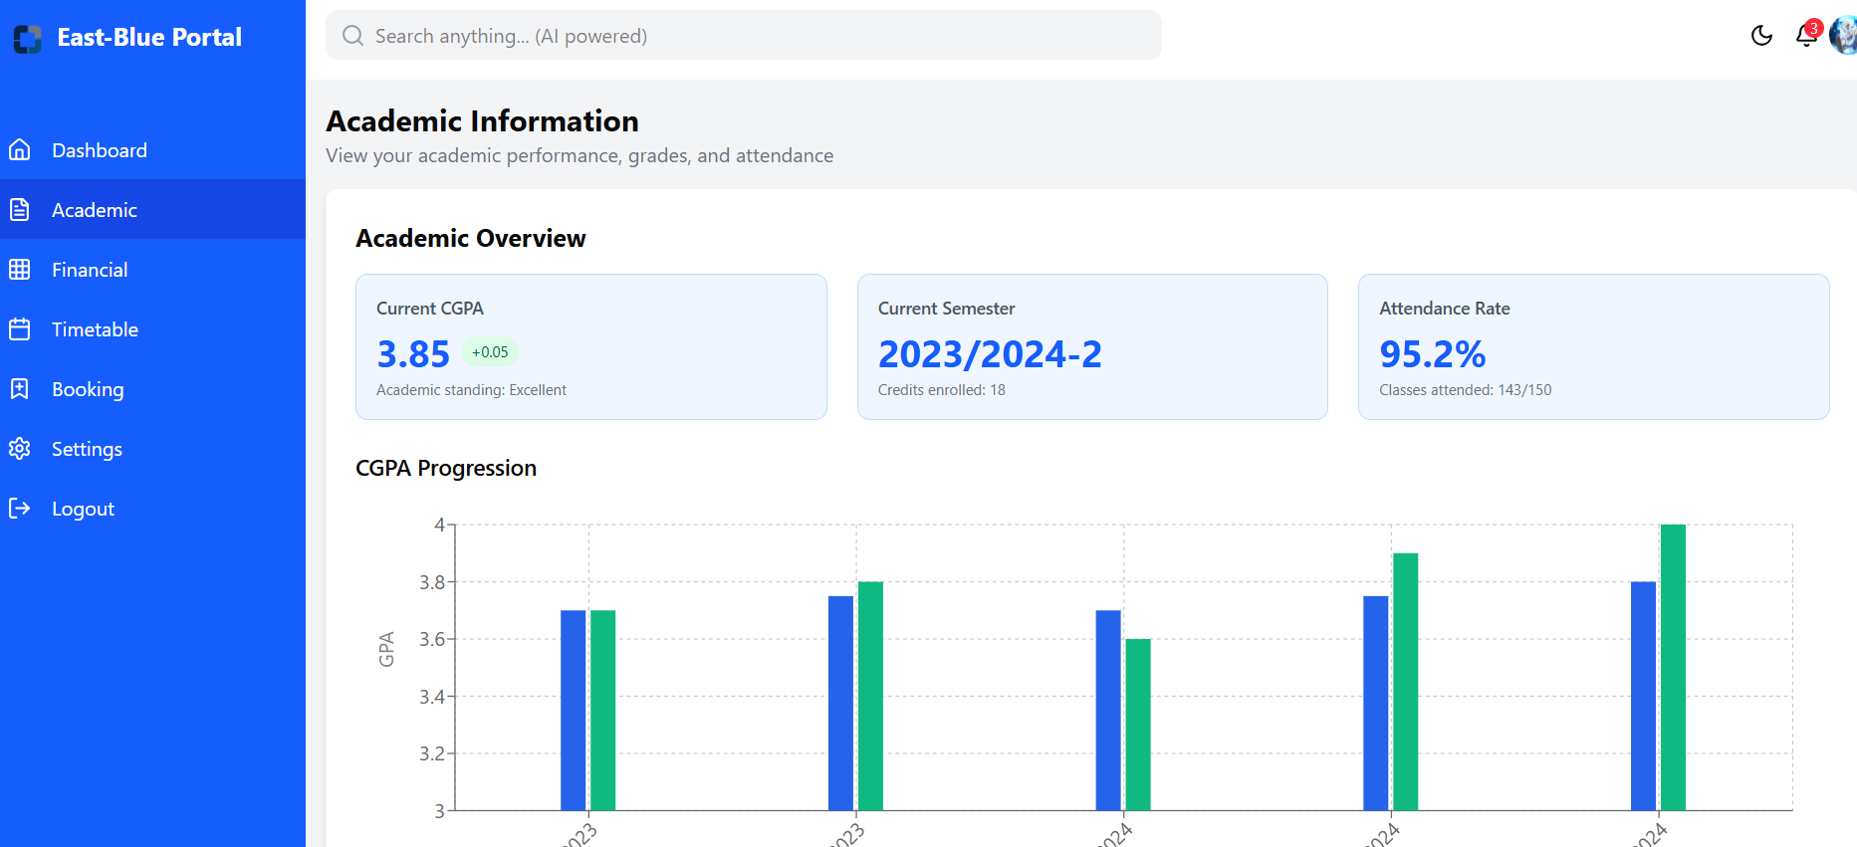

*Figure 3.4.2.1.5 Desktop Academic Page*

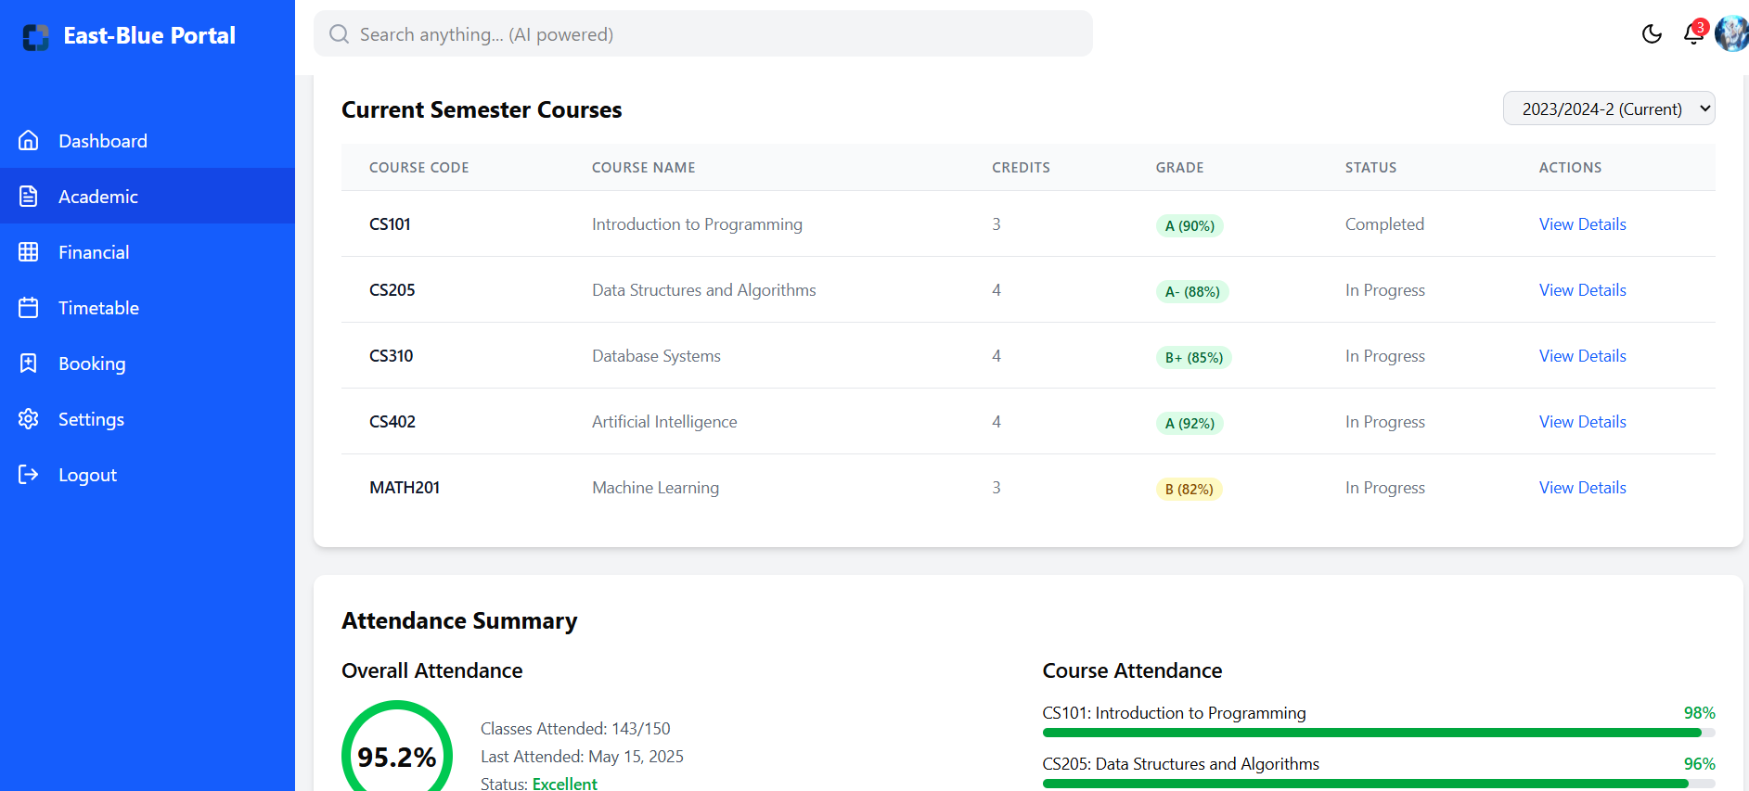

*Figure 3.4.2.1.6 Desktop Academic Page*

* Mobile Academic Page

Figure 3.4.2.1.7 displays the mobile academic page, which provides the same features as shown in Figures 3.4.2.1.5 and 3.4.2.1.6. However, it is optimized for viewing within the mobile application.

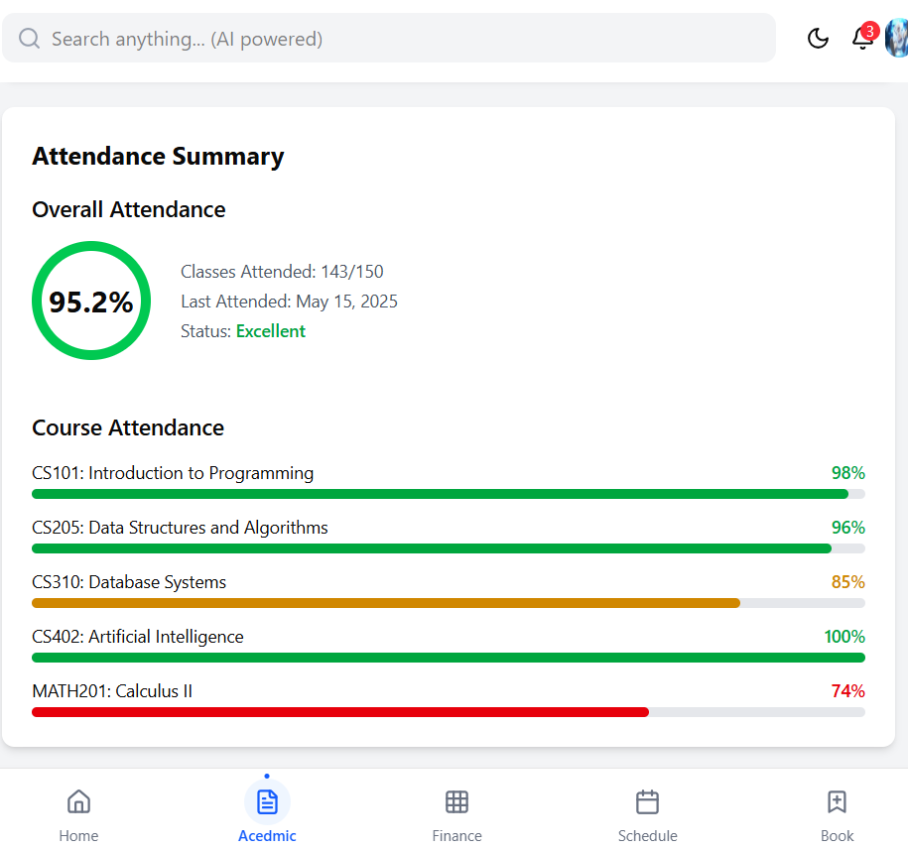

*Figure 3.4.2.1.7 Mobile Academic Page*

* Desktop Financial Page  
  Figures 3.4.2.1.8 and 3.4.2.1.9 display the Desktop Financial Page, which offers comprehensive money management features including balance overview with pending payments, downloadable payment history receipts, multiple online payment options, financial aid information, and payment deadline notifications.

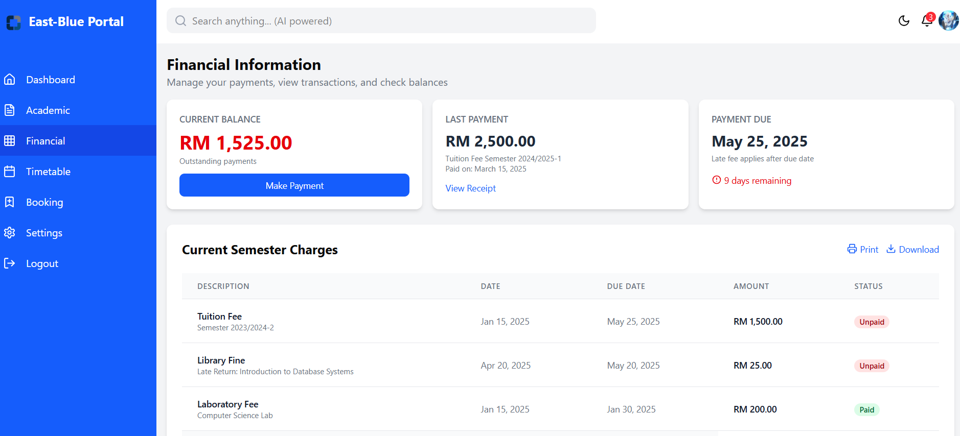

*Figure 3.4.2.1.8 Desktop Financial Page*

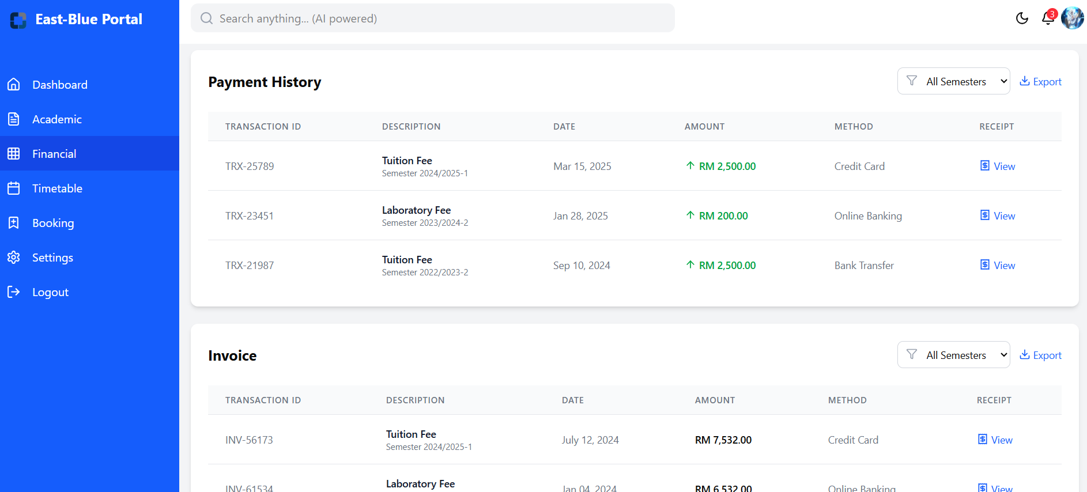

*Figure 3.4.2.1.9 Desktop Financial Page*

* Mobile Financial Page  
  Figure 3.4.2.1.10 displays the mobile Financial Page, which provides the same features as shown in Figures 3.4.2.1.8 and 3.4.2.1.9. However, it is optimized for viewing within the mobile application.

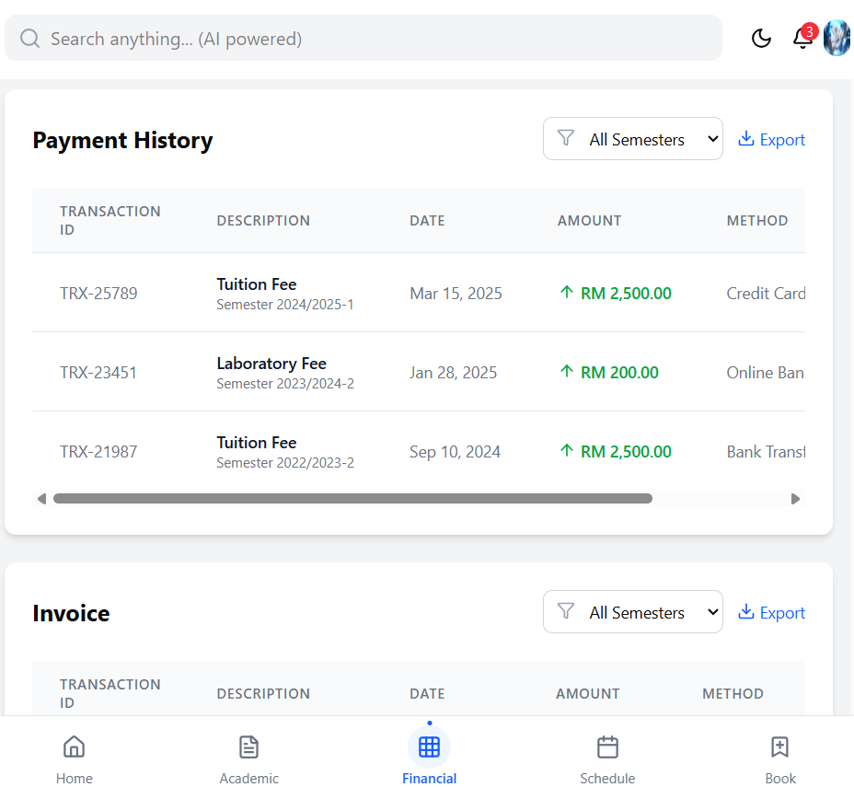

*Figure 3.4.2.1.10 Mobile Financial Page*

* Desktop Timetable Page  
  Figures 3.4.2.1.11 and 3.4.2.1.12 display the Desktop Timetable Page, featuring an interactive calendar with daily, weekly, or monthly views, color-coded events for classes, exams, and deadlines, schedule export capabilities, and visual indicators for upcoming events. Figures 3.4.2.1.13 and 3.4.2.1.14 display the Desktop Timetable Page, showcasing the auto-enrollment feature that recommends optimal course schedules. Users can set preferences such as minimum and maximum credits, required and recommended courses, and optional schedules.

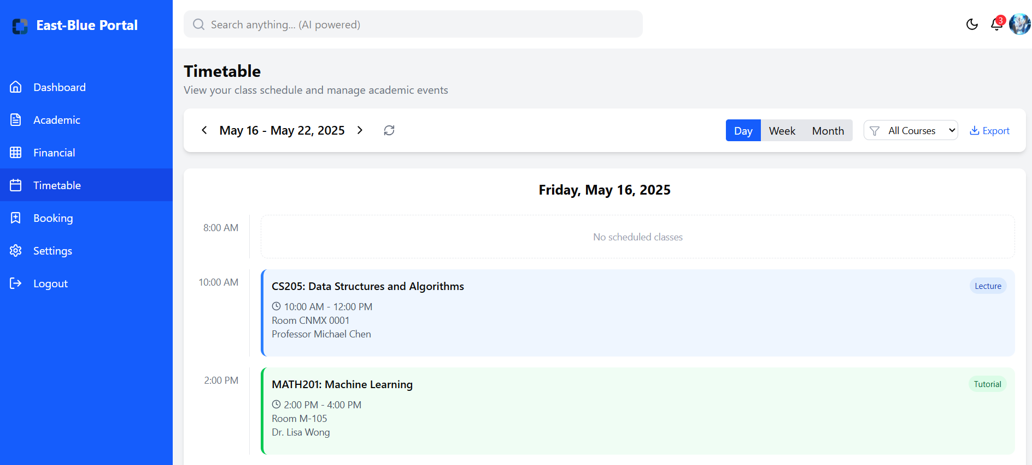

*Figure 3.4.2.1.11 Desktop Timetable Page*

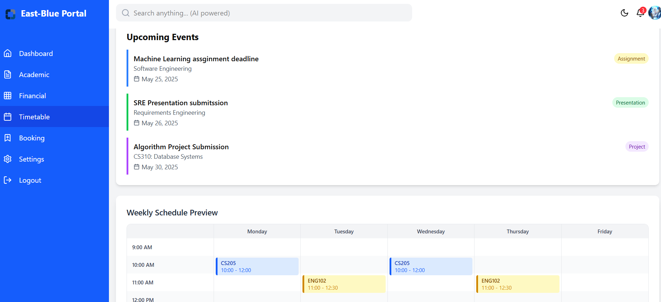

*Figure 3.4.2.1.12 Desktop Timetable Page*

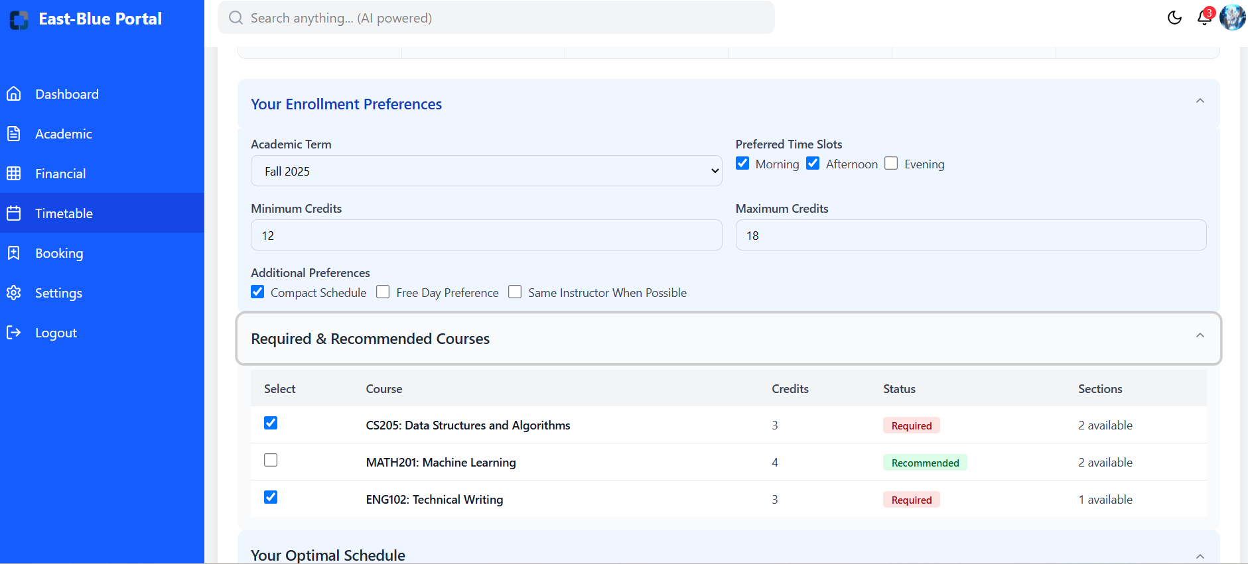

*Figure 3.4.2.1.13 Desktop Timetable Page*

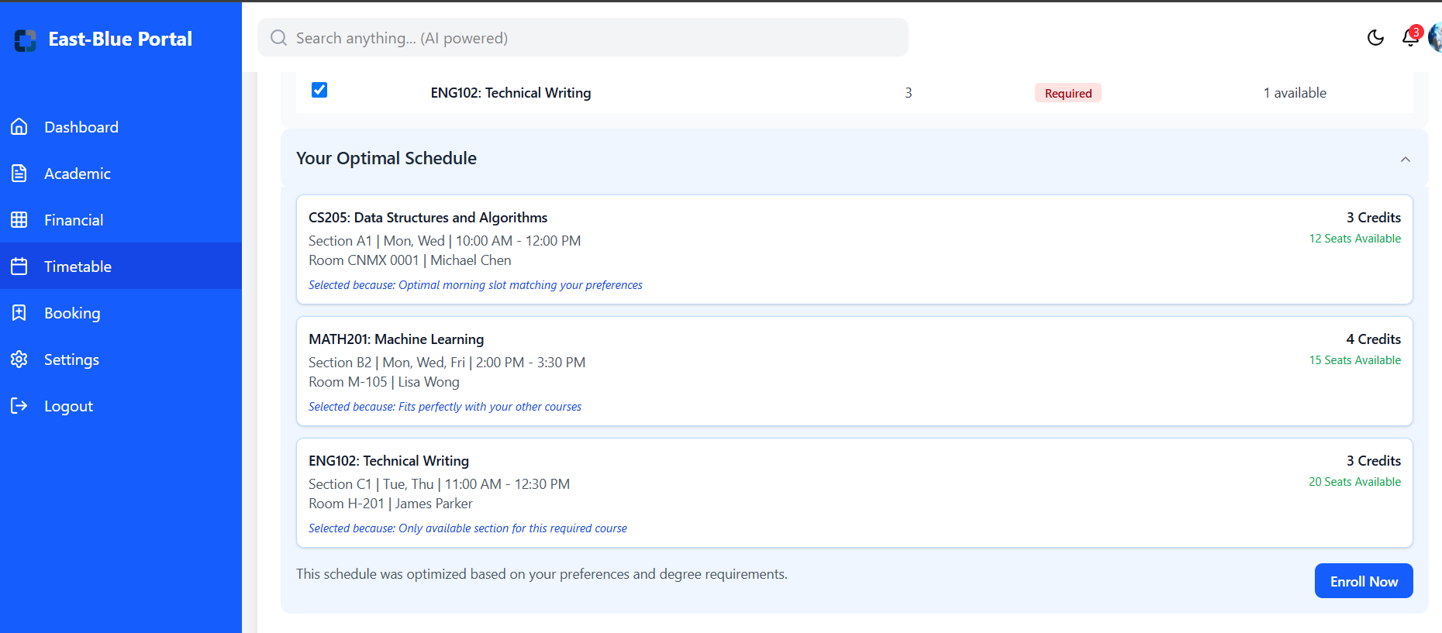

*Figure 3.4.2.1.14 Desktop Timetable Page*

* Mobile Timetable Page

Figure 3.4.2.1.15 displays the mobile Timetable Page, which provides the same features as shown in Figures 3.4.2.1.11 until Figures 3.4.2.1.14. However, it is optimized for viewing within the mobile application.

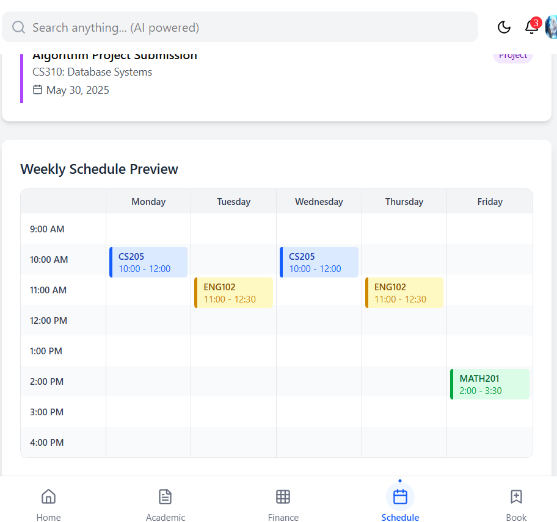*Figure 3.4.2.1.15 Mobile Timetable Page*

* Booking Page  
  Figures 3.4.2.1.16 and 3.4.2.1.17 display the Desktop Booking Page, featuring lecturer consultation scheduling with available time slots, classroom and study space reservations, resource booking capabilities, appointment confirmations with reminders, and comprehensive booking history tracking.

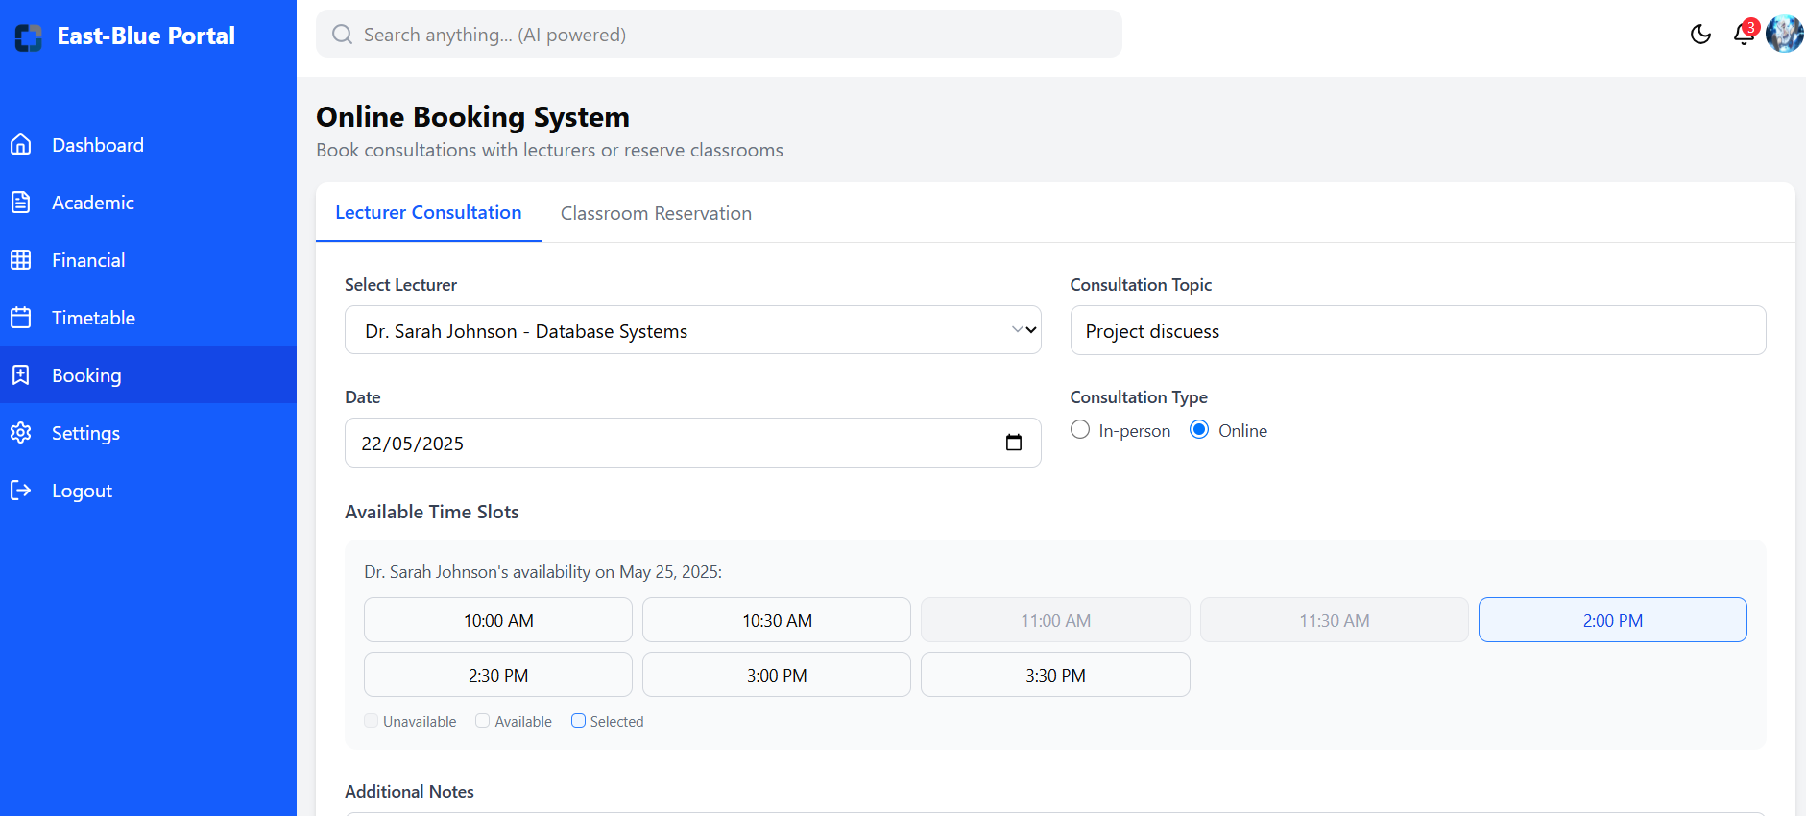

*Figure 3.4.2.1.16 Desktop Booking Page*

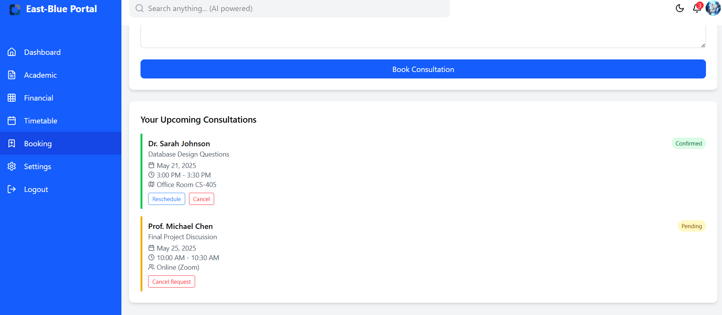

*Figure 3.4.2.1.17 Desktop Booking Page*

* Mobile Booking Page

Figure 3.4.2.1.18 displays the mobile Booking Page, which provides the same features as shown in Figures 3.4.2.1.16 and 3.4.2.1.17. However, it is optimized for viewing within the mobile application.

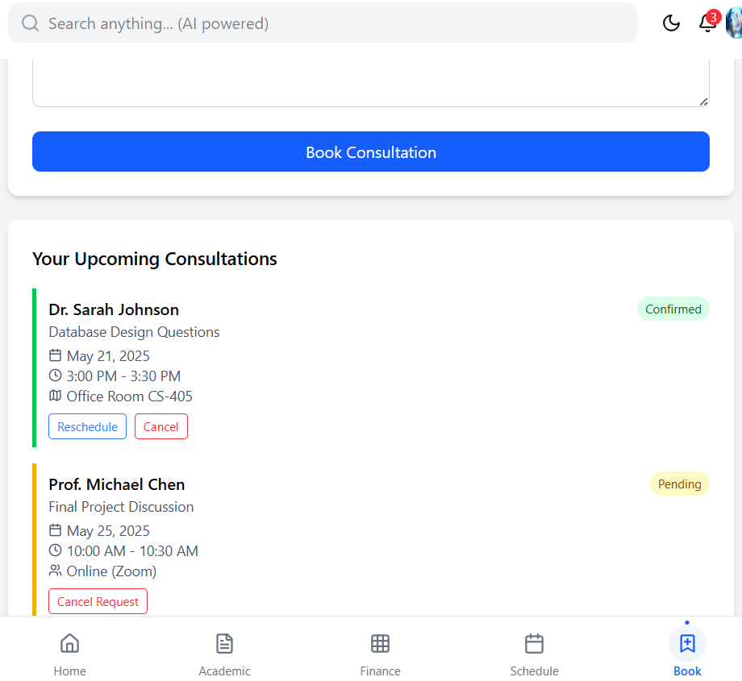

*Figure 3.4.2.1.18 Mobile Booking Page*

* Desktop Settings  
  Figures 3.4.2.1.19 through 3.4.2.1.23 display the Desktop Settings Pages, offering comprehensive profile management capabilities, customizable notification preferences, appearance settings including theme options, language and regional preferences, privacy and security controls, and account access management features.

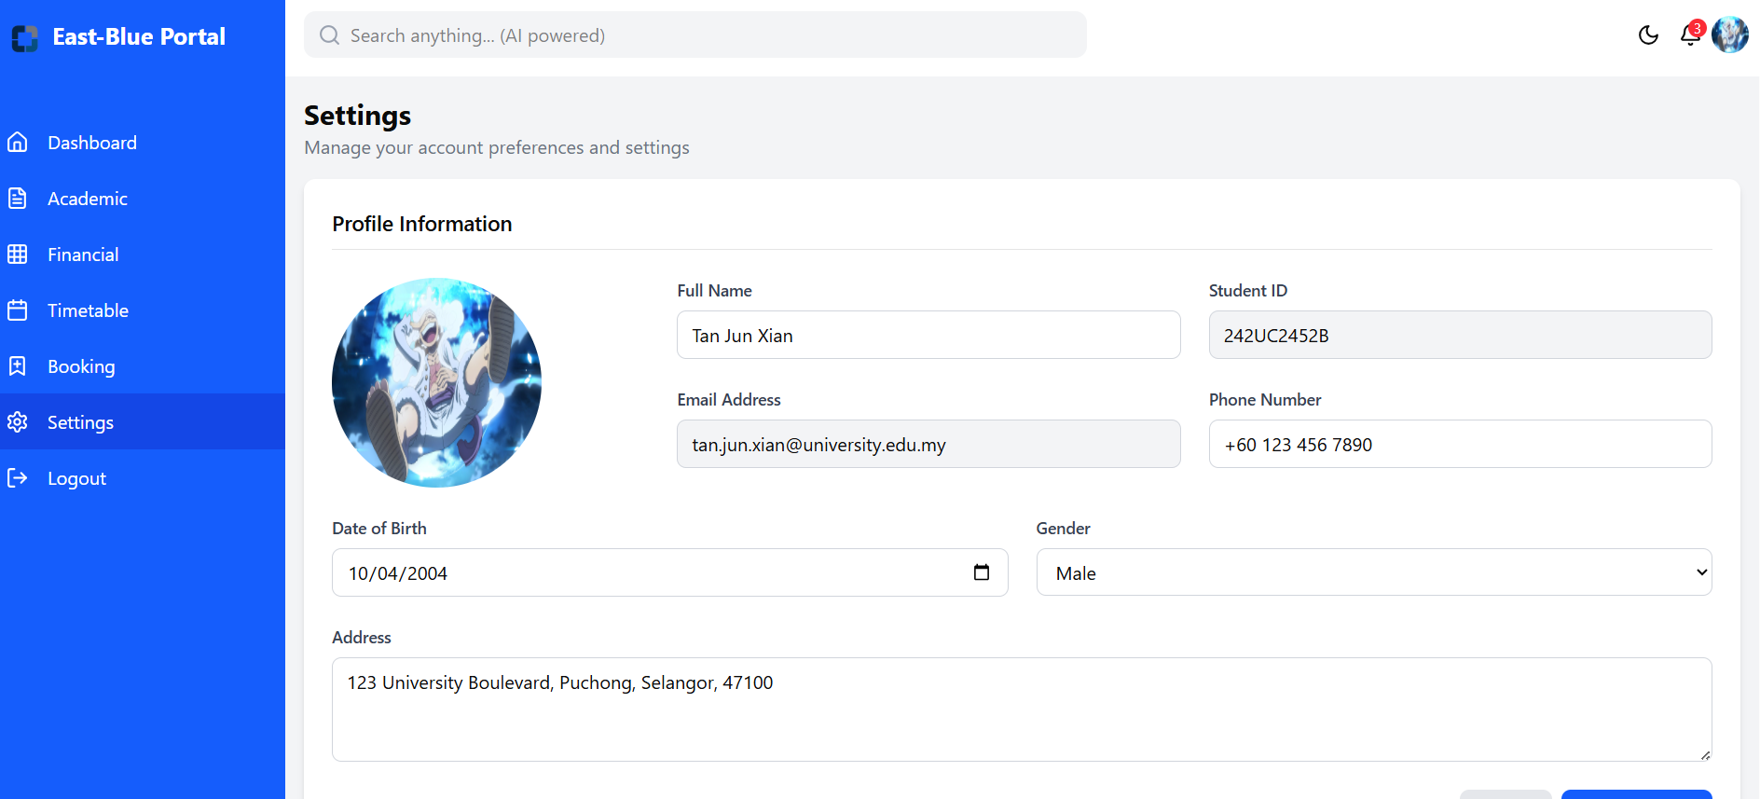

*Figure 3.4.2.1.19 Desktop Settings*

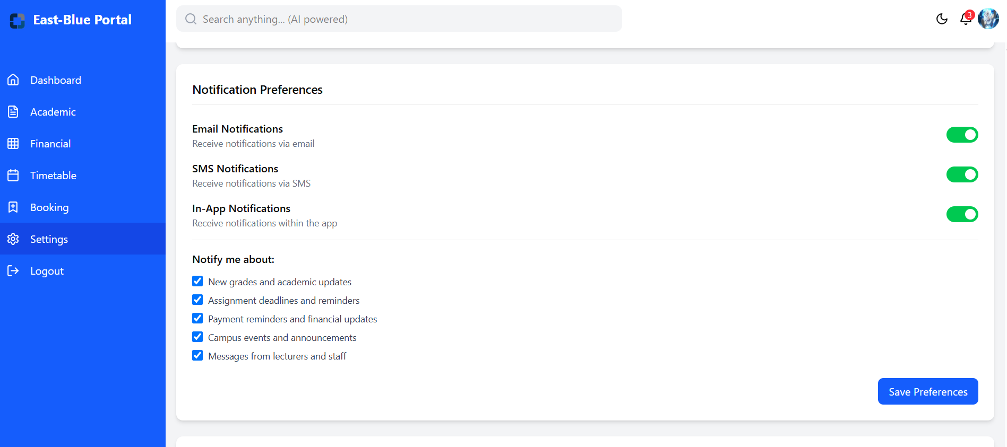

*Figure 3.4.2.1.20 Desktop Settings*

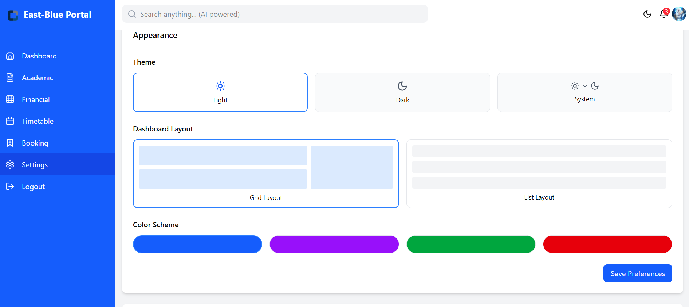

*Figure 3.4.2.1.21 Desktop Settings*

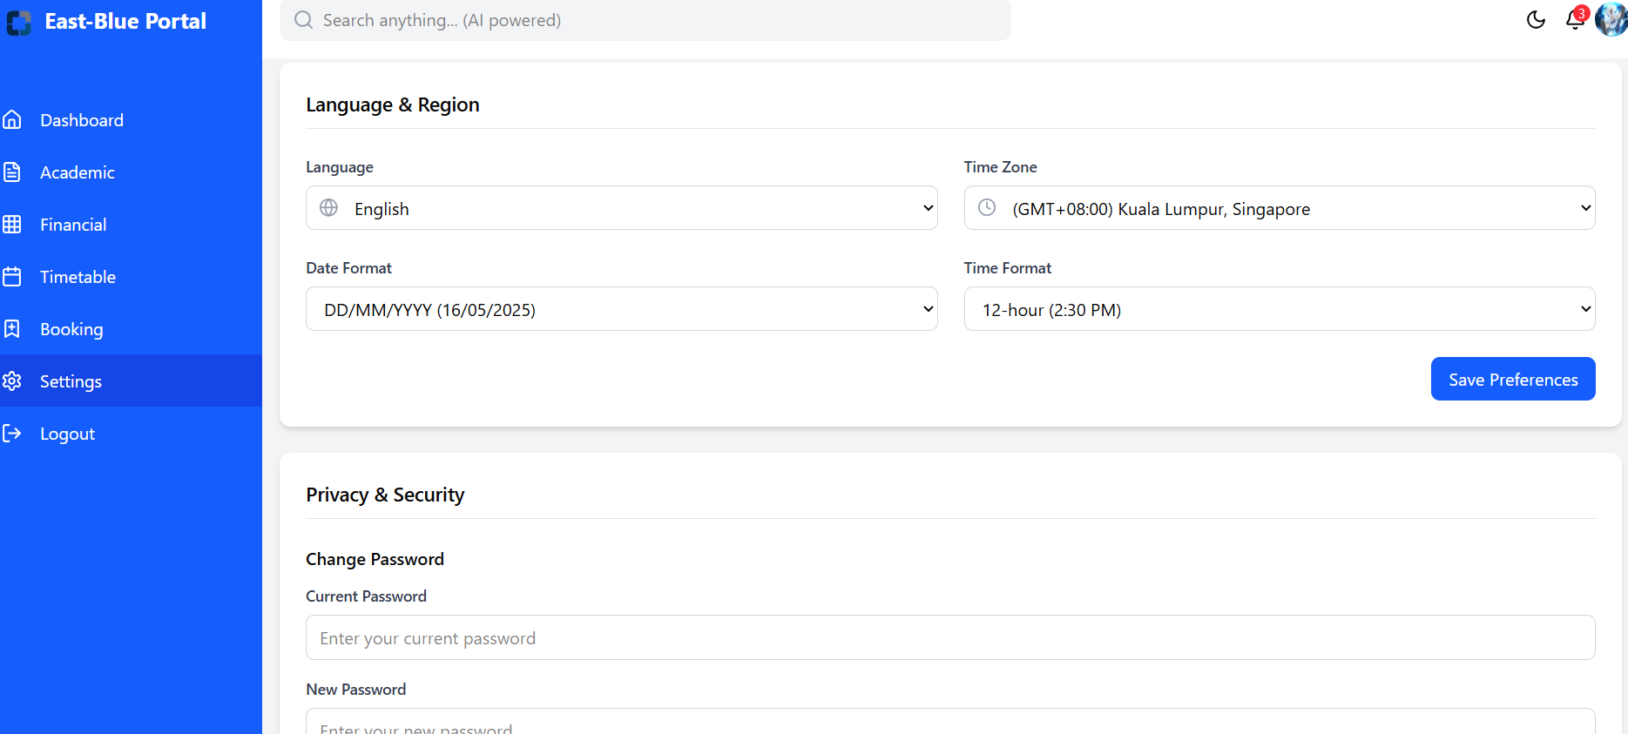

*Figure 3.4.2.1.22 Desktop Settings*

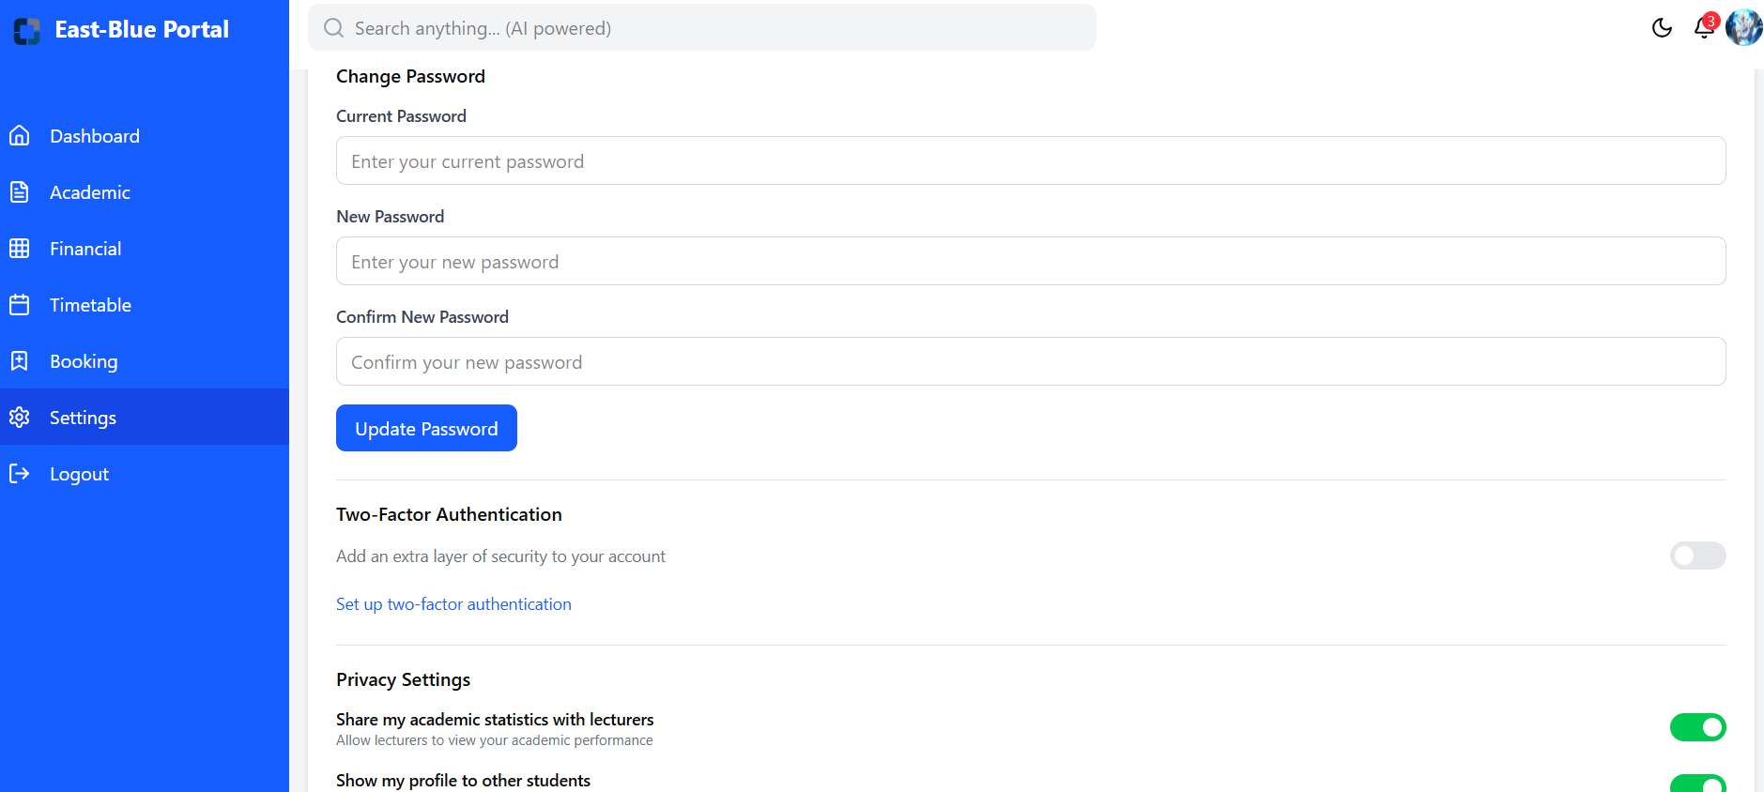

*Figure 3.4.2.1.23 Desktop Settings*

* Mobile Settings

Figure 3.4.2.1.24 displays the mobile Settings Page, which provides the same features as shown in Figures 3.4.2.1.19 through 3.4.2.1.23. However, it is optimized for viewing within the mobile application.

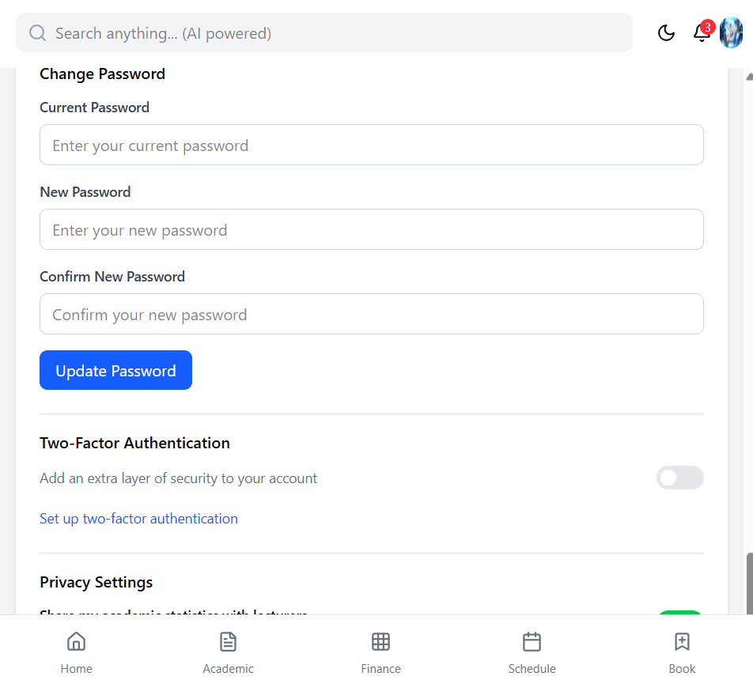

*Figure 3.4.2.1.24 Mobile Settings*

#### Lecturer

* Dashboard  
  Figures 3.4.2.2.1 and 3.4.2.2.2 display the Dashboard Pages, providing quick access to key metrics including courses, students, attendance rates, and pending assignments, along with upcoming events, schedules, and comprehensive course attendance and assignment submission statistics.

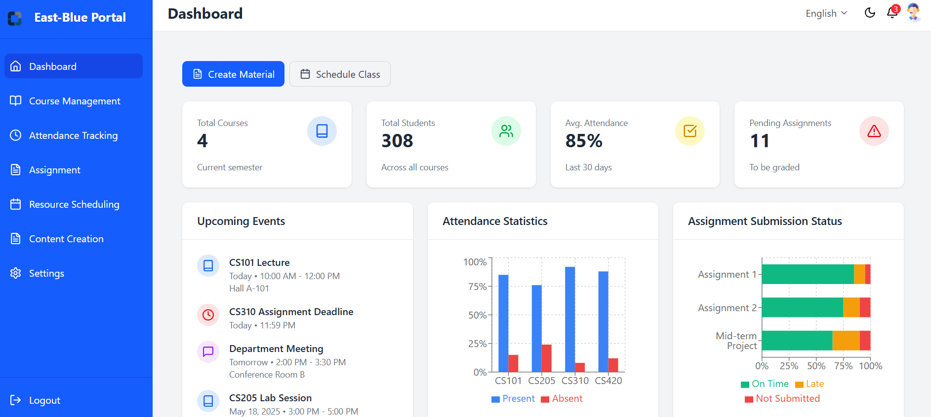

*Figure 3.4.2.2.1 Dashboard*

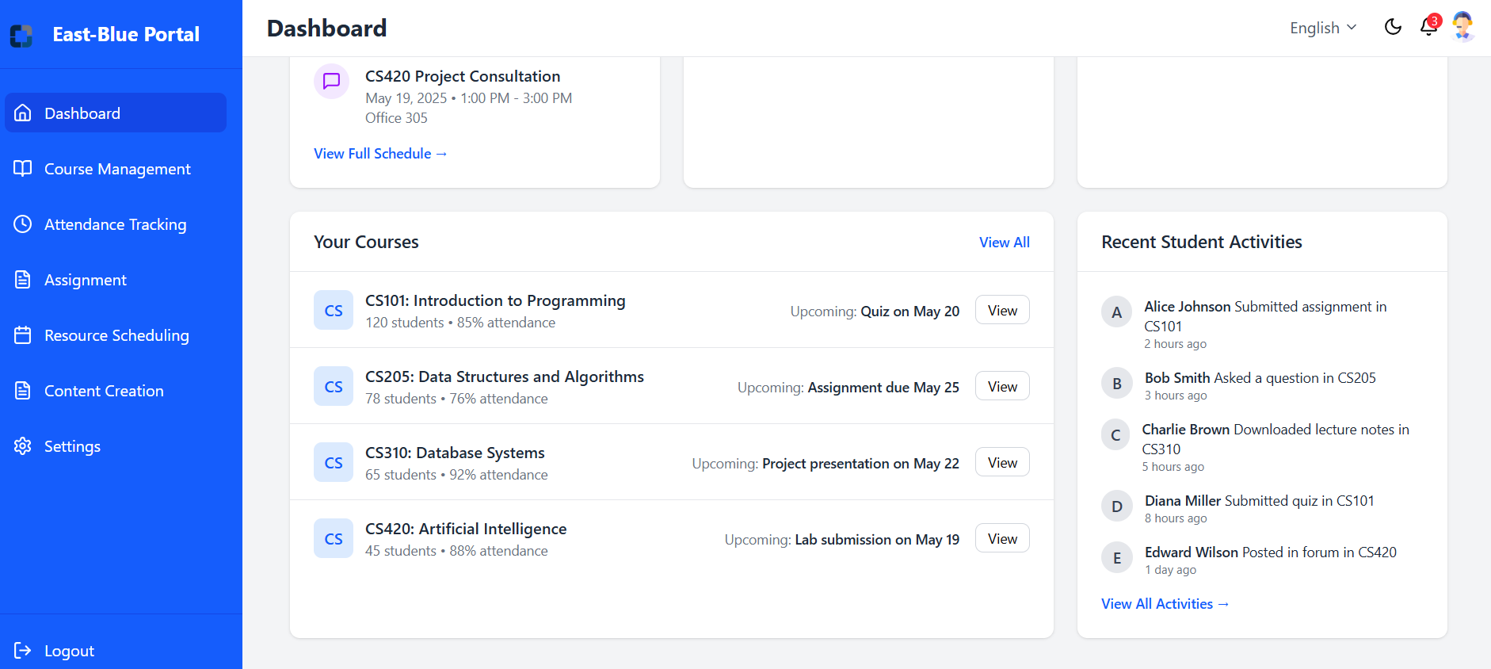

*Figure 3.4.2.2.2 Dashboard*

* Course Management  
  Figure 3.4.2.2.3 displays the Course Management Page, featuring tools to manage courses, view and edit upcoming class schedules, and monitor student enrollment with status information.

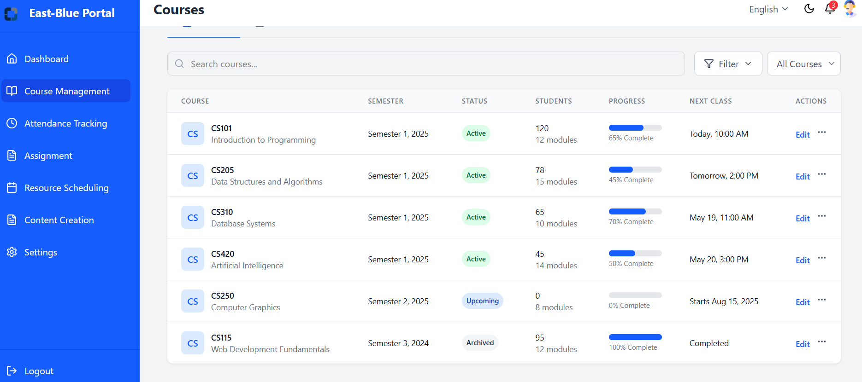

*Figure 3.4.2.2.3 Course Management*

* Attendance Tracking  
  Figures 3.4.2.2.4 and 3.4.2.2.5 display the Attendance Tracking Pages, featuring tools to record and monitor student attendance, view course-specific statistics, identify at-risk students with attendance issues, send automated reminders, and generate comprehensive attendance reports with visualizations.

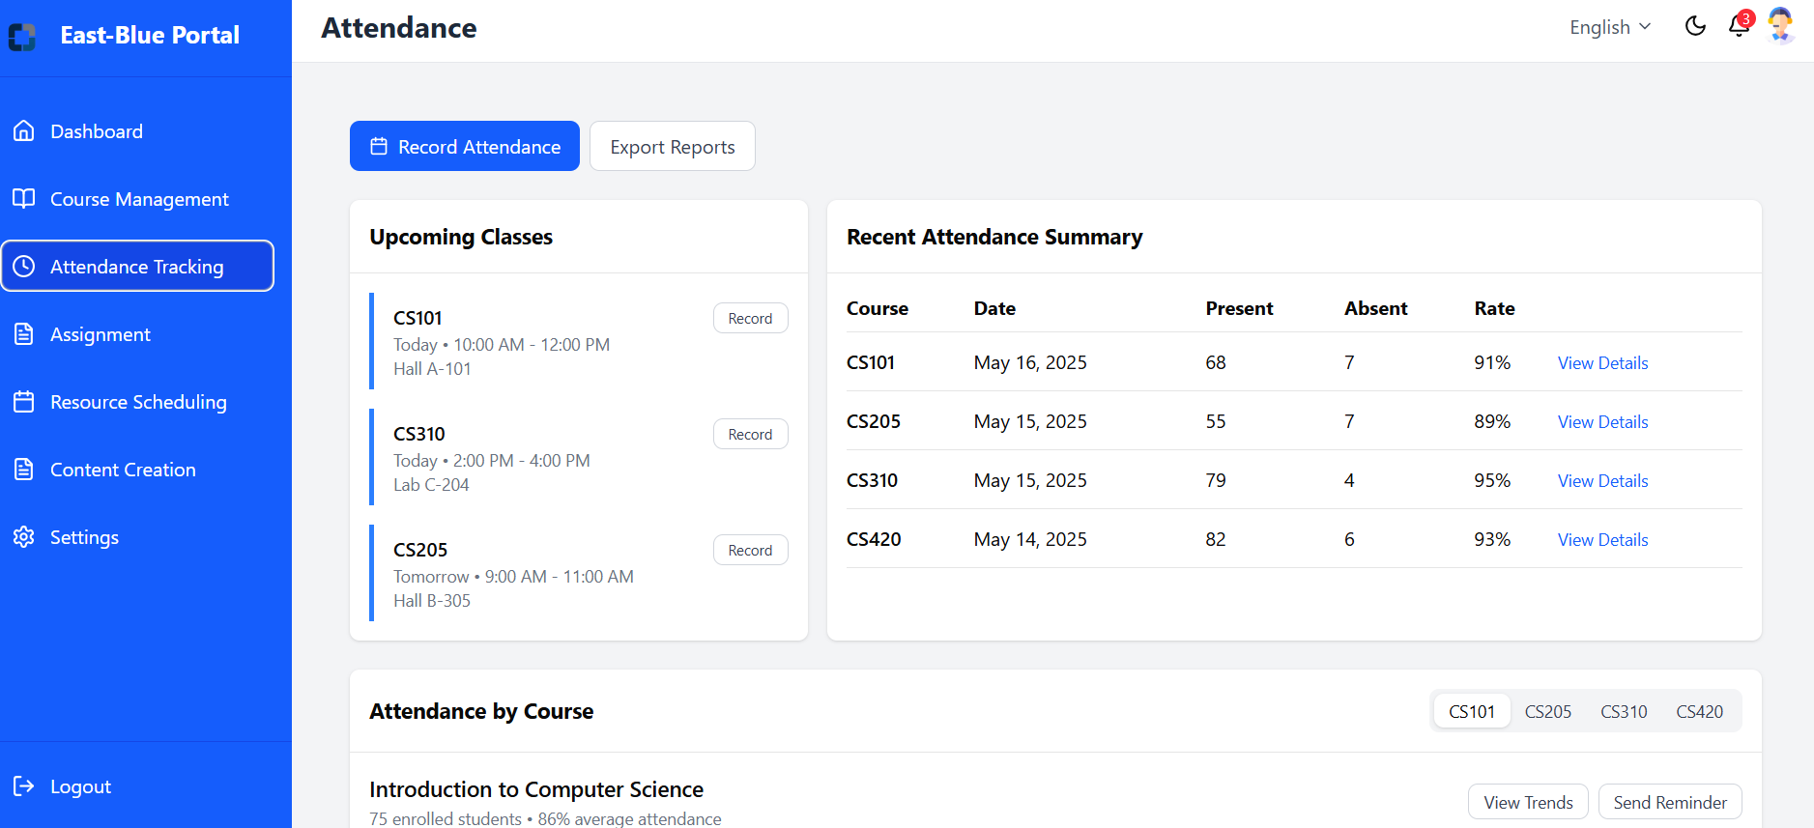

*Figure 3.4.2.2.4 Attendance Tracking Pages*

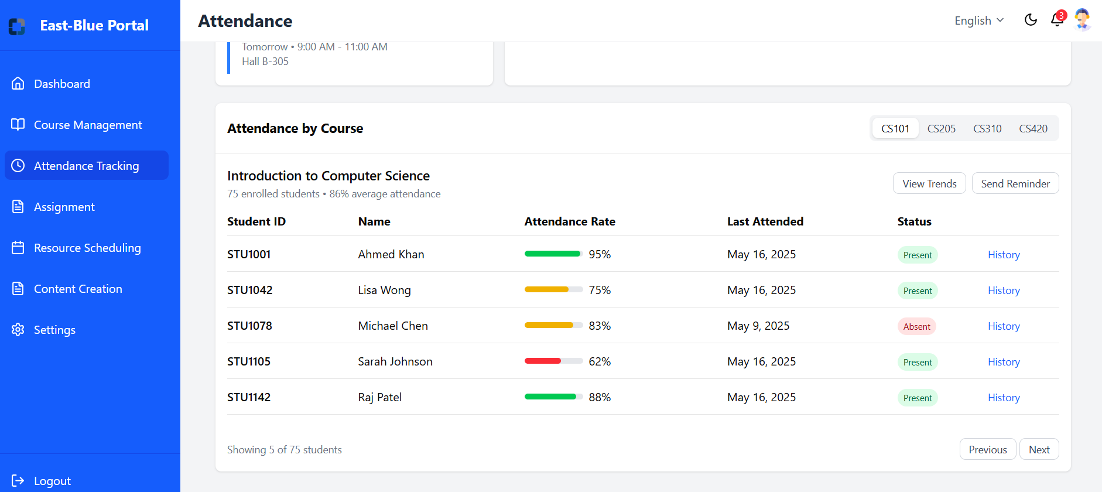

*Figure 3.4.2.2.5 Attendance Tracking Pages*

* Assignment Pages

Figures 3.4.2.2.6 and 3.4.2.2.7 display the Assignment Pages, featuring tools to create and manage assignments with deadlines, establish grading criteria and rubrics, track submission status, provide student feedback, and analyze performance across different assignments.

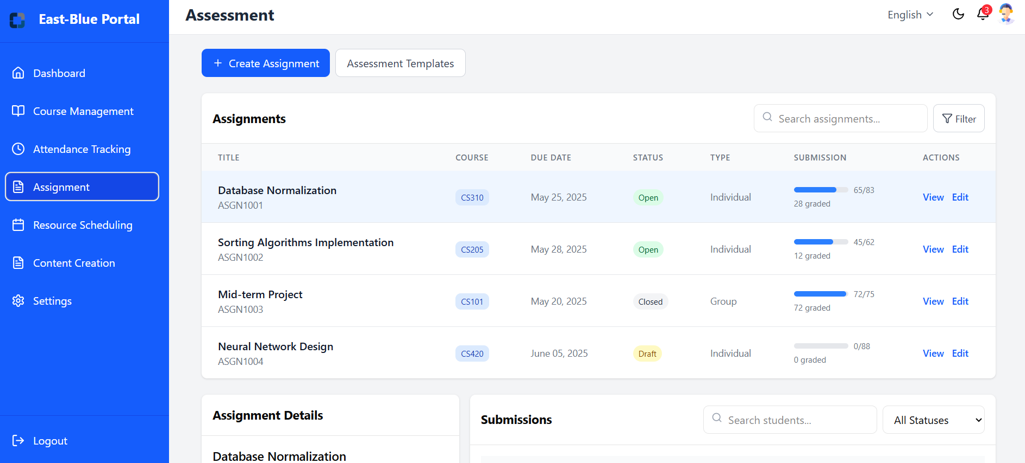

*Figure 3.4.2.2.6 Assignment Pages*

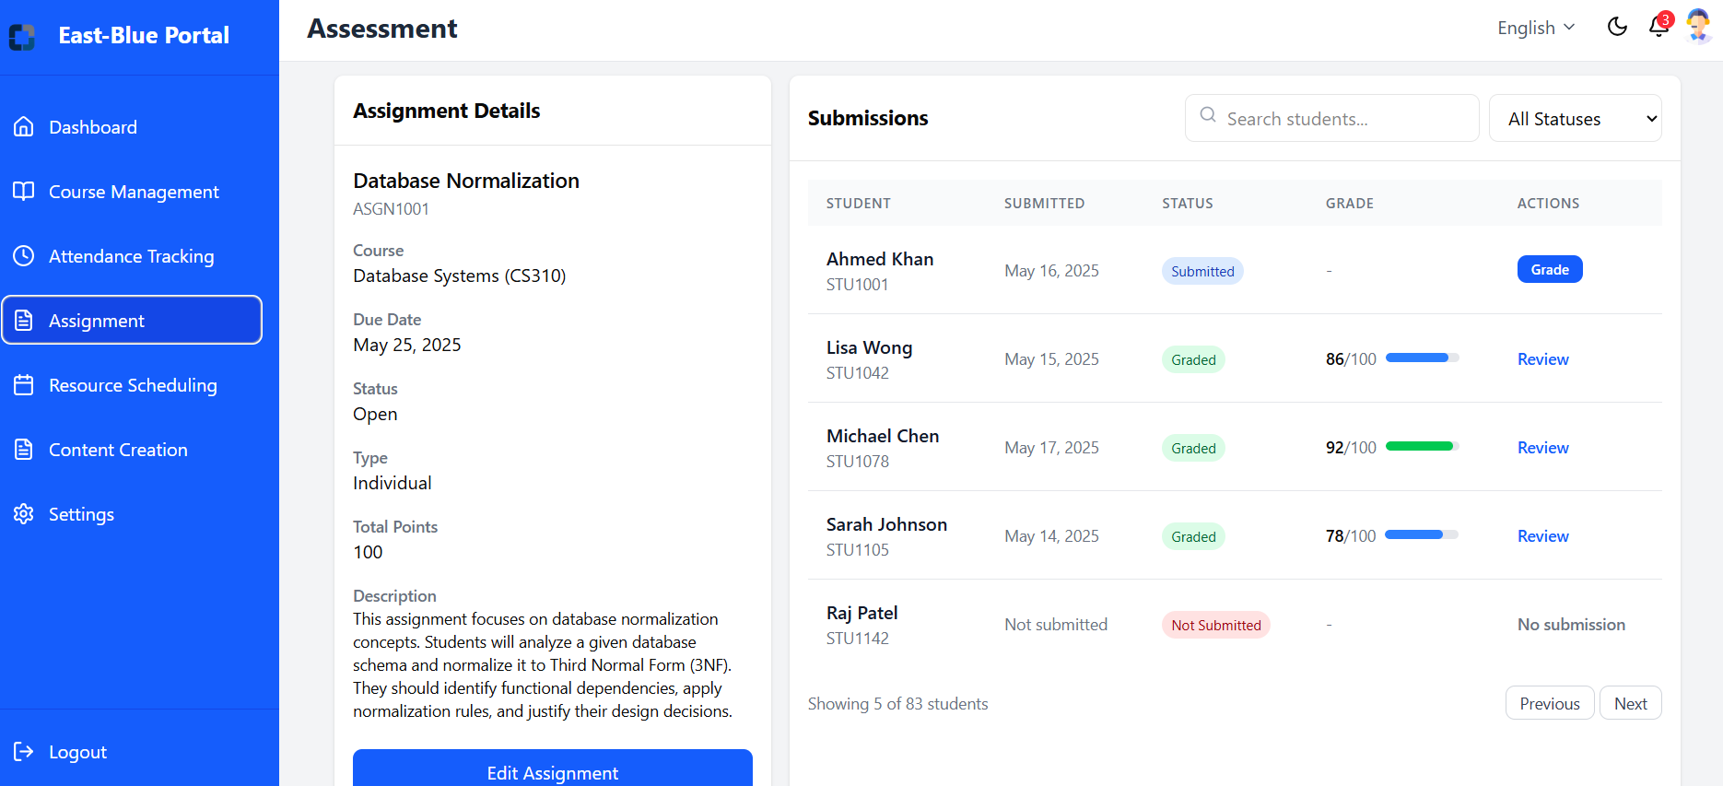

*Figure 3.4.2.2.7 Assignment Pages*

* Resource Scheduling Pages

Figures 3.4.2.2.8 through 3.4.2.2.10 display the Resource Scheduling Pages, featuring tools to book lecture halls, labs, and spaces with equipment like projectors, manage teaching equipment requests, set up student consultation office hours, view resource scheduling calendars, and track booking status.

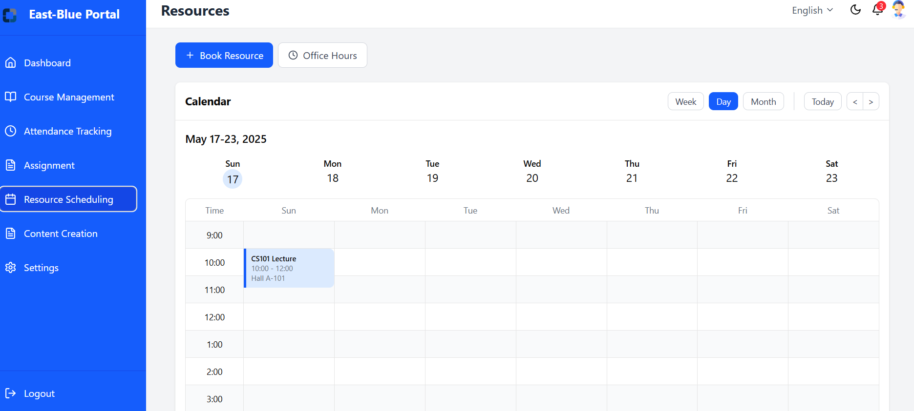

*Figure 3.4.2.2.8 Resource Scheduling Pages*

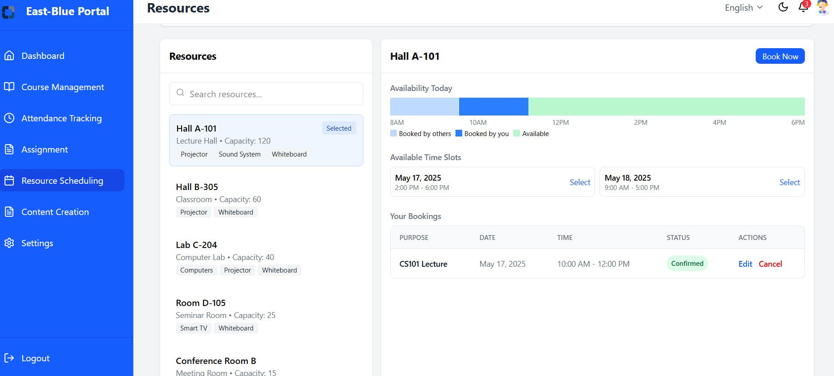

*Figure 3.4.2.2.9 Resource Scheduling Pages*

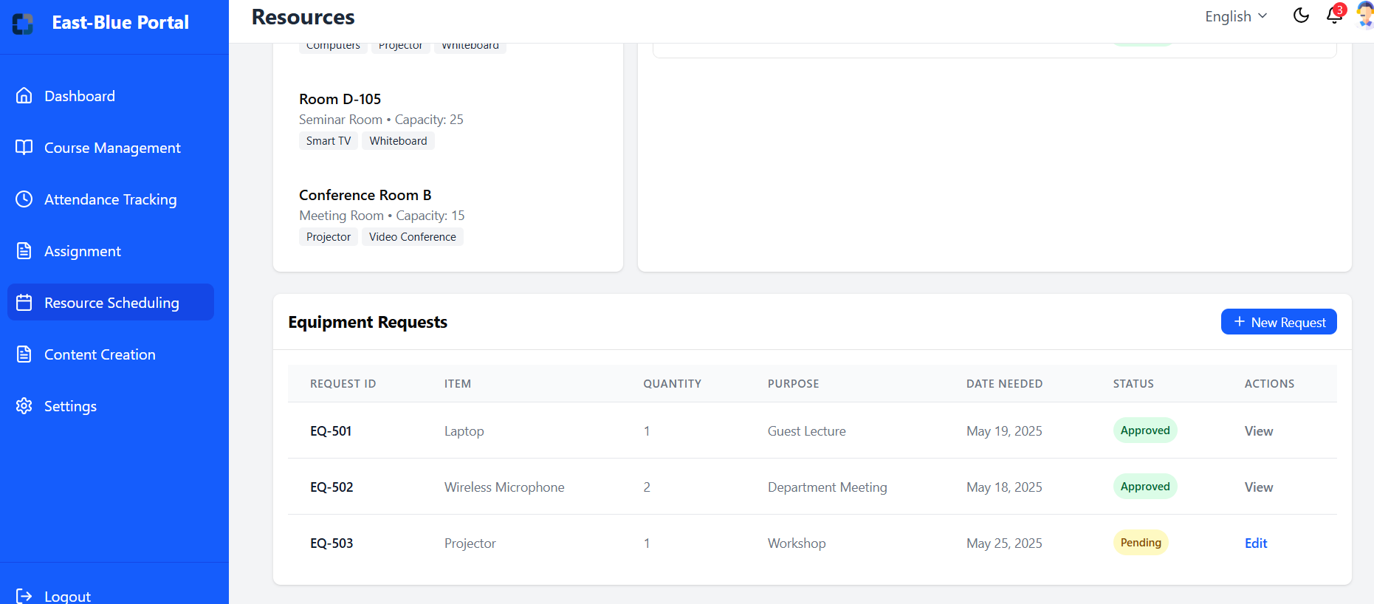

*Figure 3.4.2.2.10 Resource Scheduling Pages*

* Content creation  
  Figures 3.4.2.2.10 through 3.4.2.2.12 display the Content Creation Pages, featuring tools to develop and organize course materials, upload various learning resources, structure content into modules, control material visibility, and track student engagement through analytics.

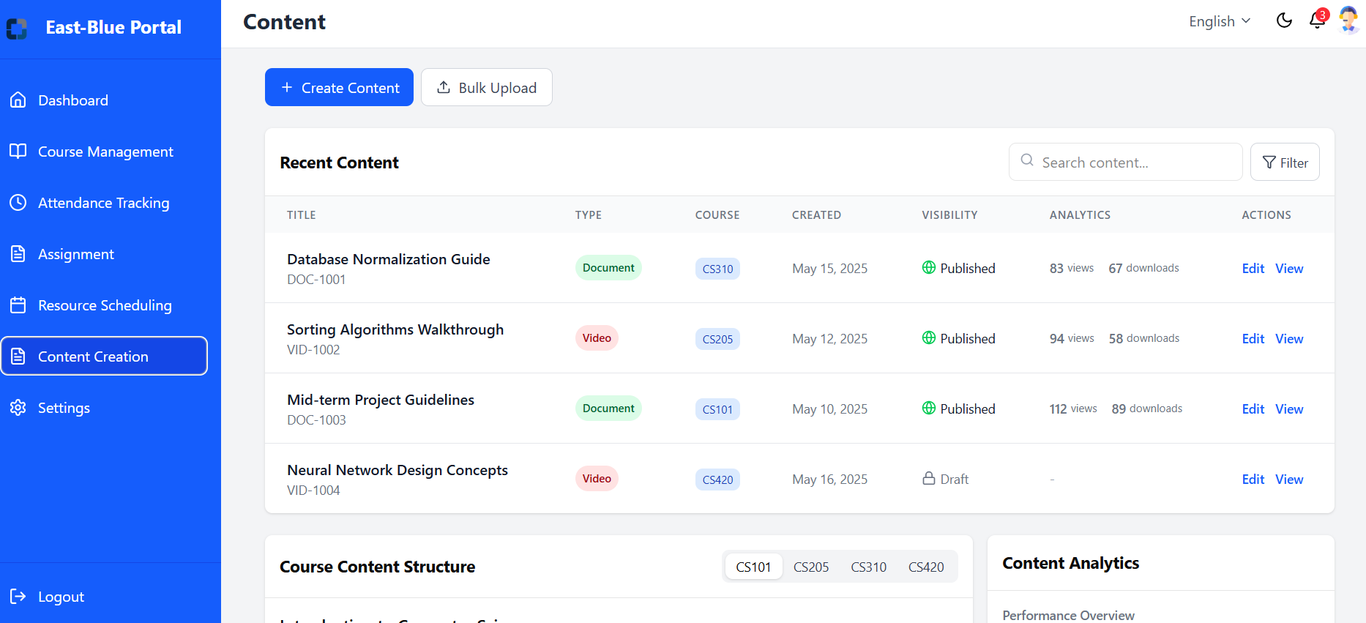

*Figure 3.4.2.2.11 Content Creation Pages*

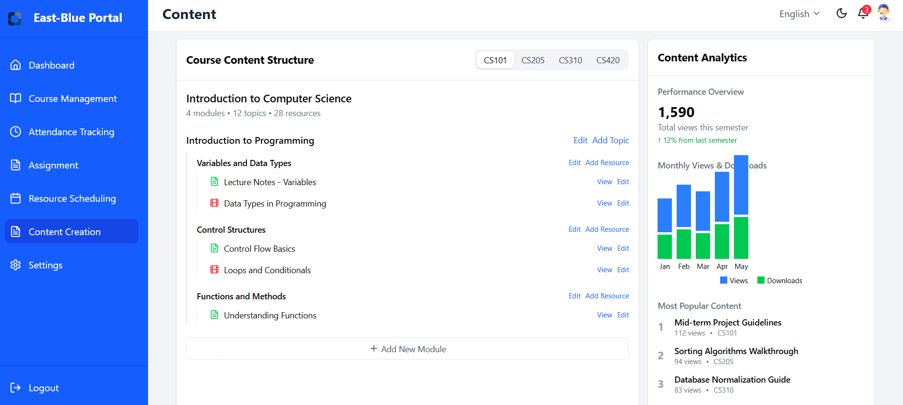

*Figure 3.4.2.2.12 Content Creation Pages*

* Setting pages  
  Figure 3.4.2.2.13 displays the Setting Pages, featuring tools to configure user preferences and system options.

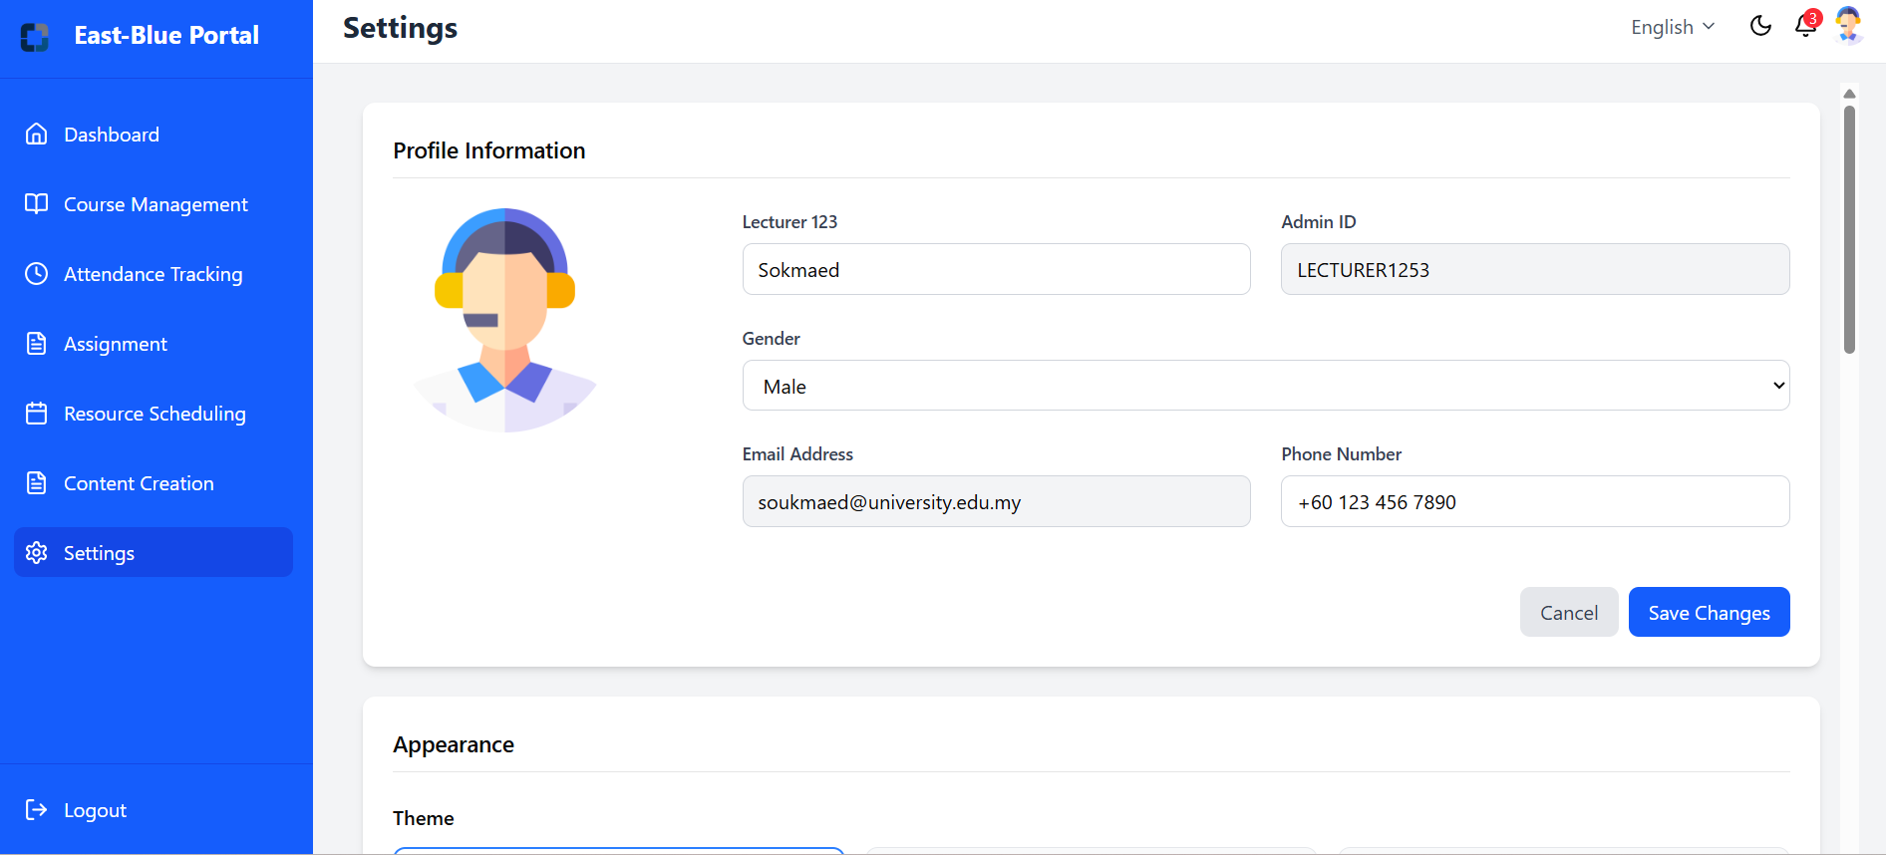

*Figure 3.4.2.2.13 Setting Pages*

* Figure 3.4.2.2.14 displays the Login Pages, it is designed to save login credentials in cookies, so that lecturers do not need to enter their username and password each time they log in.

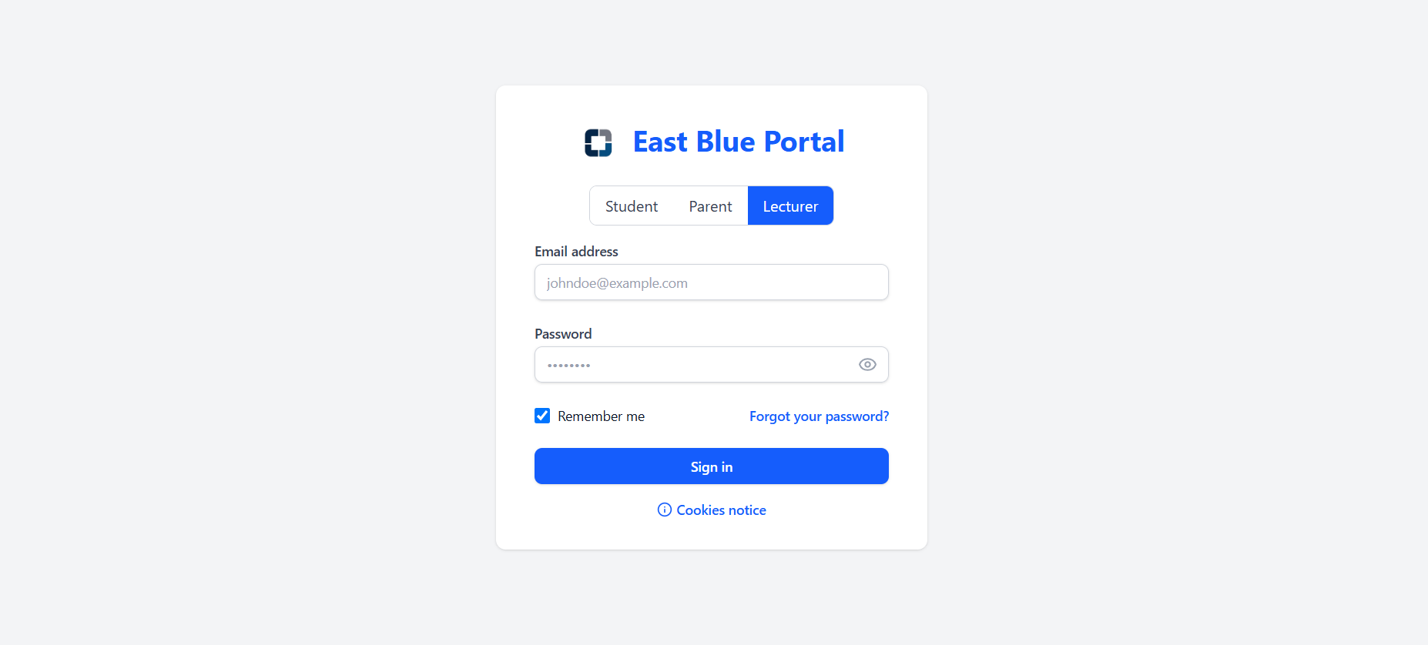

*Figure 3.4.2.2.14 Login pages*

#### Administrators

* Login pages

Figure 3.4.2.3.1 displays the Login Page, which requires the admin to enter their username and password each time they log in.

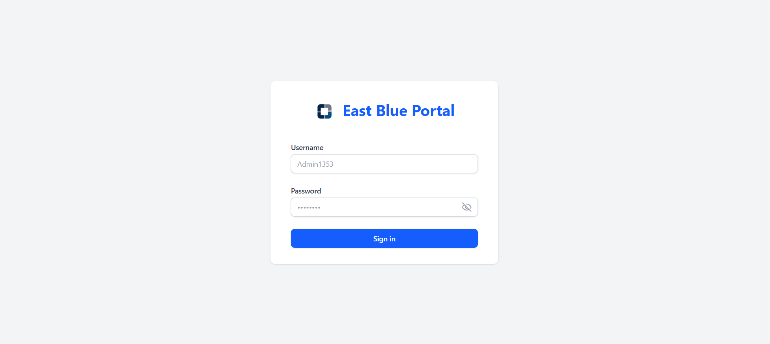

*Figure 3.4.2.3.1 Login pages*

* Dashboard Pages  
  Figures 3.4.2.3.2 and 3.4.2.3.3 display the Dashboard Pages, featuring system analytics with total user counts, active courses and system status, fee collection metrics, user activity charts, system monitoring graphs, and recent system logs.

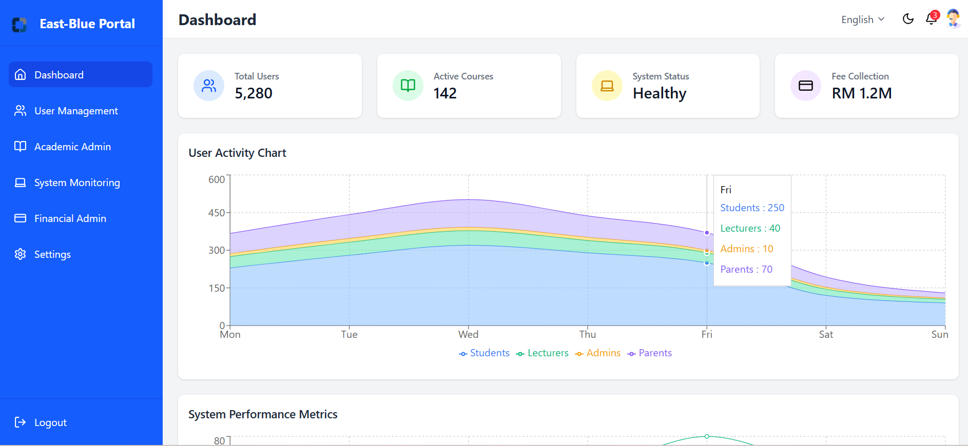

*Figure 3.4.2.3.2 Dashboard Pages*

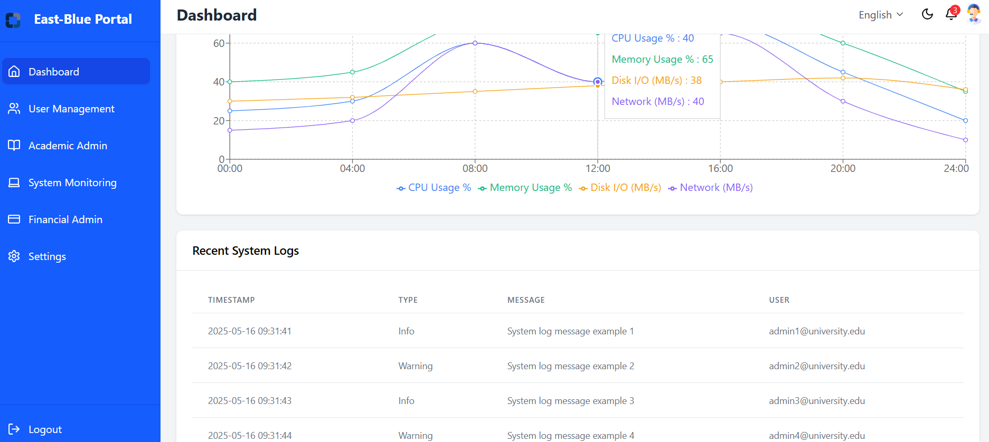

*Figure 3.4.2.3.3 Dashboard Pages*

* User Management Pages

Figure 3.4.2.3.4 displays the User Management Pages, featuring comprehensive tools to create, edit, and deactivate user accounts across all roles, assign and modify permissions, perform bulk user operations, and manage account security including password resets.

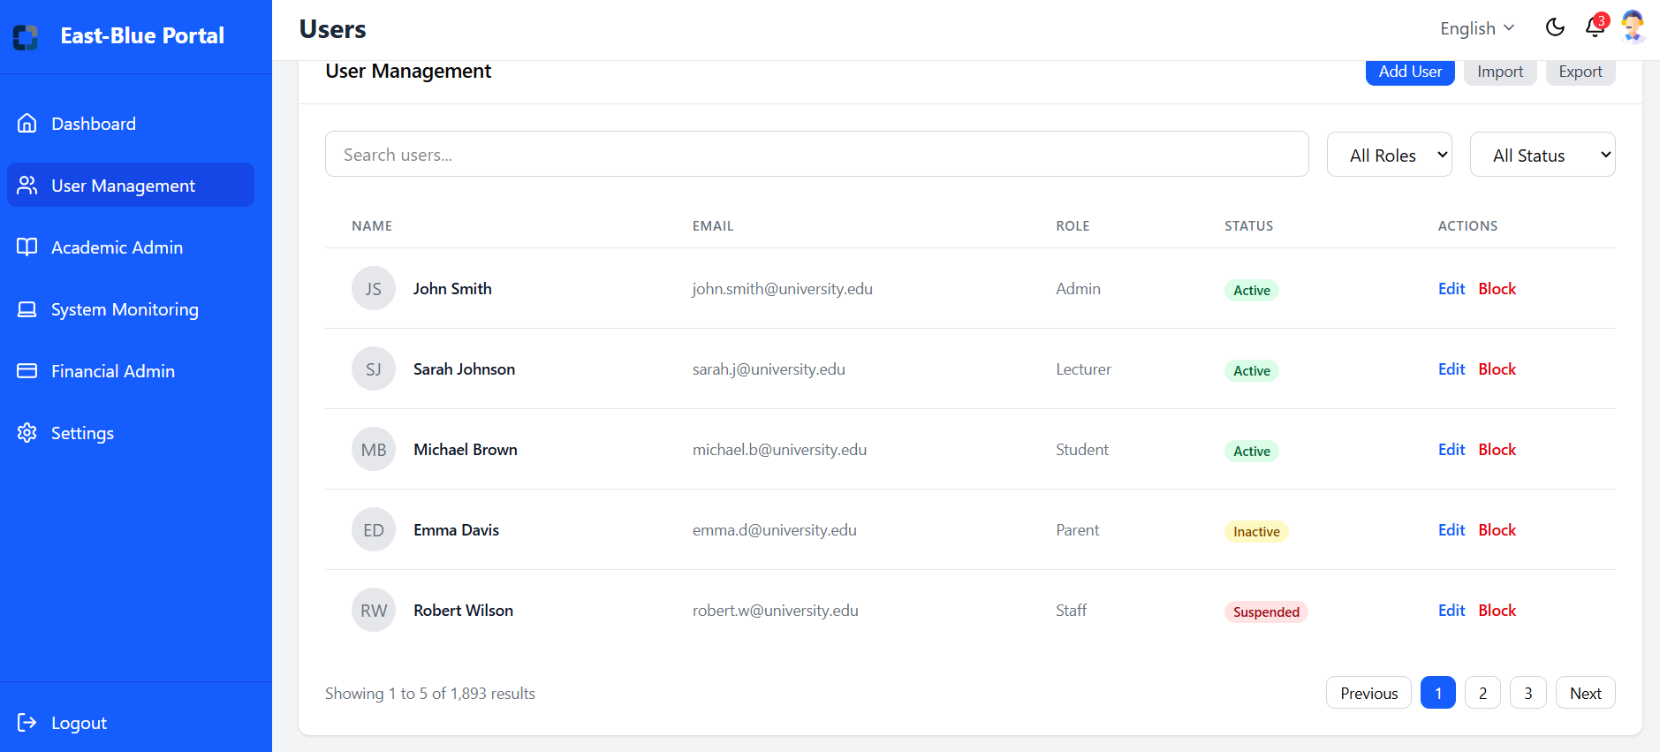

*Figure 3.4.2.3.4 User Management Pages*

* Academic Admin Pages  
  Figure 3.4.2.3.5 and Figure 3.4.2.3.6 displays the Academic Admin Pages, featuring tools to configure academic periods, establish organizational structures, manage course creation and scheduling, override enrollment parameters, and set up grading scales with academic policies.

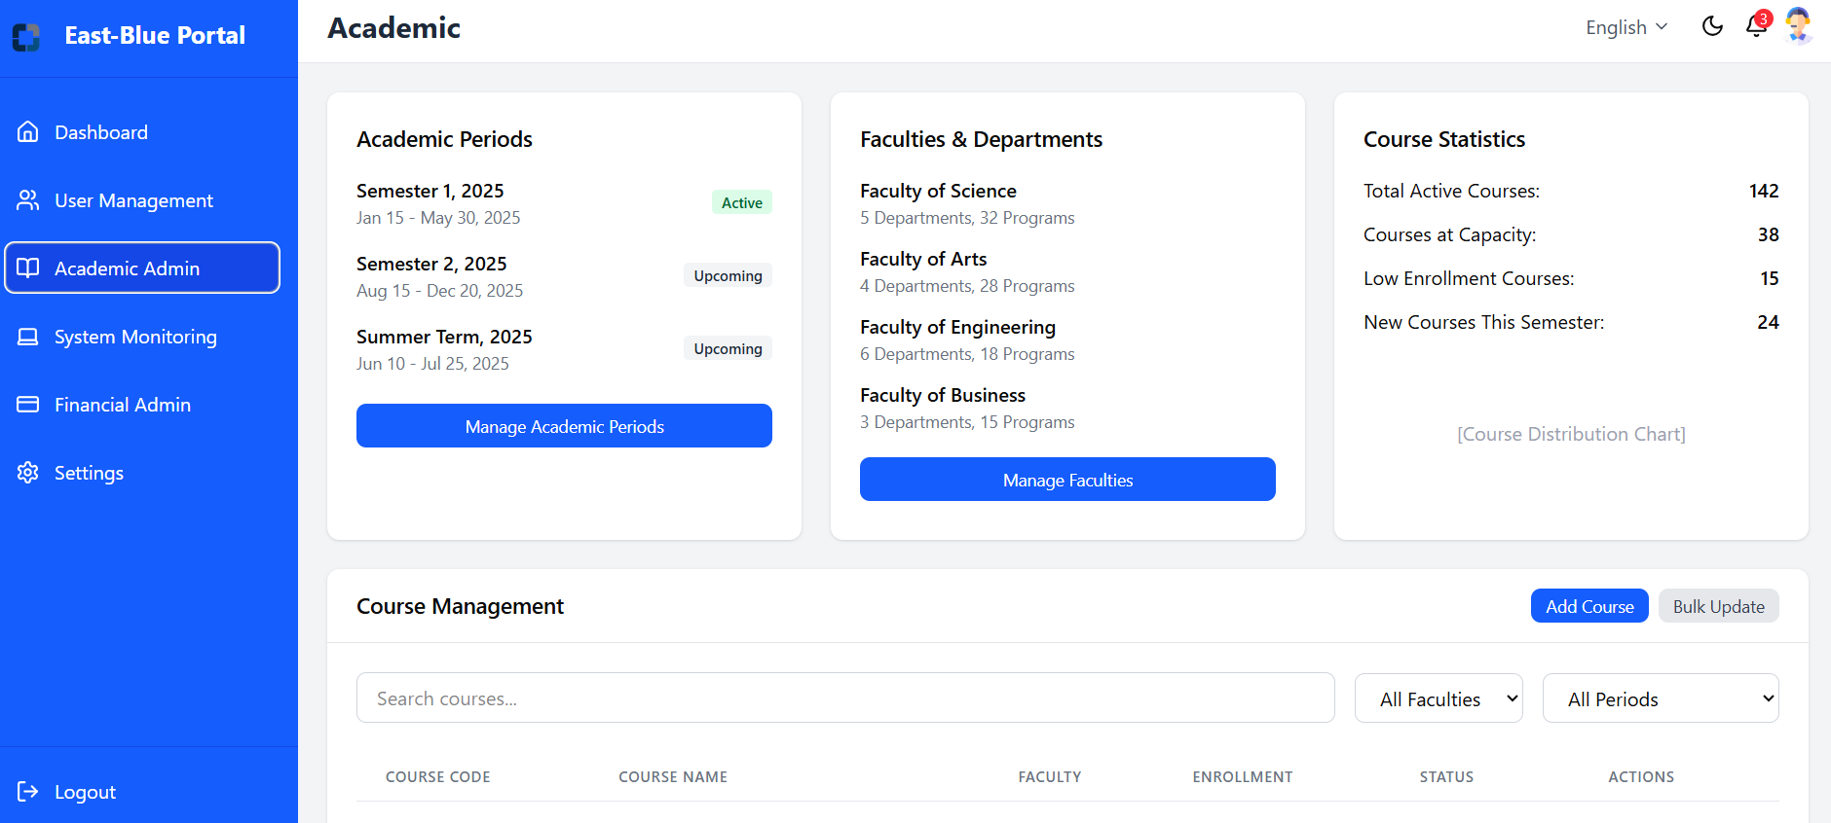

*Figure 3.4.2.3.5 Academic Admin Pages*

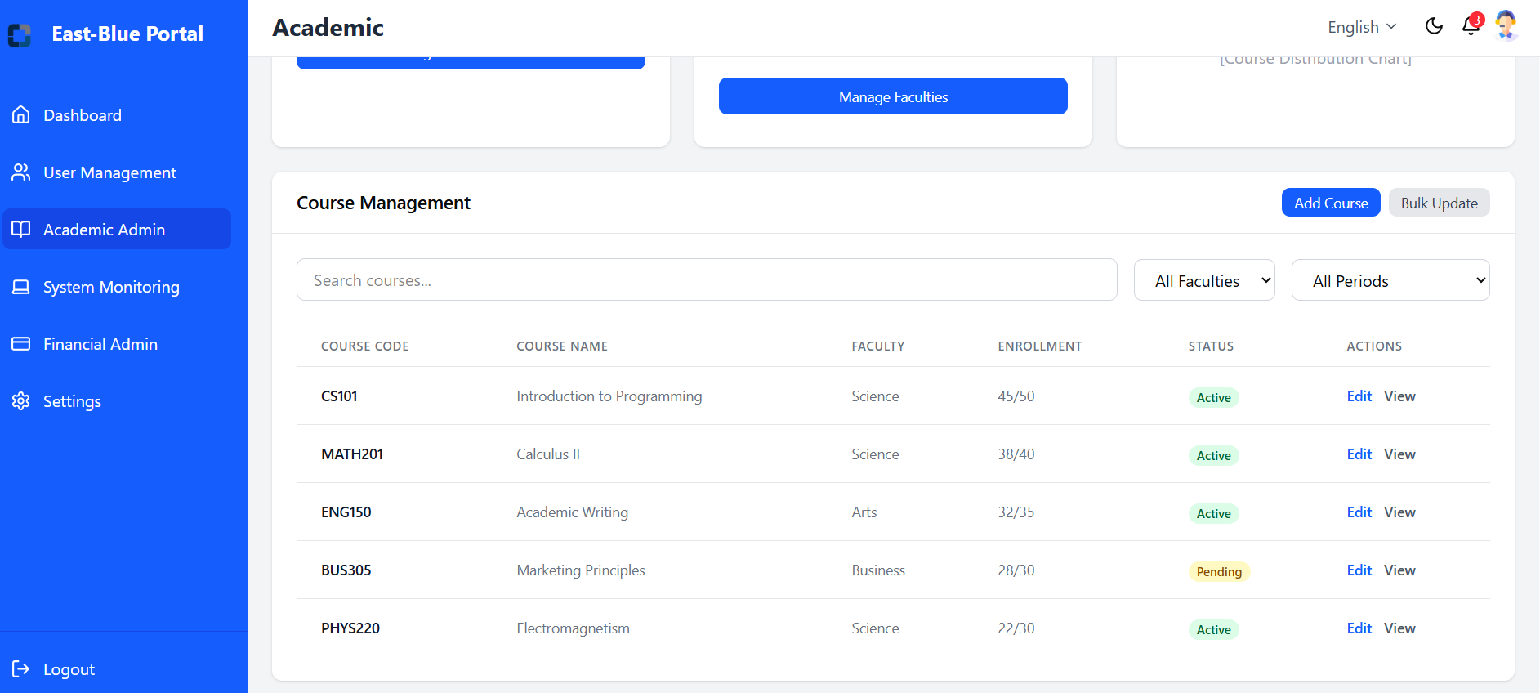

*Figure 3.4.2.3.6 Academic Admin Pages*

* System Monitoring Pages

Figures 3.4.2.3.7 and 3.4.2.3.8 display the System Monitoring Pages, featuring comprehensive system health statistics, server and database performance metrics, user activity tracking, usage analytics with reporting capabilities, and error log review for troubleshooting.

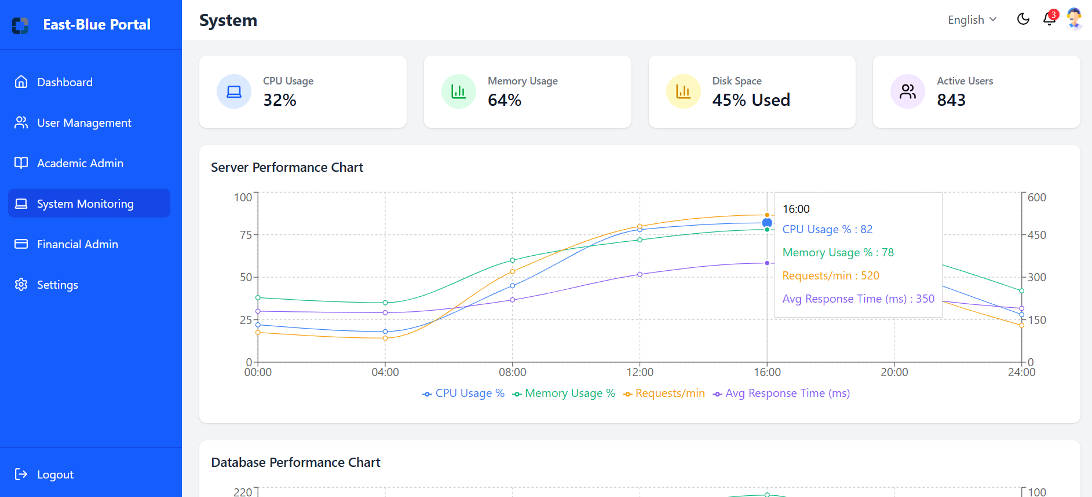

*Figure 3.4.2.3.7 System Monitoring Pages*

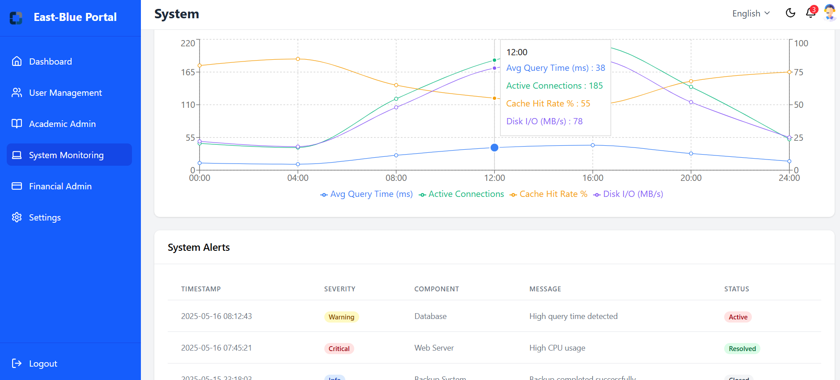

*Figure 3.4.2.3.8 System Monitoring Pages*

* Financial Admin Pages  
  Figures 3.4.2.3.9 and 3.4.2.3.10 display the Financial Admin Pages, featuring tools to configure payment systems and gateways, establish fee structures with payment schedules, generate financial reports with audit logs, and process refunds and financial adjustments.

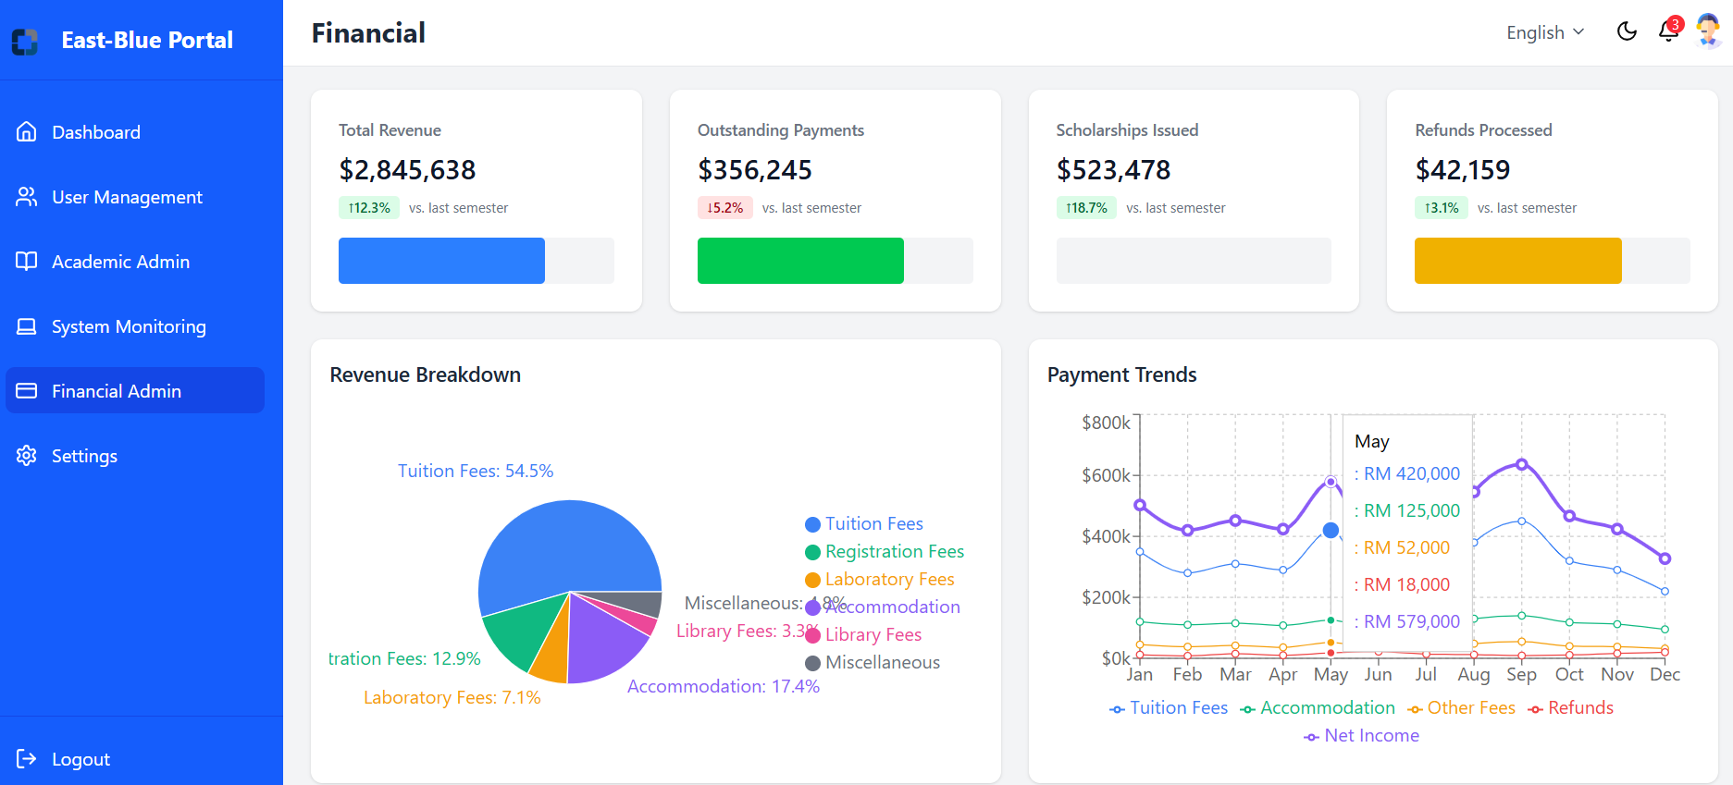

*Figure 3.4.2.3.9 Financial Admin Pages*

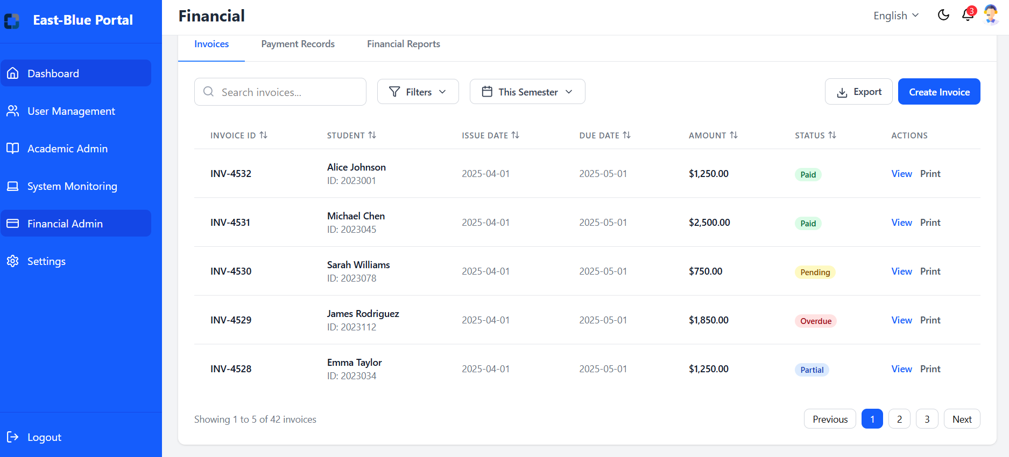

*Figure 3.4.2.3.10 Financial Admin Pages*

* Setting Pages

Figure 3.4.2.3.11 displays the Setting Pages, featuring tools to configure user preferences and system options.

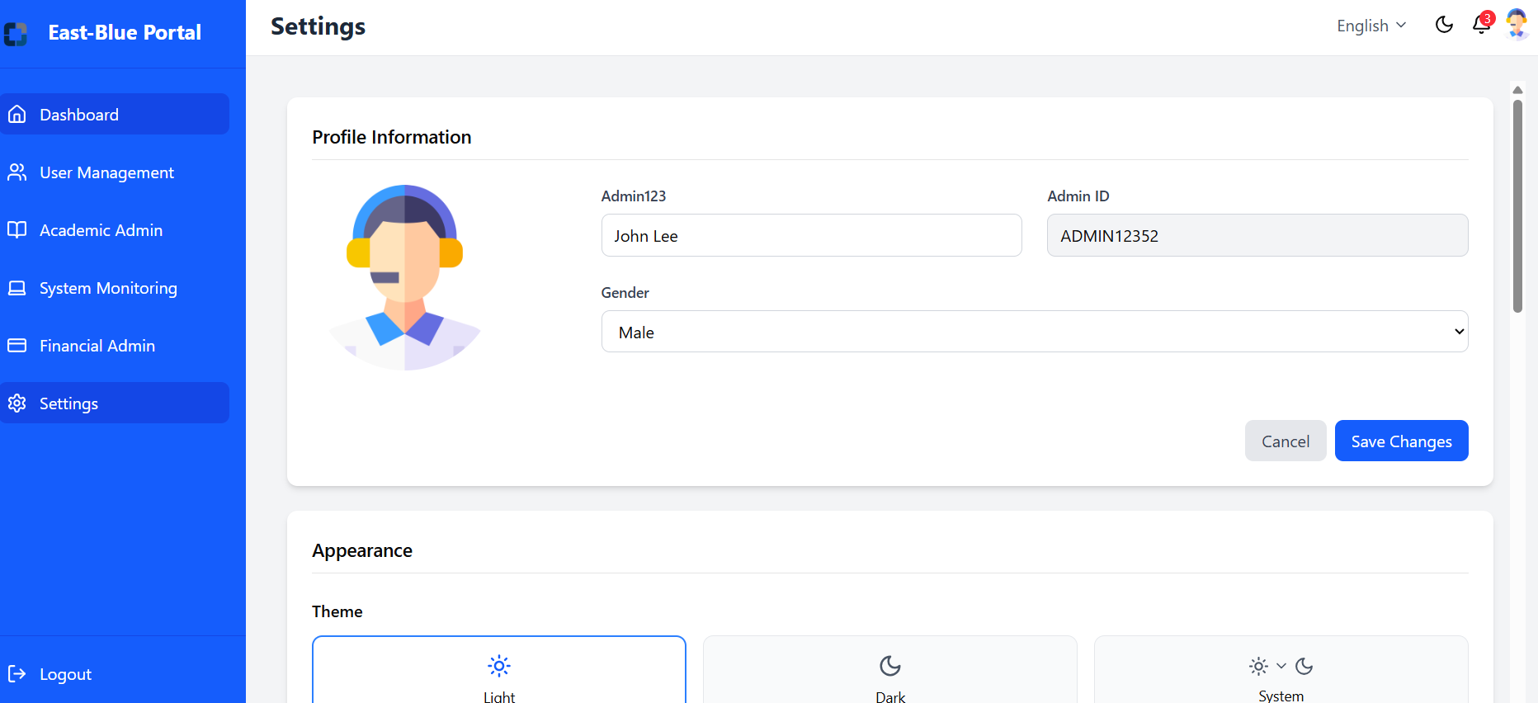

*Figure 3.4.2.3.11 Setting Pages*

#### Parent

* Login Pages  
  Figure 3.4.2.4.1 displays the Login Pages, it is designed to save login credentials in cookies, so that parents do not need to enter their username and password each time they log in.

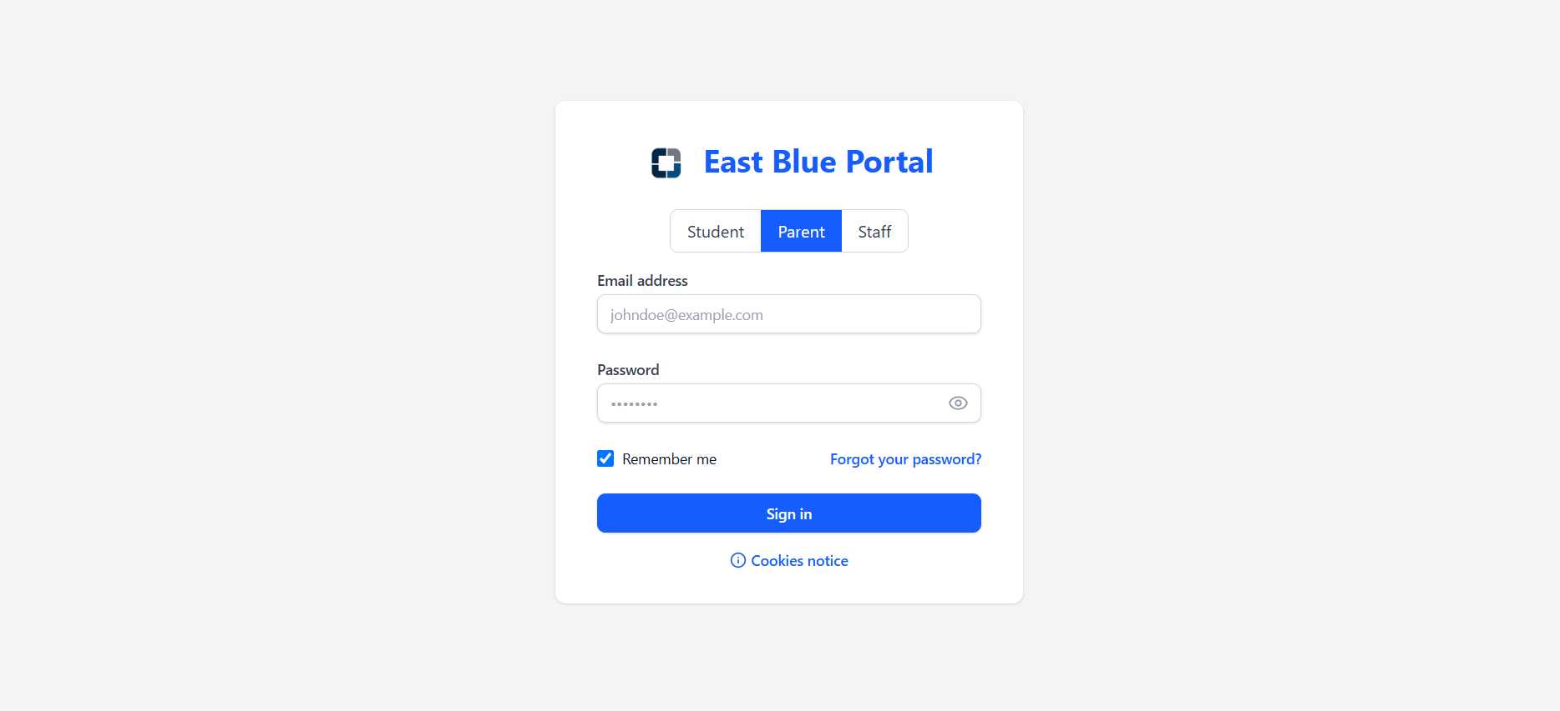

*Figure 3.4.2.4.1 Login Pages*

* Dashboard Pages  
  Figure 3.4.2.4.2 displays the Dashboard Pages, featuring a comprehensive parent overview of their child's academic standing with key metrics, financial obligations, recent grades, attendance records, academic alerts, and upcoming university events with notifications.

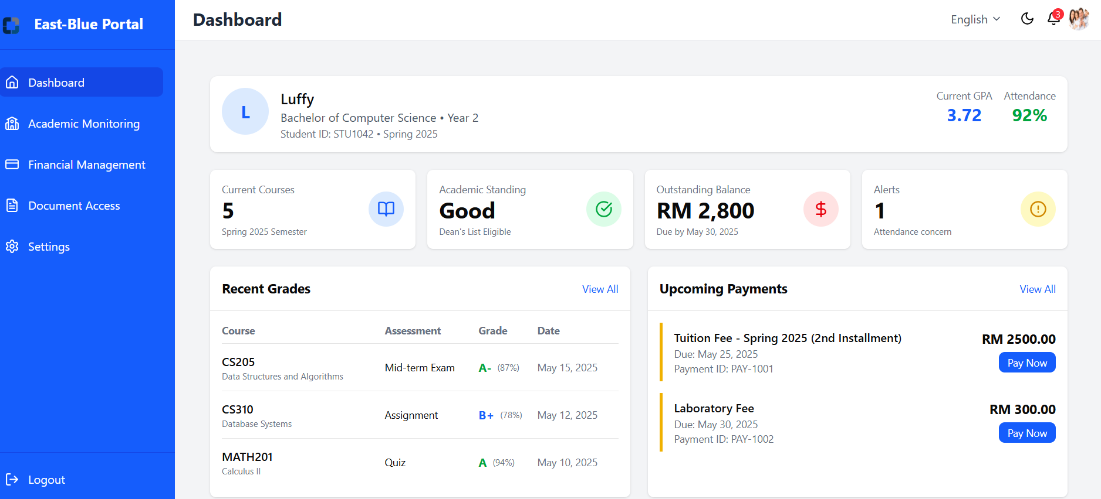

*Figure 3.4.2.4.2 Dashboard Pages*

* Academic Monitoring Pages

Figures 3.4.2.4.3 and 3.4.2.4.4 display the Academic Monitoring Pages, featuring comprehensive views of student academic performance, current courses with status indicators, detailed assessment results, attendance tracking, academic history, and GPA trend analysis with academic standing information.

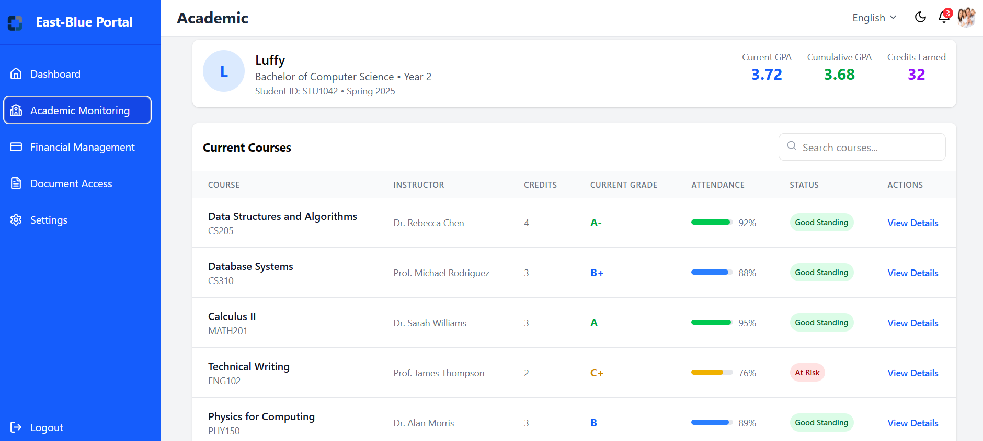

*Figure 3.4.2.4.3 Academic Monitoring Pages*

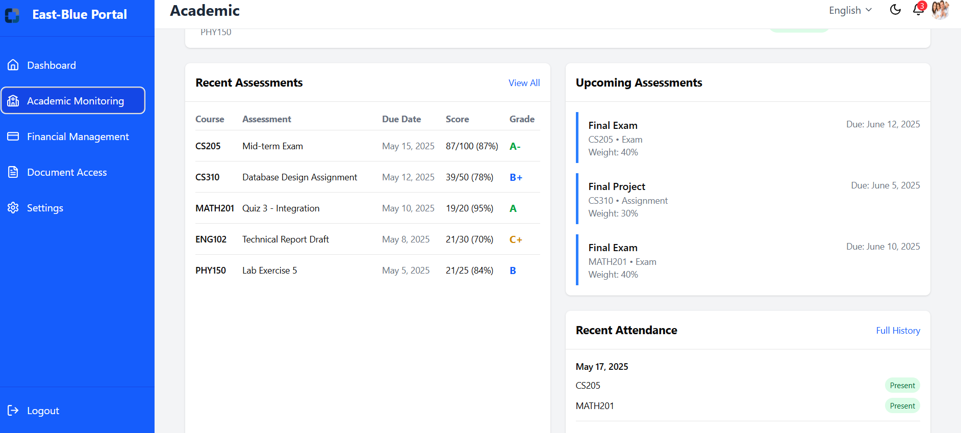

*Figure 3.4.2.4.4 Academic Monitoring Pages*

* Financial Management Pages

Figures 3.4.2.4.5 and 3.4.2.4.6 display the Financial Management Pages, featuring comprehensive financial overview with fee breakdowns, payment schedules with status indicators, transaction history with receipts, payment method management, full fee history, and options for downloading statements and making payments.

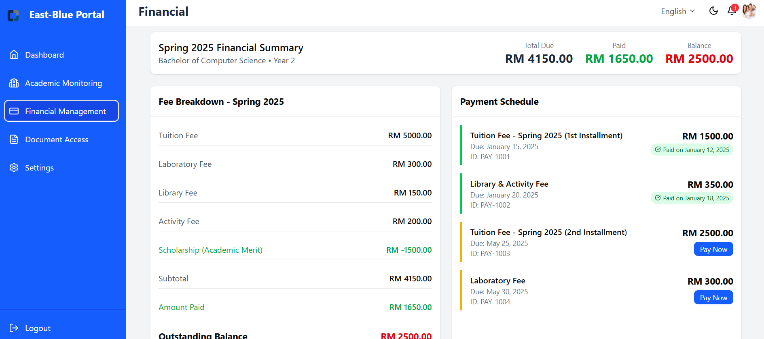

*Figure 3.4.2.4.5 Financial Management Pages*

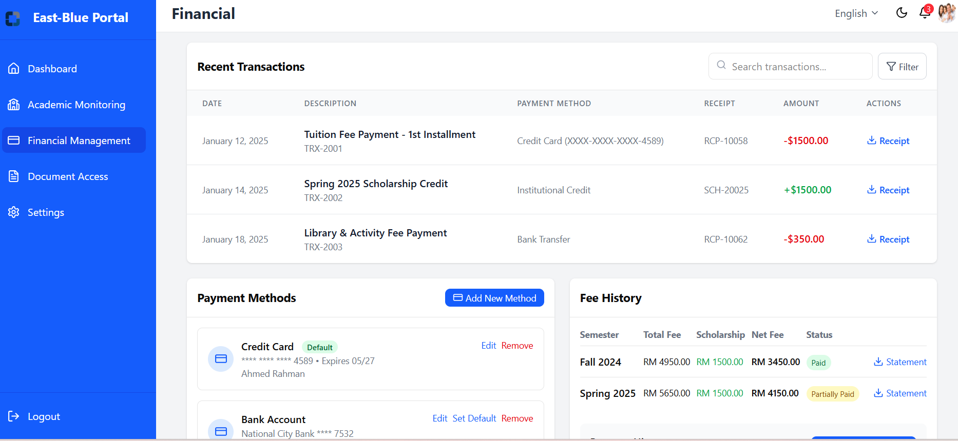

*Figure 3.4.2.4.6 Financial Management Pages*

* Document Access Pages

Figures 3.4.2.4.7 and 3.4.2.4.8 display the Document Access Pages, featuring a central repository for all student-related documents including academic reports, transcripts, financial statements, administrative notices, document notifications, and parent resources.

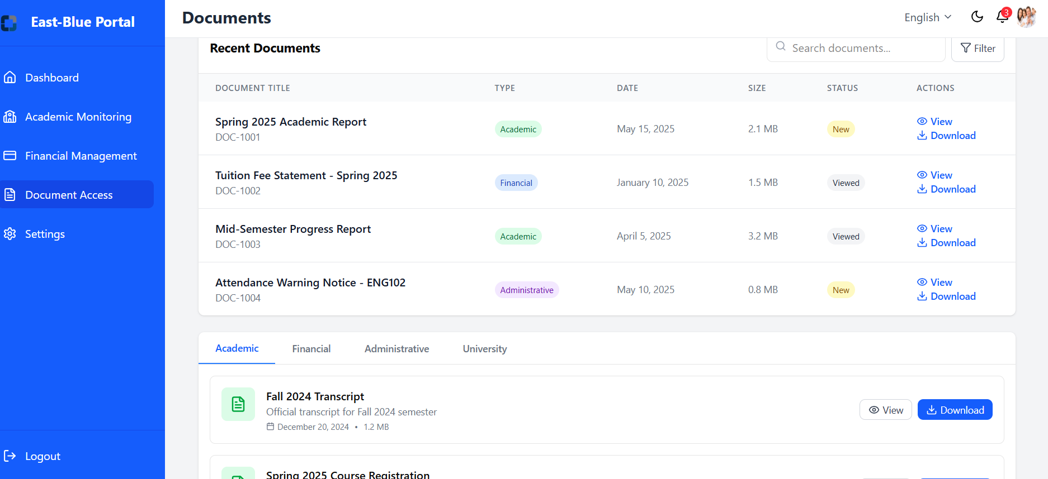

*Figure 3.4.2.4.7 Document Access Pages*

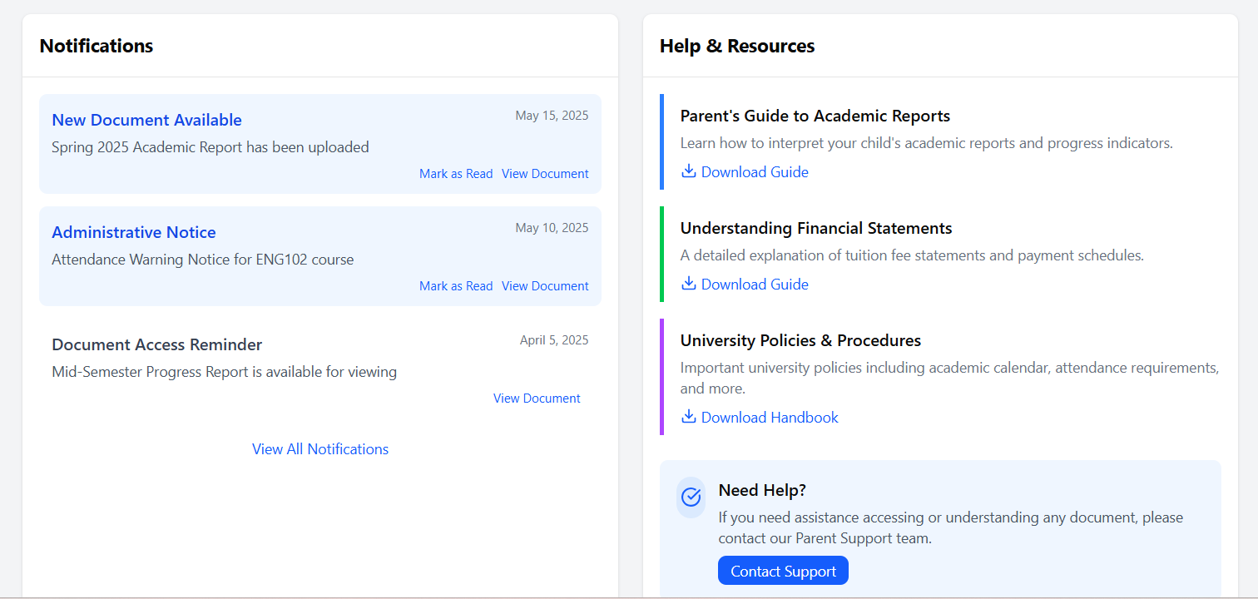

*Figure 3.4.2.4.8 Document Access Pages*

* Setting Pages

Figure 3.4.2.4.9 displays the Setting Pages, featuring tools to configure user preferences and system options.

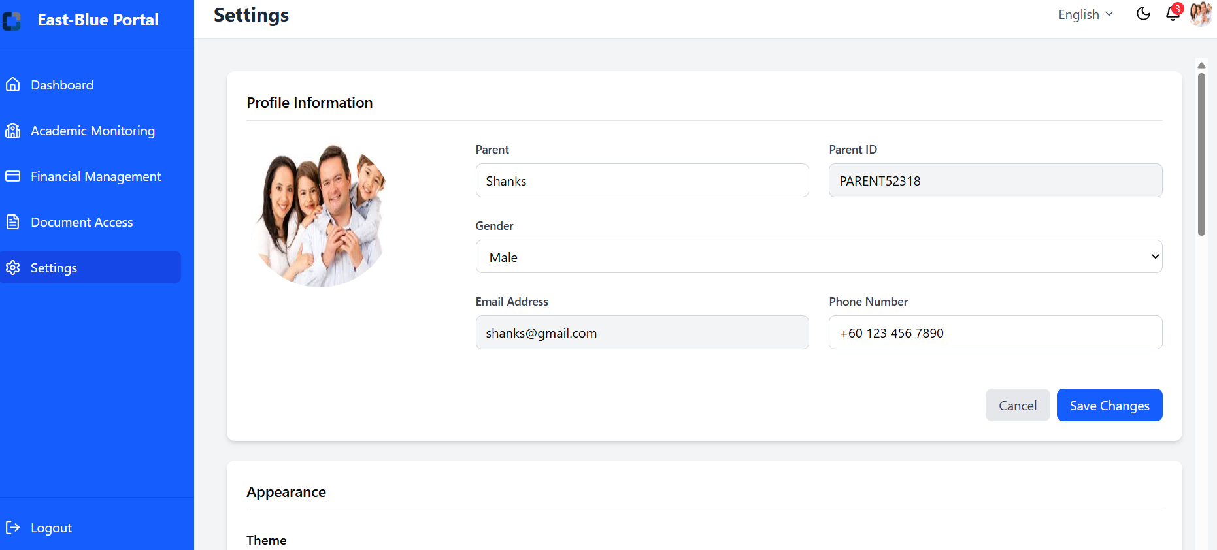

*Figure 3.4.2.4.9 Setting Pages*

### Hardware Interfaces

* + - 1. Server Requirements
* Application Servers: AWS EC2 instances with minimum 8 CPU cores, 16GB RAM
* Database Servers: AWS RDS instances with 16GB RAM, 100GB storage
* File Storage: AWS S3 buckets for document storage with appropriate encryption
  + - 1. Client Device Requirements
* Desktop Access
  + CPU: Dual-core 2.0GHz or better
  + RAM: 4GB minimum (8GB recommended)
  + Storage: 1GB free space for desktop application
  + Resolution: Minimum 1280×720 display
* Mobile Access
  + Supported OS: iOS 14+ and Android 9+
  + RAM: 2GB minimum
  + Storage: 100MB free space for mobile application
  + Camera: Required for document scanning and identity verification

### Software Interfaces

* + - 1. Development Stack
* Frontend:
  + Web: React 18+ with TypeScript,Next JS shadcn/ui component library
  + Desktop: Electron with React and Redux for state management
  + Mobile: React Native with Redux
* Backend:
  + Node.js with Express.js framework
  + RESTful API architecture
  + GraphQL for complex data queries
* Database:
  + AWS PostgreSQL RDS for relational data
  + Redis for caching and session management
    - 1. Third-Party Integrations
* Payment Processing: Stripe
* SMS Service: Twilio API for text message notifications
* Cloud Storage: AWS S3 API for document storage
* Analytics: Google Analytics and custom event tracking

### Communications Interfaces

* + - 1. Network Requirements
* HTTPS with TLS 1.3 for all data transmission
* WebSockets for real-time notifications and AI assistant chat
  + - 1. Data Exchange
* JSON as primary data exchange format
* JWT (JSON Web Tokens) for authentication
  + - 1. Security Protocols
* AES-256 encryption for sensitive data
* CORS implementation for web security
  + - 1. Messaging System
* Push notifications using Firebase Cloud Messaging
* In-app notification system using WebSockets
  + - 1. AI Assistant Communication
* WebSocket connection for real-time chat functionality
* Natural Language Processing via cloud-based AI services
* Voice recognition integration for accessibility

## Logical Database Requirements

* + 1. Entity Relationship Diagram (ERD)

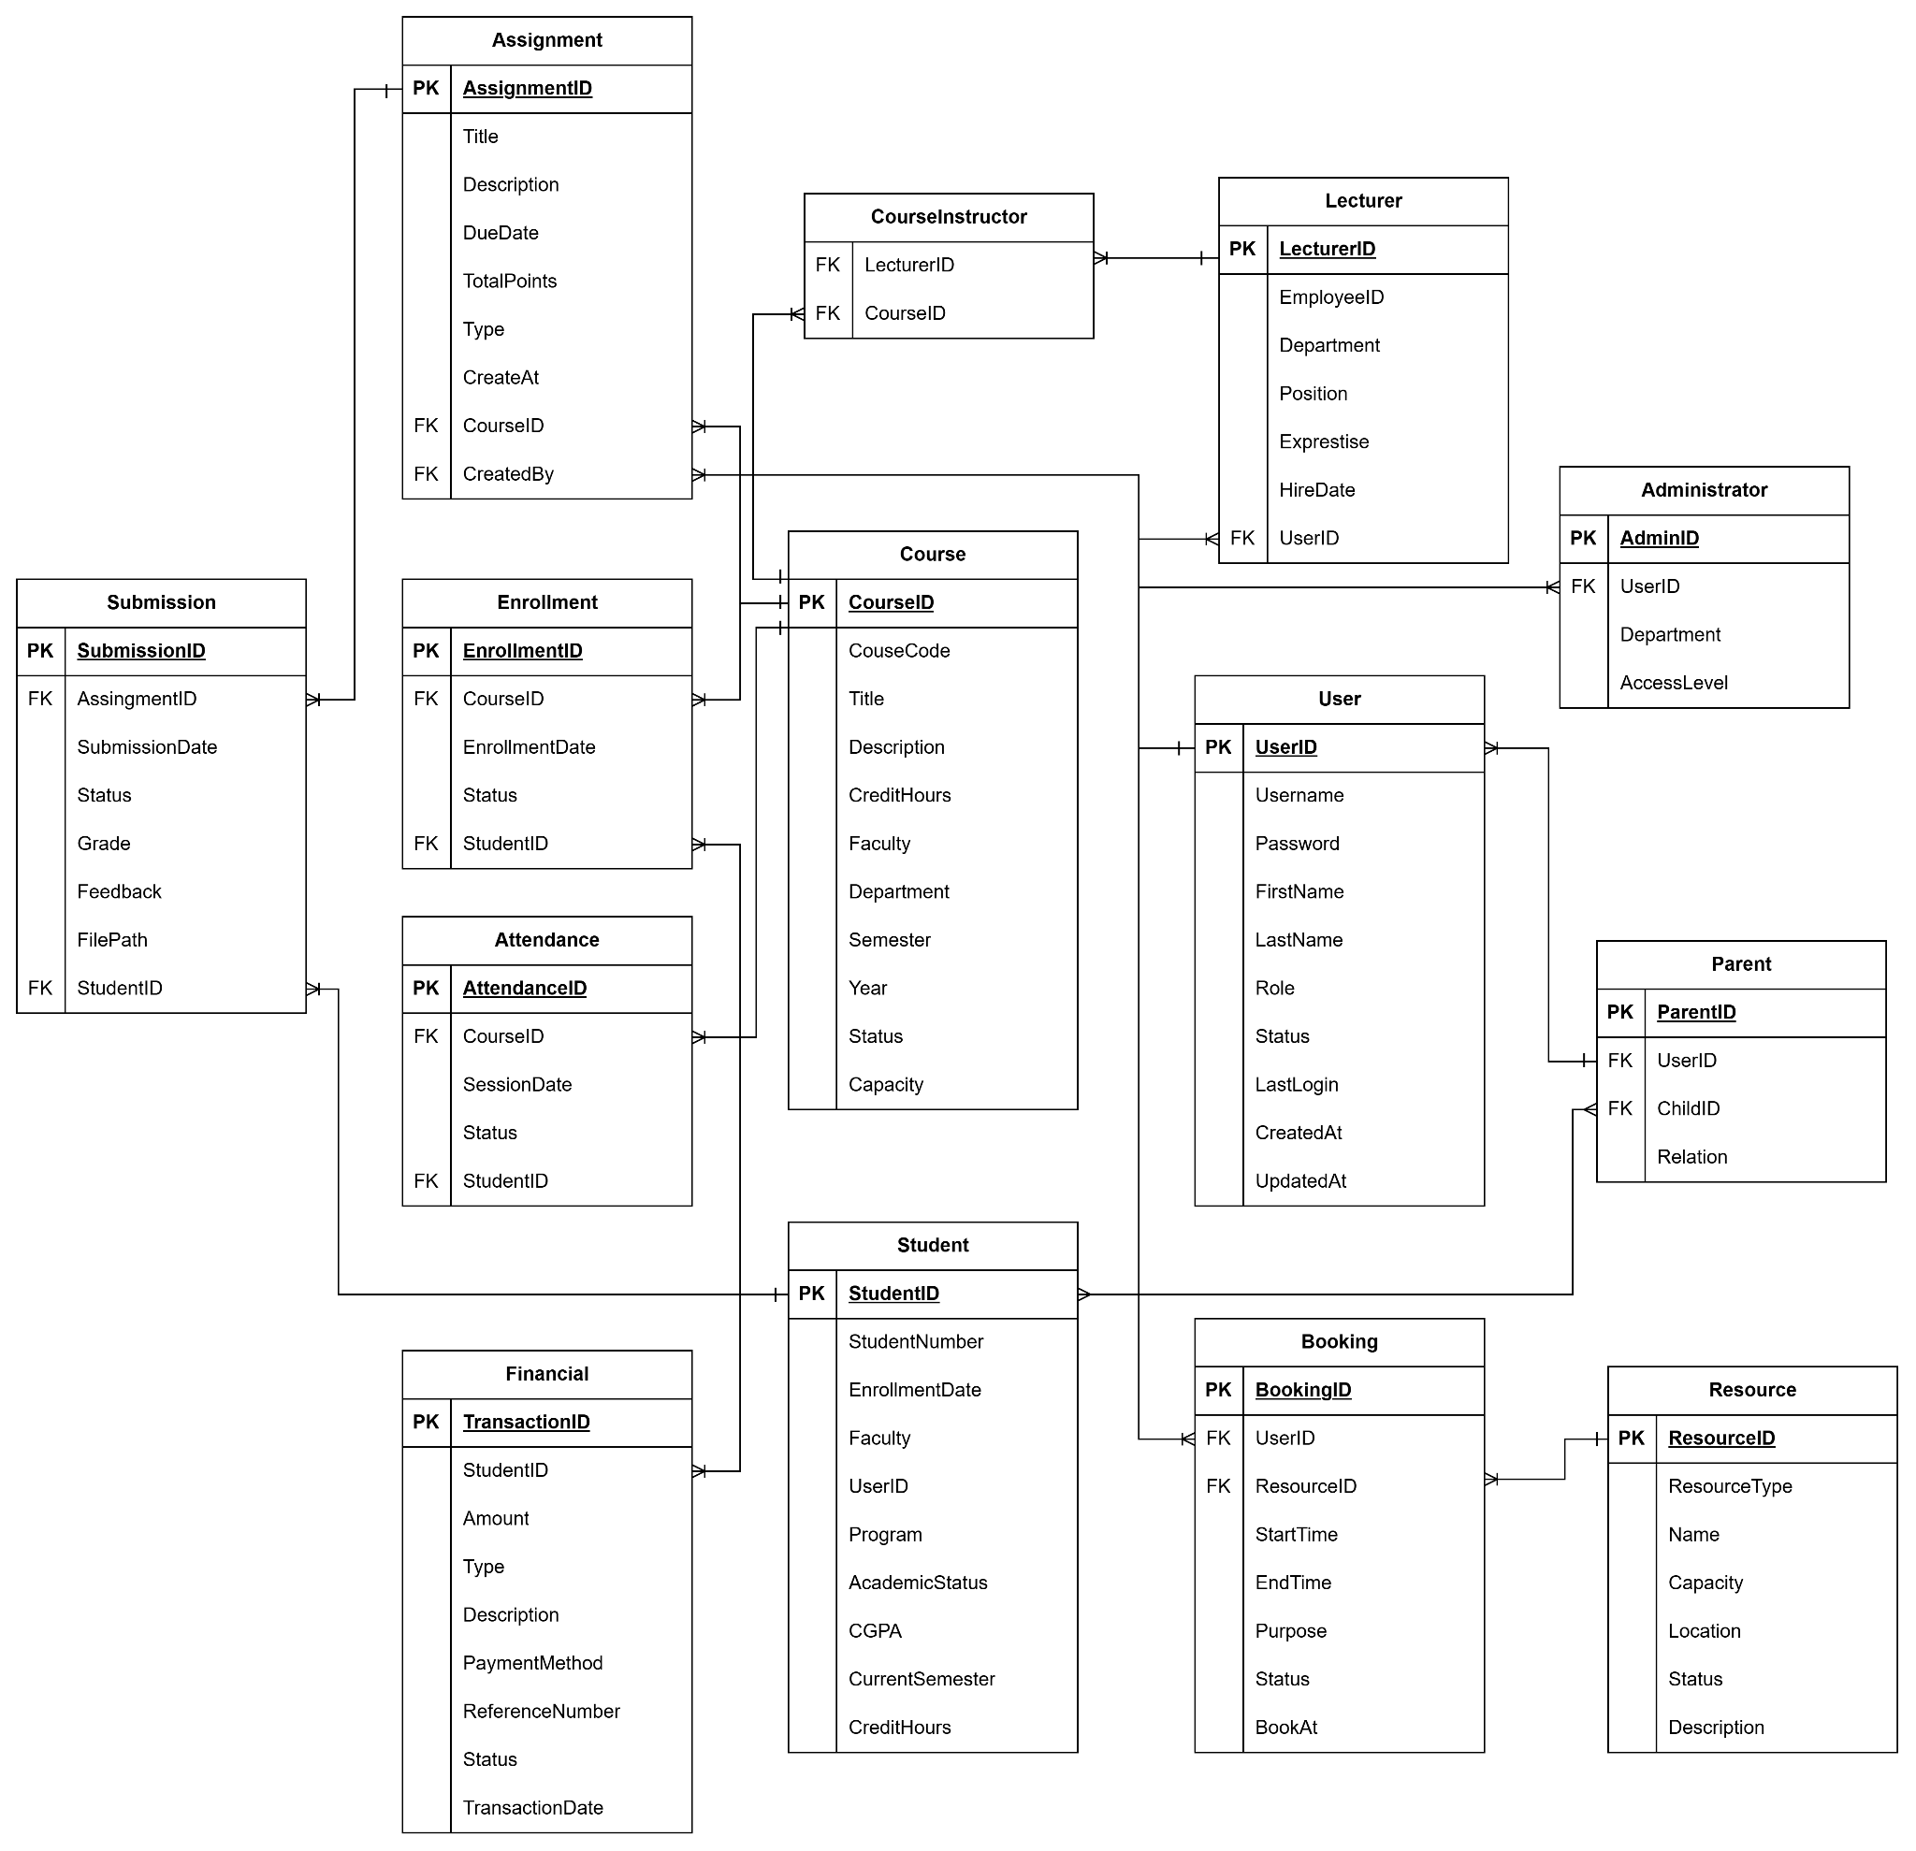

*Figure 3.5.1.1 ERD*

<https://drive.google.com/file/d/1JnCAi-yHJR8-E8RWUKVrynEZBMQKvRA2/view?usp=sharing>

* + 1. Core Entities and Relationships
       1. User
* Attributes
  + UserID (PK), Username, Password, FirstName, LastName, Role, Status, LastLogin, CreatedAt, UpdatedAt
* Relationships
  + One-to-many with Student, Lecturer, Parent, and Administrator
* Constraints
  + Unique username
  + password complexity requirements
    - 1. Student
* Attributes
  + StudentID (PK), UserID (FK), StudentNumber, EnrollmentDate, Faculty, Program, AcademicStatus, CGPA, CurrentSemester, CreditHours
* Relationships
  + One-to-many with Attendance, Assignment, Payment
* Constraints
  + StudentNumber must be unique
    - 1. Lecturer
* Attributes
  + StudentID (PK), UserID (FK), StudentNumber, EnrollmentDate, Faculty, Program, AcademicStatus, CGPA, CurrentSemester, CreditHours
* Relationships
  + One-to-many with CourseInstructor
* Constraints
  + EmployeeID must be unique
    - 1. Parent
* Attributes
  + ParentID(PK), UserID(FK), CholdID(FK), Relation
* Relationships
  + Many-to-many with Student
* Constraints
  + Each parent record must be linked to a valid User account
    - 1. Administrator
* Attributes
  + AdminID(PK), UserID(FK), Department(FK), AccessLevel
* Constraints
  + Each administrator record must be linked to a valid User account
    - 1. CouseInastructor
* Attributes
  + LecturerID(FK), CouseID(FK)
* Relationships
  + Many-to-one with Lecturer and Course
* Constraints
  + The combination of LecturerID and CourseID must be unique.
    - 1. Enrollment
* Attributes
  + EnrollmentID (PK), StudentID (FK), CourseID (FK), EnrollmentDate, Status, Grade
* Relationships
  + Many-to-one with Student and Course
* Constraints
  + A student can only enroll once in a course
    - 1. Course
* Attributes
  + CourseID (PK), CourseCode, Title, Description, Credits, Faculty, Department, Semester, Year, Status, Capacity
* Relationships
  + One-to-many with Student
  + One-to-many with Lecturer
* Constraints
  + CourseCode must be unique within a semester
    - 1. Assignment
* Attributes
  + AssignmentID (PK), CourseID (FK), Title, Description, DueDate, TotalPoints, Type, CreatedBy, CreatedAt
* Relationships
  + Many-to-one with Course
  + One-to-many with Submission
* Constraints
  + Assignment due dates must be within semester dates
    - 1. Submission
* Attributes
  + SubmissionID (PK), AssignmentID (FK), StudentID (FK), SubmissionDate, Status, Grade, Feedback, FilePath
* Relationships
  + Many-to-one with Assignment and Student
* Constraints
  + A student can only submit once per assignment
    - 1. Attendance
* Attributes
  + AttendanceID (PK), CourseID (FK), StudentID (FK), SessionDate, Status
* Relationships
  + Many-to-one with Course and Student
* Constraints
  + Only one attendance record per student per course session
    - 1. Financia
* Attributes
  + TransactionID (PK), StudentID (FK), Amount, Type, Description, PaymentMethod, ReferenceNumber, Status, TransactionDate
* Relationships
  + Many-to-one with Student
* Constraints
  + Transaction amounts must be non-negative
    - 1. Resource
* Attributes
  + ResourceID (PK), ResourceType, Name, Capacity, Location, Status, Description
* Relationships
  + One-to-many with Booking
* Constraints
  + Resource must have a valid type
    - 1. Booking
* Attributes
  + BookingID (PK), ResourceID (FK), UserID (FK), StartTime, EndTime, Purpose, Status, BookedAt
* Relationships
  + Many-to-one with Resource and User
* Constraints
  + No overlapping bookings for the same resource

## Design Constraints

User-Friendly Interface

* This system should have an intuitive and user-friendly interface accessible to students, faculty, administrators and parents. This includes easy navigation, clear instructions and responsive design for mobile compatibility.

Compliance with University IT Policies

* The system must fully comply with all existing University IT governance frameworks, data security standards (including encryption protocols for sensitive data), and privacy policies (e.g., PDPA compliance if applicable in the Malaysian context). This includes any university-mandated authentication protocols.

Integration with Existing University Systems

* The East Blue Portal must integrate with the current versions of the University's Student Information System (SIS) and Learning Management System (LMS) using their officially provided APIs and data exchange formats. The design cannot necessitate major changes to these existing core systems.

Branding and Style Guidelines

* The user interface of the East Blue Portal must adhere to the official University branding guidelines, including the use of approved logos, color palettes, and typography to ensure a consistent user experience with other university platforms.

## 

## Software System Attributes

The quality and performance of the East Blue Portal depend on various non-functional attributes. These attributes define how well the system performs under different conditions, how secure and maintainable it is, and how users experience it. The following software system attributes are essential to ensure the portal meets the expectations of its stakeholders.

1. **Reliability**

The East Blue Portal must operate consistently and correctly over time, without unexpected failures or data loss. Reliability is crucial since the portal will be used by students, lecturers, administrators, and parents for accessing academic and administrative services.

* The system should be able to recover from a crash within 1 minute.
* In case of failure, the system should support automatic recovery and failover mechanisms.
* Reliability testing should be conducted to ensure all critical features (e.g., login, notifications, data retrieval) function correctly under normal and stress conditions.

1. **Availability**

High availability ensures that the system is accessible to users whenever needed. The East Blue Portal must be accessible 99.9% of the time, especially during peak periods like course registration, result releases, and payment deadlines and working hours (Monday through Friday, 8 AM to 6 PM).

* Scheduled maintenance must be announced at least 24 hours in advance.
* Real-time monitoring tools should be implemented to track server health.
* In the event of downtime, a user-friendly message and estimated restoration time should be shown.

1. **Security**

Security is paramount, especially as the system deals with sensitive academic and financial data.

* The system must use HTTPS encryption for all data transmissions.
* Role-based access control (RBAC) must be enforced to ensure users can only access data and features permitted for their role (Student, Lecturer, Parent, Admin).
* Login should be secured using strong password policies and optional two-factor authentication (2FA).
* Data must be encrypted in storage and comply with university data privacy policies and applicable regulations.

1. **Maintainability**

Maintainability refers to the ease with which the system can be updated, debugged, or modified. A modular and well-documented system is essential for long-term support.

* The codebase should follow clean coding standards and be accompanied by developer documentation.
* The system should be designed using a modular architecture so that updates to one component do not affect others.
* Source code should be version-controlled and update logs should be maintained.
* Logs for system errors, user actions, and security events should be stored for audit and debugging.

1. **Portability**

The system should be portable across different environments to support development, testing, and deployment.

* The system must run on Linux, macOS and Windows-based web servers.
* It should support containerization such as Docker for easier deployment across multiple environments.
* Configuration files should be environment-based (e.g., dev, test, prod) for flexible deployment.

## 

## Supporting Information

### Summary of Key Elicitation Findings

#### Type of Elicitation Used

For the East Blue Portal project, several elicitation techniques were employed to gather comprehensive user requirements. The primary technique used was a questionnaire-based survey designed using the Kano model. This method allowed the team to capture user preferences and expectations regarding various portal features across stakeholder groups including students, lecturers, administrators, and parents.

In addition to the survey, a series of brainstorming sessions were conducted with selected participants. These sessions followed a structured approach aligned with the Kano model, categorizing requirements into basic (Must-Be), performance (One-Dimensional), and attractive (Delighter) features. The brainstorming discussions took place virtually via Discord and were moderated by a facilitator. Each session targeted a specific requirement type, promoting focused and relevant idea generation.

Following the brainstorming activities, the team developed a prioritization matrix to further refine the captured requirements. This matrix helped map each feature’s perceived value against the estimated implementation effort, allowing the team to prioritize development based on impact and feasibility.

#### Explanation of Elicitation Use

The questionnaire served as a scalable method for gathering input from a large number of users. By applying the Kano model, the team could classify responses in terms of user delight, performance expectation, or basic necessity. Questions were intentionally designed to be simple and accessible to all target groups, including multiple-choice and Likert-scale formats. The data gathered provided quantifiable insights into what users truly valued, expected, or could live without.

The brainstorming sessions complemented the questionnaire by allowing participants to speak openly about their needs, frustrations, and ideas for improving the current system. These sessions created a collaborative environment where new, sometimes unexpected ideas emerged. Participants helped surface features that might not have been captured through closed-form questions. The discussions were transcribed and analyzed, leading to the identification of recurring themes and requirements.

The resulting prioritization matrix was developed using inputs from both the questionnaire and brainstorming sessions. It served as a strategic planning tool to help the team decide which requirements should be addressed first. Features that were highly valued by users and easy to implement were marked as early-phase priorities, while more complex or low-priority features were deferred to later stages.

#### Benefits

Using a combination of structured surveys and open-ended brainstorming allowed the team to approach the elicitation process from both a quantitative and qualitative perspective. The questionnaire enabled the team to reach a wide pool of users efficiently, while the brainstorming sessions provided deeper insight into context, real-world scenarios, and user expectations.

The process ensured that feature prioritization was not arbitrary but instead rooted in actual user feedback. It also helped surface “delighter” features, which are enhancements that users hadn’t expected but appreciated, such as chatbots and personalized dashboards. The prioritization matrix ensured a practical balance between user desire and development effort, helping to guide implementation planning.

#### Challenges Faced

While the elicitation process yielded useful results, the team encountered several challenges. One issue was lower participation among some stakeholder groups, particularly parents and administrative staff. Despite targeted outreach, student responses dominated the dataset, potentially introducing bias toward student-centric features.

There were also some interpretation challenges with the Kano-style questions. Some respondents may not have fully understood the difference between “I like it that way” and “I expect it that way”, potentially impacting the clarity of feature classification. In future iterations, additional instruction or examples could be provided alongside the survey.

Another notable challenge was the time constraint. Conducting surveys, facilitating brainstorming sessions, and analyzing all collected data had to be done within a relatively short time frame, which limited the opportunity to conduct follow-up sessions or validations.

#### Recommendations

Based on the experience gained, it is recommended that future iterations of the project include continuous and iterative elicitation throughout the system’s lifecycle. As user needs evolve, maintaining a feedback loop will help the system remain relevant and user-friendly.

To address stakeholder diversity, future efforts should include more targeted recruitment strategies to improve participation among parents, lecturers, and administrators. This could involve working directly with faculty or department heads to distribute surveys or invite participants.

Combining elicitation techniques with usability testing and direct observation could also enhance understanding of user needs, especially regarding interface behavior and accessibility. Furthermore, the use of automated analytics tools may help streamline the analysis of large-scale questionnaire results and reduce manual workload.

Finally, it is recommended to maintain and update the prioritization matrix as new features are proposed or implemented. This ensures that system evolution continues to reflect real user value and practical constraints.

## Sample Input/Output Formats

* + - 1. Student Semester Report Export (Output):
* Format: PDF (Portable Document Format)
* Content Example Snippet:
* Header: University Logo, Student Name, Student ID, Program, Semester/Year
* Body: Table with columns (Course Code, Course Name, Credits, Grade, Grade Points)
* Footer: Semester GPA, CGPA, Academic Standing, Official Remarks, Date of Issue.
* Reference: See Use Case verification scenario 1.
  + - 1. SMS Notification for Low Attendance (Output):
* Format: Plain Text SMS
* Content Example: "East Blue Portal Alert: Dear [Student Name], your attendance for [Course Code] [Course Name] has fallen to [XX]%. Please ensure regular attendance. Contact [Lecturer Name/Admin Office] if you need assistance."
* Reference: See Use Case verification scenario 5.
  + - 1. Course Registration Data (Input - conceptual for batch processing or API):
* Format: CSV (Comma Separated Values) or JSON (JavaScript Object Notation)
* CSV Example: StudentID,CourseCode,Action "S1001","CS101","REGISTER" "S1002","MA202","REGISTER"
* JSON Example:

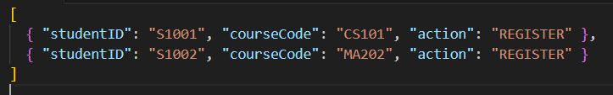

*Figure 3.8.2.3.1 Sample JSON File*

# Verification

## Verification Approach

**Methods of Verification (How):**

* **Functional Testing:** To verify that all features and functions specified in functions (section 3.1) and detailed in the use case specifications (section 3.1.1) operate correctly. This will involve executing test cases derived from these requirements.
  + *How:* Manual and automated test case execution. Test scenarios like those outlined in the initial draft of SRS (section 4.1) (e.g., One-Click Semester Report Export, Online Booking) will be formalized into test cases.
* **Performance Testing:** To assess the system's responsiveness, stability, and scalability under various load conditions, ensuring it meets the performance requirements outlined in performance requirements (section 3.2).
  + *How:* Automated load testing tools will simulate peak concurrent user loads and measure response times, throughput, and resource utilization.
* **Usability Testing:** To evaluate the ease of use, learnability, and user satisfaction of the portal, ensuring it meets the usability requirements specified in usability requirements (section 3.3).
  + *How:* Observation of representative users (students, lecturers, parents, administrators) performing predefined tasks using a think-aloud protocol. Feedback will be collected via questionnaires (e.g., SUS) and interviews.
* **Interface Testing:** To verify that all external and internal interfaces (System, User, Hardware, Software, Communications) defined in interface requirements (section 3.4) function correctly and integrate seamlessly.
* **Security Testing:** To identify and address potential vulnerabilities, ensuring the system meets the security attributes defined in software system attributes (section 3.7.c). This will include checks for data encryption, role-based access control, and protection against common web vulnerabilities.
* **Logical Database Testing:** To ensure data integrity, correct relationships, and adherence to constraints as defined in ERD (section 3.5).

**Responsible Parties (who):**

* **Development Team:** Responsible for unit testing and initial integration testing.
* **Quality Assurance (QA) Team:** Responsible for functional testing, performance testing, interface testing, security testing, and coordinating usability testing.
* **Selected End-Users (Students, Lecturers, Parents, Admin Staff):** Will participate in usability testing and User Acceptance Testing (UAT).

**Timing of Verification (When):**

* **Unit Testing:** Conducted by developers continuously during each development sprint.
* **Integration Testing:** Conducted after each sprint when new modules are integrated.
* **System Testing (Functional, Performance, Security, Interface):** Conducted by the QA team at the end of each major development phase or release cycle (e.g., Alpha, Beta releases).
* **Usability Testing:** Carried out at significant turning points, such as prior to UAT and following the creation of significant UI components.
* **User Acceptance Testing (UAT):** Conducted by end-users prior to final system deployment.

**Locations/Environments for Verification (Where):**

* **Development Environment:** Used for unit and initial integration testing.
* **Staging/QA Environment:** A dedicated environment mirroring the production setup, used for system testing (functional, performance, security, interface) and UAT. This environment will be used for tests simulating remote access and on-campus access.
* **University Computer Labs/Classrooms:** Utilized for controlled usability testing sessions with students and lecturers.
* **University Administrative Offices:** Used for specific UAT scenarios involving administrative staff and functions.
* **Parent** **Home environment:** Used for UAT scenarios involving parent portal access, student progress monitoring, and communication features from remote locations with varying internet connectivity and device types.

## 

## **Verification Criteria**

**Functional Criteria**

*Table 4.2.1 Functional Criteria*

| **VC_FUNC_001 (Login):** | Users (Student, Lecturer, Parent) with valid credentials can successfully log in within 3 attempts. The system correctly saves credentials in cookies if selected. Admin users must manually enter credentials each time and successfully log in. |
| --- | --- |
| **VC_FUNC_002 (Student Dashboard Customization):** | A logged-in student can add, remove, and rearrange widgets on their dashboard, and the layout changes persist across sessions. |
| **VC_FUNC_003 (View Academic Record):** | A logged-in student/parent can view the student's complete academic record, including current and past grades, CGPA progression, course enrollment, and attendance, accurately reflecting data from the SIS. |
| **VC_FUNC_004 (Online Booking):** | A logged-in student can successfully search for available venue/consultation slots and complete a booking. The booking is recorded, and confirmation is provided. |
| **VC_FUNC_005 (AI Chatbot):** | The AI chatbot correctly interprets and responds to student queries regarding academic or administrative information contained within the system (e.g., assignment due dates, financial deadlines). |
| **VC_FUNC_006 (Manage Finance - Student):** | A logged-in student/parent can view current balances, payment history, and successfully initiate an online payment through the integrated payment gateway. |

**Performance Criteria**

*Table 4.2.2 Performance Criteria*

| **VC_PERF_001 (Response Time):** | All user interactions (e.g., logging in, accessing course materials, submitting assignments) shall be responded to within 5 seconds under normal load (up to 500 concurrent users). |
| --- | --- |
| **VC_PERF_002 (Concurrent Users):** | The system shall support a minimum of 1000 concurrent users during peak usage times without performance degradation below specified response times. |
| **VC_PERF_003 (Downtime):** | Scheduled system downtime shall not exceed 4 hours per month. Unscheduled downtime shall not exceed 1 hour per month. |

**Usability Criteria:**

*Table 4.2.3 Usability Criteria*

| **VC_USAB_001 (Task Completion - Effectiveness):** | 90% of student users shall be able to successfully complete the task of viewing their grades within 3 minutes without assistance. |
| --- | --- |
| **VC_USAB_002 (Efficiency):** | Key system pages (e.g., Dashboard, Academic Page, Timetable) shall load within 3 seconds under normal load conditions. |
| **VC_USAB_003 (Satisfaction):** | The system shall achieve a System Usability Scale (SUS) score of at least 75/100 in post-deployment usability surveys. |
| **VC_USAB_004 (Error Prevention):** | Critical actions (e.g., deleting records, submitting payments) shall require user confirmation before execution. |

**Interface Criteria**

*Table 4.2.4 Interface Criteria*

| **VC_INT_001 (SIS Integration):** | Data related to student enrollment, academic records, and course details shall be accurately and consistently synchronized between the East Blue Portal and the SIS. |
| --- | --- |
| **VC_INT_002 (UI Responsiveness):** | The user interface shall be responsive and display correctly on common desktop browsers (Chrome, Firefox, Edge latest versions) and mobile devices (iOS 14+, Android 9+). |

**Software System Attribute Criteria**

*Table 4.2.1 Software System Attribute Criteria*

| **VC_ATTR_001 (Reliability):** | The system shall recover from a crash within 1 minute. |
| --- | --- |
| **VC_ATTR_002 (Availability):** | The system shall be available 99.9% of the time during working hours (Monday through Friday, 8 AM to 6 PM). |
| **VC_ATTR_003 (Security - RBAC):** | Users shall only be able to access data and features permitted for their defined role (Student, Lecturer, Parent, Admin) as specified in the use cases. |

* 1. **Timing Verification**

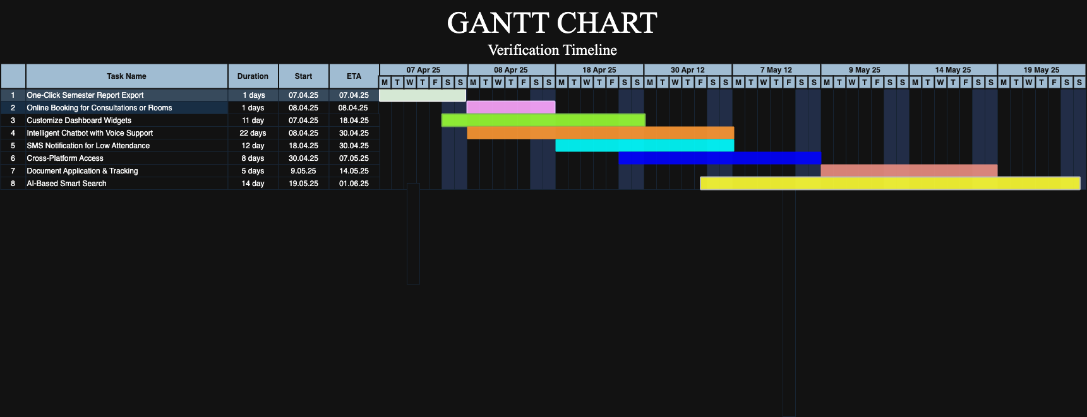

*Figure 4.3.1 Gantt Chart*

The method of production has been thoroughly tested in certain locations and conditions. These settings simulate real-world usage scenarios, ensuring the system functions consistently under different conditions.

**Remote Access Testing:**Purpose:

The verification of the remote access testing is to ensure a smooth experience for users operating from off-campus locations.

Environment :

Users access the system using personal devices (laptops, tablets) from different places. To simulate normal remote usage, the remote testing environment should have stable internet access.

**Computer Labs/Classrooms:**

Purpose:

Its aim is to provide a regulated environment for students and instructors to interact with technology.

Environment:

Classrooms and labs are commonly used by students and lecturers, making them conveniently accessible.

**University Administrative Offices**

Purpose:

To test academic record management and student enrolment systems in a real-world administrative environment.

Environment:

Staff personnel access all of the systems (SIS, LMS, databases) through desktop PCs connected to the university network.

# 

# **Appendices**

## **Assumptions and Dependencies**

## **Assumptions and Dependencies**

User Availability

* Enough administrative staff and student participation are assumed for the testing and observation phases.

Technical Environment

* It is assumed that the required technical infrastructure—such as databases, email, messaging platforms, and authentication systems—is completely functional and compatible with East Blue Portal.

Consistent Usage

* In order to gather useful information on user interactions and system performance, it is assumed that users will interact with the software on a regular basis throughout the observation period.

Data Security

* All information transferred between East Blue Portal and the current university systems is presumed to be safe and impervious to unwanted access.

**Dependencies**

Integration with Existing Systems

* For East Blue Portal to operate as planned, it must successfully integrate with the university's Learning Management System (LMS) and Student Information System (SIS).

IT Support

* The university's IT department must provide ongoing assistance in order to resolve any technical problems that might come up during the testing and observation stages.

User Feedback

* Active and honest user feedback is important to the observation process' efficacy. Finding and fixing any usability or functionality problems requires this users feedback

Regulatory Compliance

* To guarantee that the implementation and use of East Blue Portal are morally and legally acceptable, loyalty to university policies and pertinent legal requirements (such as data protection laws) is required.

## 

## **Acronyms and Abbreviations**

* + - * + AI: Artificial Intelligence
        + API: Application Programming Interface
        + AWS: Amazon Web Services
        + CGPA: Cumulative Grade Point Average
        + CORS: Cross-Origin Resource Sharing
        + CPU: Central Processing Unit
        + CRUD: Create, Read, Update, Delete
        + CSV: Comma-Separated Values
        + DB: Database
        + ERD: Entity Relationship Diagram
        + GUI: Graphical User Interface
        + HTML: HyperText Markup Language
        + HTTPS: Hypertext Transfer Protocol Secure
        + IEEE: Institute of Electrical and Electronics Engineers
        + I/O: Input/Output
        + ISO: International Organization for Standardization
        + JSON: JavaScript Object Notation
        + JWT: JSON Web Token
        + LMS: Learning Management System
        + NLP: Natural Language Processing
        + OS: Operating System
        + PDPA: Personal Data Protection Act (Malaysian context)
        + PDF: Portable Document Format
        + QA: Quality Assurance
        + RAM: Random Access Memory
        + RBAC: Role-Based Access Control
        + RDS: Relational Database Service (AWS)
        + S3: Simple Storage Service (AWS)
        + SIS: Student Information System
        + SMS: Short Message Service
        + SRS: Software Requirements Specification
        + SUS: System Usability Scale
        + TLS: Transport Layer Security
        + UAT: User Acceptance Testing
        + UI: User Interface
        + UX: User Experience